IALA

USE CASES FOR VTS Digital Communications

Revisions to this document are to be noted in the table prior to the issue of a revised document.
Date | Details | Approval

  - Document PURPOSE
To provide practical insight, use cases are developed that illustrate these services in real-world scenarios. A single service as described in the guideline may have one or more use cases.
It is recognised that use cases can evolve over time. Therefore, they are not included in the guideline itself. Instead, the use cases are reviewed and approved by the IALA VTS community and published separately on the IALA website under Topical Matters.
  - DOCUMENT STRUCTURE
The VTS Digital Communications guideline describes operational functions. Each operational function has its own chapter in this document. The associated services are paragraphs within the chapters.
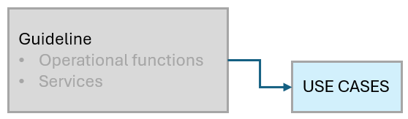
Figure 1 Document relationship
    - Document work-flow
If a use case requires revision due to new insights, an input paper shall be prepared. This paper will be reviewed and discussed during a VTS Committee meeting in working group 1 (operations) and working group 2 (technology). Based on these discussions, the use cases may be updated and approved by the VTS Committee.
If an updated or new use case affects the technical implementation, an IALA action item shall be created. This action item will be included on the agenda of the next committee meeting.
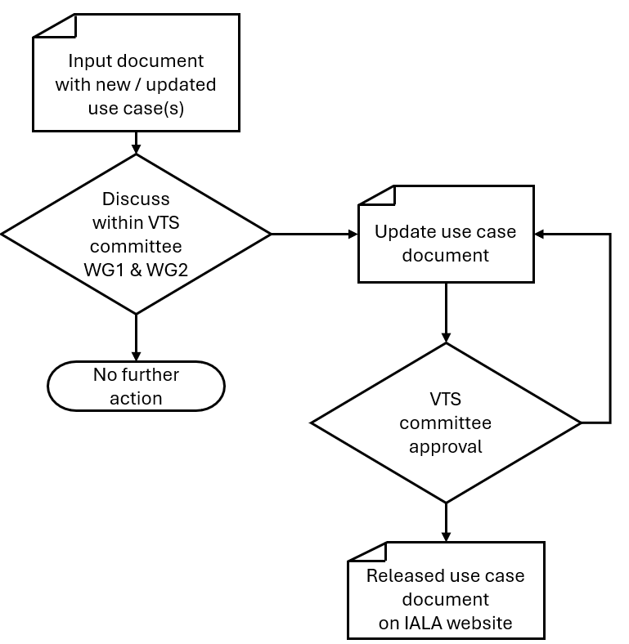
Figure 2 Document workflow
  - ROUTE functions
    - Route exchange service
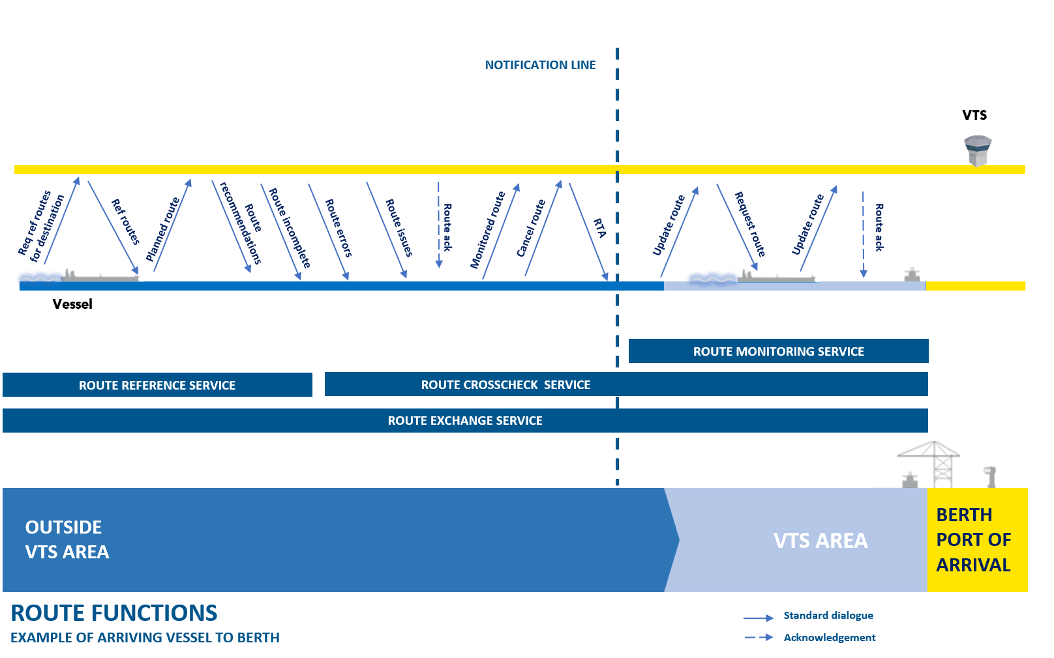
Figure 1 Example of arriving vessel to berth
      - Use case 3.1.1 - Initial Sharing of the route from Vessel to VTS
Description: Vessel shares route with VTS before entering VTS area, leaving from berth/anchorage, departing from port/anchorage.
Typical sequence:
- The route is planned in the planning station by the mariner
- Planning station crosschecks the route and upload route to the ECDIS/ECS
- The ECDIS/ECS should send the route to the “Route Exchange Function” before departure, but the route must be shared at latest according to local rules
- The Route Exchange Function checks that at least following information is included in the route
- Vessel Identification Information
- Waypoints (WP)
- Schedule / times of WPs
- Legs (including cross track distance limit (XTDL)
- Wheel over point (WOP)
- The Route Exchange Function sends this planned route to the VTS System
- The Route Exchange Function sends “received” acknowledgement automatically
- VTS System can display the route as needed to the VTS personnel

      - Use case 3.1.2 - VTS gives route recommendation to vessel within a geographically defined area
Description: VTS gives route recommendation to vessel for example due to:
    - A certain part of the route is inaccessible, for example due to navigational danger, environmental conditions, or for monitoring and managing vessel traffic
      - Changing the geography of the route
      - Changing the ETA to a specific waypoint
    - Enhanced navigational assistance
      - Changing the radius of the turn
Typical sequence:
- Vessel has already sent route to VTS
- VTS personnel creates the recommendation for vessel
  - VTS system can assist VTS personnel to create the route recommendation
- VTS system sends back the recommended route to ECDIS (planning station)
  - Route can contain changes to waypoints and/or schedule
- Vessel sends “route received” acknowledgement automatically
- One of the following
  - Vessel does not agree with changes
  - Vessel process the route and sends it to VTS
- The Route Exchange Service sends “received” acknowledgement automatically
- VTS System can display the route as needed to the VTS personnel

      - Use case 3.1.3 - VTS requests route from vessel
Description: VTS has not received route from vessel and requests route from vessel for situational awareness and/or traffic management.
Typical sequence:
- VTS request route from vessel
- Vessel sends route as requested
- The Route Exchange Service sends “received” acknowledgement automatically
- VTS System can display the route as needed to the VTS personnel with ability to highlight any changes

      - Use case 3.1.4 - Vessel´s route changes
Description: Vessel wants to change its route
Typical sequence:
- Vessel has already sent route to VTS
- Mariner makes changes to its route
- The on-board system sends updated information to VTS as monitored route
  - If VTS has requested updates according to use case 3.1.3 that request must be honored
- VTS system sends “received” acknowledgement automatically
- VTS System can display the route as needed to the VTS personnel with ability to highlight the changes

      - Use case 3.1.5 - Vessel does not arrive to VTS area as planned
Description: Vessel changes route and does not arrive to VTS area as part of its voyage (use case 3.1.1)
Typical sequence:
- Vessel has already sent route to VTS
- Mariner makes changes the route where no waypoints are located inside geometry area
- Vessel sends cancellation to VTS system by means as route cancelled message
- VTS system sends “received” acknowledgement automatically
- VTS System can display the route as needed to the VTS personnel with ability to highlight the changes/cancellation

      - Use case 3.1.6 - VTS acknowledges the route
Description: VTS acknowledges vessel’s route without changes
Typical sequence:
- Vessel has already sent route to VTS
- VTS system sends the route to Route Crosscheck Function if available to checks the route
- Route Crosscheck Service checks the route and marks it as compliant
  - If the route is not compliant go to use case 3.1.2 or 3.1.8
- VTS personnel takes in consideration the monitoring and managing vessel traffic and marks the route “ok” on the VTS system
  - If the route is not suitable go to use case 3.1.2
- VTS system sends VTS acknowledge message to ECDIS
- ECDIS can display the VTS acknowledged status of the monitored route to mariner

      - Use case 3.1.7 - VTS personnel acknowledges the route
Description: VTS personnel acknowledges vessel’s route without changes
Typical sequence:
- Vessel has already sent route to VTS
- VTS personnel checks the route and marks the route “ok” on the VTS system
  - VTS personnel also takes in consideration the monitoring and managing vessel traffic
  - If the route is not suitable go to use case 3.1.2 or 3.1.8
- VTS system sends VTS acknowledge message to ECDIS
- ECDIS can display the VTS acknowledged status of the route to mariner

      - Use Case 3.1.8 - VTS sends route back with comments
Description: VTS does not acknowledge vessel´s route and sends it back with comments
Typical sequence:
- Vessel has already sent route to VTS
- Route Crosscheck Function or/and VTS personnel checks the route and finds issues with the route
- VTS personnel decides not to make a recommendation
- VTS sends part of the route back to the vessel with comments, which can be:
  - Recommendations (route modification readily to be used by the mariner, including human readable explanation why this recommendation is given)
  - Issues (including human readable text to explain the issue)
  - Errors (technical issues of the route, not necessarily human action)
  - Route incomplete (VTS decides there are too many issues to be explained to the mariner, so this route incomplete message is a request to the mariner to re-plan the route)
- Vessel changes its route [go to use case 4]

      - Use Case 3.1.9 - Vessel gets multiple changes to their route
Description: Vessel sends its route to many VTS areas and gets multiple change recommendations to their route.
Typical sequence:
- Vessel has already sent route to multiple VTS areas
- VTS areas can give multiple recommendations to vessel´s route
  - VTS can send recommended route or/and comments (issues, errors)
- Vessel receives multiple change recommendations to their route and adjust it

    - Route Reference service
No use cases defined yet.

    - Route Crosscheck service
No use cases defined yet.

    - Route Monitoring Service
No use cases defined yet.

  - TRAFFIC functions
    - Traffic Image Service
No use cases defined yet.

    - Intended Track Exchange Service
No use cases defined yet.

    - Navigation Assistance Service
No use cases defined yet.

  - VTS INFORMATION functions
    - VTS Reporting Service
Use cases under construction in the working paper “Working paper on use cases for VTS Digital Communication”.

    - VTS Information Service
Use cases under construction in the working paper “Working paper on use cases for VTS Digital Communication”.

  - planning functions
    - Traffic Clearance Service
      - Use Case 6.1.1 - Departing vessels from berth or anchorage
Description: Vessel sends prior to its departure the intended ETD and route through the VTS area to the VTS. The VTS validates the intended ETD and route and approves or sends a denial or a proposal with recommended information on when the vessel can leave the berth/anchorage. The vessel approves the recommended route.
Typical sequence:
- Vessel wants to leave berth/anchorage
- The vessel sends message (ETD) through its system to the service and requests traffic clearance to leave berth/anchorage
- If vessel's schedule is suitable VTS [go to step 7]
- If vessel's plan (ETD) is not suitable, VTS sends denial or a proposal with recommended information on when vessel can leave the berth/anchorage.
- Service delivers response to the vessel
- The vessel acknowledges revised ETD and sends response to the VTS or creates new plan [go to step 2]
- Berth/anchorage location with ETD are acknowledged by the VTS and sends approval
- The vessel leaves berth/anchorage

      - Use Case 6.1.2 - Entering or passing through a VTS area
Description: Vessel request for Traffic Clearance entering of passing through a VTS area but has no destination within the VTS area.
Typical sequence:
- Vessel is about to pass through the VTS area
- The vessel sends message (ETA) through its system to the service and requests traffic clearance to proceed through the VTS area from the service
- If vessel's planned route and schedule is suitable, [go to step 7]
- If vessel's planned route or schedule is not suitable, VTS sends denial or a RTA to the vessel through the service
- Service delivers response to the vessel
- The vessel acknowledges revised ETA and sends response to the VTS or creates new plan [go to step 2]
- Route with ETA are acknowledged by the VTS and sends approval,
- The vessel enters the VTS area

      - Use Case 6.1.3 - Arriving vessels taking berth
Description: Vessel outside the VTS area request for Traffic Clearance to a berth within the VTS area.
Typical sequence:
- Vessel is about to enter the VTS area
- The vessel sends message (ETA at berth location) through its system to the service and requests traffic clearance to proceed to the predefined berth from the service
- If vessel's planned route and ETA is suitable, then VTS send acknowledgement [go to 7]
- If vessel's planned route or ETA is not suitable, VTS sends denial or a RTA to the vessel through the service
- Service delivers response to the vessel
- The vessel acknowledges revised ETA and sends response to the VTS or creates new plan [go to step 2]
- Berth location with ETA are acknowledged by the VTS and sends approval
- The vessel enters the VTS area

      - Use Case 6.1.4 - Arriving vessels heading for anchorage
Description: Vessels from outside the VTS area request for Traffic Clearance to an anchorage within the VTS area.
Typical sequence:
- Vessel is about to enter the VTS area
- The vessel sends message (ETA at anchorage location) through its system to the service and requests traffic clearance to proceed to the predefined anchorage from the service
- If vessel's planned route and ETA is suitable, then VTS send acknowledgement [go to 7]
- If vessel's planned route or ETA is not suitable, VTS sends denial or a recommended plan to the vessel through the service
- Service delivers response to the vessel
- The vessel acknowledges recommended plan and sends response to the VTS or creates new plan [go to step 2]
- Anchorage location with ETA are acknowledged by the VTS and sends approval
- The vessel enters the VTS area

      - Use Case 6.1.5 - Transit within a VTS area
Description: Request for traffic clearance while the vessel is already in the VTS area.
Typical sequence:
- Vessel wants to leave berth or anchorage.
- The vessel sends message (ETD) through its system to the service and requests traffic clearance to leave berth/anchorage and take other berth or anchorage in the area.
- If vessel's schedule is suitable VTS, [go to step 7]
- If vessel's schedule is not suitable VTS sends a denial or proposal which may include additional information on when vessel can leave the berth/anchorage
- Service delivers response to the vessel
- The vessel acknowledges revised ETD and sends response to the VTS or creates new plan [go to step 2]
- ETD and ETA with location are acknowledged by the VTS and sends approval
- The vessel leaves berth/anchorage

      - Use Case 6.1.6 - External influence to change traffic clearance by VTS
Description: When an approved Traffic Clearance changes due to external causes a new clearance should be agreed.
Typical sequence:
- Approved plan needs changes due external influences, like weather conditions, delay or occurring hazardous situation
- VTS or vessel sends request to amend of the approved plan
- Vessel creates new plan and sends new request via Use case 6.1.1-6.1.5

    - Slot management service
Use cases under construction in the working paper “Working paper on use cases for VTS Digital Communication”.

