From: DTEC Committee | DTEC2-12.2.2.2
To: ARM, ENG, VTS Committee | 28 March 2024

LIAISON NOTE

Update of Emerging Technology Review

INTRODUCTION
The DTEC Committee reviewed the comments from the LAP Committee on the New Technology Review Summary table and update with the outcome of DTEC 2.

DISCUSSION
The DTEC Committee welcomed the comments provided, which enhance the summary table. Based on the comments from other Committees, the summary table has been reviewed and revised. Specifically:
- A Disclaimer Notice from LAP committee has been added.
- The status of each candidate technology has been updated.
As experience with completing the summary table was gained, there could be an option to group the reviews under specific categories however, at the moment, it was felt that the easiest way to manage the summary reviews was to continue with the chronological listing of each technology as it was presented for review.
To facilitate access to the summary of technology reviews, the folder was located to the parent folder of the Committee File Share.
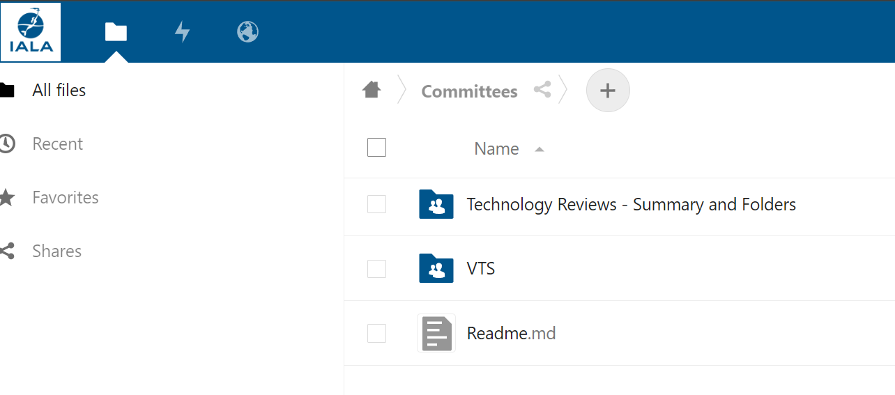
Based on the feedback, the table has been revised, as provided in the Annex to this liaison note.

ACTION REQUESTED
The IALA ARM, ENG, and VTS Committees are invited to note the comments provided.

ANNEXES
- Revised version of the Emerging Technology Candidate Technology Review Summary

Annex A - Emerging Technologies – Candidate Technology Review Summary
The development of digital technologies continues to be rapid, and it impacts on almost all aspects of the maritime industry, including maritime communications, aids to navigation and VTS. Digital technologies deal with the creation and practical use of digital or computerised information using devices, methods, or systems. (Source http://www.dictionary.com)

Review of technologies
It is important to evaluate emerging digital technologies in consideration of user requirements and the needs of IALA membership. These evaluations are a preliminary, high level, desktop study. The reviews identify the key features and capabilities, advantages/disadvantages, limitations, and application to aids to navigation, VTS and other services and systems within the remit of IALA.
The simplified set of assessment criteria has been established to provide a consistent review approach, as provided in IALA G1153. The review process is an initial step in determining further steps that may be taken to confirm that technology is appropriate and feasible for the use of IALA members. When providing information on a new technology the organisation which provides the information should also identify how the technology may be adopted or adapted for use by IALA members.
The Emerging Technologies – Technology Tracker is a summary of those technologies reviewed within the IALA ENAV Committee (WG2).
IALA is an international association that deals with Marine Aids to Navigation. The association aims to provide information and support to its members and the maritime community through its standards, recommendations, guidelines and other documents as accurately as possible. However, the planning, implementation and operation of Marine Aids to Navigation remains the sole responsibility of the respective national members, authorities, administrations or other entities according to their respective national law including the decision to use IALA’s standards, recommendations, guidelines and other documents. IALA shall in no event be held responsible for any claim, damages or other liability, whether in an action of contract, tort or otherwise, arising from, or out of or in connection with the above-mentioned documents, the use of or other dealings with them.

Summary of Technologies
When a review is completed, a rating of red, amber or green is identified. Technologies rated as:
- red are not considered suitable for use within a given context;
- amber could be considered for use with possible changes or developments;
- green could be considered suitable for use within a given context.
The Technology Tracker is updated following the completion of a technology review. The Technology tracker and supporting review document (completed G1153 review table) is provided on the IALA FileShare, under Committees / Technology Reviews – Summary and Folders.

Reviews against G1153
These technology reviews have been reviewed against G1153 Ed 1.0 (December 2019).

Candidate Technology Tracker
No. | Candidate Technology | Rating | ENAV / DTEC Start Session | ENAV / DTEC Planned  End Session | Revised  End Session | Review  (% complete) | Comments
 | 3GPP – 4G (including LTE) | Green | ENAV22  Oct 2018 | ENAV24  Oct 2019 | ENAV 24  Oct 2019 | 100% | Completed / forward to WG3
 | LoRa (Lorawan) | Green (some amber) | ENAV 25  March 2020 | ENAV 26  Oct 2020 | ENAV 27  March 2021 | 100% | Some issues identified as Amber related to costs (unknown / ongoing fees) and risks associated with licensed and unlicensed services. NB-IoT – licenced – guarantee of service; ISM bands by nature unlicensed with no guarantee of service.
 | Digital VHF - dPMR | Green (some amber) | ENAV 23  March 2019 | ENAV 25  March 2020 | ENAV 31 (ENAV EM1)  Feb 2023 | 100% | Digital VHF voice technology is proven and could be suitable for use by IALA members. Amber elements relate to issues with IPR for the CODEC, and the ongoing work at ITU for the digitalisation of the maritime mobile VHF Channels. Further work on the development and implement of digital VHF voice for use in the maritime domain is required.
 | Leo Constellation Developments – including Virgin/OneWeb; SpaceX/Starlink; Amazon/Kuiper, (2026); Telsat Lightspeed, (2026); ESA | Green | ENAV 25  March 2020 | --- | ENAV 31 (ENAV EM1)  Feb 2023 | 100% | Developments in solid state antenna suitable for the maritime environment, along with increasing number of satellites in the constellations, could provide significant capability. Upfront costs for users related to the terminal, antenna and monthly data plan subscription.
 | NAVDAT – development in progress, updates provided to IMO. | On hold | ENAV 25  March 2020 | --- | --- | 10% | Noting the work at IMO on NAVDAT, deemed not suitable for full template review. May be reviewed if further input is received.
 | LiFi (Light Fidelity) | On hold | ENAV 25  March 2020 | --- | --- | 10% | No input or expertise available in WG2. Will review when more input is received.
 | Resilience in PNT: GPS/GNSS (presented by Orolia, technology called M SecureSync) | Amber (some green) | ENAV 28  Oct 2021 | ENAV 29  March 2022 | ENAV 29  March 2022 | 100% | Review template for Orolia covers both M SecureSync and GNSS Antenna. For M SecureSync, the systems is not yet mature, awaiting feedback from trials. There are patens on the technology.
 | Resilience in PNT: GPS/GNSS (presented by Orolia, GNSS antenna systems) | Green (some amber) | ENAV 28  Oct 2021 | ENAV 29  March 2022 | ENAV 29  March 2022 | 100% | Review template for Orolia covers both M SecureSync and GNSS Antenna. The GNSS antenna is a mature technology, appears to have ease of implementation.
 | 5G Private Network and Positioning in a port environment (presented by Qualcomm) | In Progress | ENAV 28  Oct 2021 | ENAV31 (ENAV EM1)  Feb 2023 |  | 50% | Continuing
 | AI detection of ships in ports / Synthetic images (Presented by SeerBI) | Deciding next steps | ENAV30  Oct 2022 | TBC |  | --- | Overtaken by events (no further action planned)
 | IMT 2020 on buoys (Presented by Jet Engineering) | Deciding next steps | ENAV30  Oct 2022 | TBC |  | --- | Overtaken by events (no further action planned)
 | Metal Surface Wave communication (Presented by KRISO/ SWT, technology called MS@MS) | Green (some amber) | ENAV30  Oct 2022 | DTEC01  Oct 2023 | DTEC01  Oct 2023 | 100% | Some Amber due to use the technology, more wide usage example for IALA remit, IPR (Intellectual Property Rights) for a non-discriminatory nature which required more time to get wide acknowledgement of foregoing technology, and training on the installation of the system (no training on the use of the system would be expected).
 | Ships Air draft remote measurement (Presented by China MSA) | Submitted | ENAV30  Oct 2022 | DTEC01  Oct 2023 | DTEC03  Oct 2024 | 30% | Continuing
 | SigFox (Irish Lights) | Green (some amber) | ENAV30  Oct 2022 | DTEC01  Oct 2023 | DTEC02  March 2024 | 100% | Overall, the technology is noted as ‘Green’ with some amber areas related to cycbersecurity, potential longevity of the technology and bandwidth requirements. It is noted that the technology would require encryption before being used to control AtoN. Use may be suitable to monitor AtoN without additional encryption.

Next steps:

- China MSA - Ship air draft (Item 13) – Planned to complete evaluation at DTEC03
- Follow up on 5G Private Network and Positioning in a port environment for review at DTEC03

