Input paper: ARM20-8.4.5

Input paper for the following Committee(s): check as appropriate Purpose of paper:
X ARM □ ENG □ PAP □ Input
□ DTEC □ VTS X Information

Agenda item 8.4
Technical Domain / Task Number ² 7.1.4
Author(s) / Submitter(s) Sewoong OH (KRISO)

Update of S-200 Test & Validation Tool

Summary
The Ministry of Oceans and Fisheries, Korea and KRISO developed the S-200 Test Bed to support the development of IALA’s S-200 series PSs and assist IALA members in testing S-200 production. The ARM meeting decided to rename the S-200 Test Bed to the 'S-200 Test & Validation Tool'. The updates to the S-200 Test & Validation Tool are reported.

Purpose of the document
The updates to the S-200 Test & Validation Tool were reported, and a proposal was made for securing test data for S-201.

Related documents
S-100 IHO Universal Hydrographic Data Model (Edition 5.2.0, June 2024)
S-97 IHO Guidelines for Creating S-100 Product Specifications (Edition 1.1.0, June 2020)
S-201 Aton Information product specification
S-125 Marine Aids to Navigation product specification

Background
The Ministry of Oceans and Fisheries and KRISO are developing and operating the S-200 Test & Validation Tool to support IALA’s S-200 development and to cooperate in the production of S-201 data.

Discussion

Update of S-200 Test & Validation Tool
At ARM19, the major updates to the S-200 Test & Validation Tool were reported, and the key improvements can be summarized as follows:
- Enabled full data production and database input for the S-200 series product specifications through Feature Catalogue (FC) registration.
- When inputting data such as S-201, feature instances, detailed attributes and assoications can be entered according to the FC data structure.
- Includes validation functionality for S-200 series data.
- Improved the symbol rendering functionality of S-200 product specifications by applying the S-100 Viewer technology developed using the OpenS-100 open source, enabling display of results on a web map.
- In addition to web-based input, a template is provided for inputting list of Atons via CSV files.
These improvements were reported at ARM19, and the S-200 Test & Validation Tool was used during the S-100/S-200 training of the IALA WWA held in Busan, Korea, in the first week of March 2025, for hands-on production of S-201, S-124, and S-125.

Aton data of Spain
The IALA Secretariat provided a example of Spain’s AtoN (Aid to Navigation) data in CSV format. The KRISO research team analyzed the CSV AtoN list from Spain (mainly lighthouses) and converted the data into the standard template supported by the S-200 Test & Validation Tool. As a result, the Spanish AtoN data was successfully converted into a format that can be uploaded to the S-200 Test & Validation Tool, allowing the data to be entered into the database and the input results to be visualized on the web map.

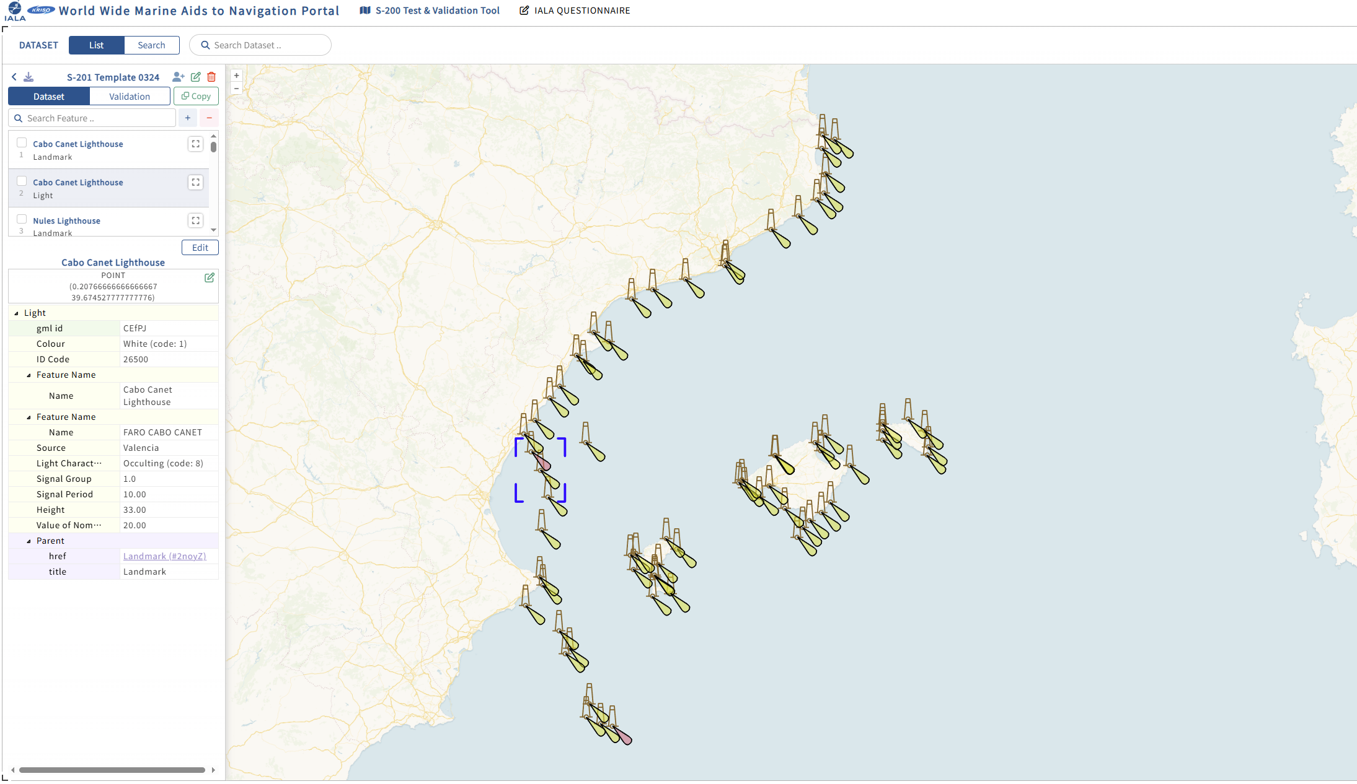
Fig. 1. Aton data of Spain in S-200 test & validation tool

A set of S-201 test data was secured using only the mandatory attributes from the Spanish AtoN dataset. It is expected that more detailed data input and expansion will be possible following the procedures below:

- The Spanish members accesses the S-200 Test & Validation Tool to enter additional attributes for the about 190 data entries already stored in the database.
- As the current dataset includes only lighthouse-related AtoNs, other types of AtoN such as light buoys and radio aids to navigation could be added.
- In addition to AtoNs along the eastern coast of Spain, data from other regions could also be input.

Proposal for Securing S-201 Test Data
Since the S-200 Test & Validation Tool is not a commercial service, the user experience is considered to be less convenient, which has limited its active use and testing by IALA members. In this regard, as demonstrated by securing S-201 test data through the Spanish AtoN dataset, the following possible approaches are proposed:

- (Option 1) Utilize the standard CSV template provided by the S-200 Test & Validation Tool to input data, and upload the CSV file to obtain basic S-201 test data.
- (Option 2) If any IALA member state is interested in using the S-200 Test & Validation Tool, they may provide their national AtoN data in an Excel format (with required fields such as Aton ID, name, position, color/shape of Aton structure, AtoN type, and light characteristics).
The Korean research team is willing to assist by analyzing the AtoN lists (CSV files) provided by IALA member states, converting them into the standard CSV template, and creating and providing basic test datasets within the S-200 Test & Validation Tool. If IALA members begin using the S-200 Test & Validation Tool, the following benefits are expected. Therefore, we kindly request that the options proposed in this document be considered.
Expected Benefits of Using the S-200 Test & Validation Tool
- Enhances understanding of the S-201/S-125/S-124 PS, particularly the data models and feature catalogue structures.
- Enables IALA members to produce and review S-200 series datasets.
- Supports review and feedback on IALA’s S-200 series product specifications.
- Provides insight for IALA member states to conduct preliminary reviews when considering the implementation of S-201 in their national AtoN information systems.
- Offers validation functionality for S-200 series data.
- Allows for preliminary assessment of data management and maritime service implementation based on S-200 series datasets.

User manual of S-200 Test & Validation Tool and Tutorial video
During the S-100/S-200 training conducted by IALA WWA, the S-200 Test & Validation Tool was used as a hands-on training tool. In response to participants’ feedback that a tutorial video explaining how to use the system would be helpful, the Korean research team produced a tutorial video for the S-200 Test & Validation Tool. The video has been uploaded to YouTube and can be accessed via the link below:
S-200 Test & Validation Tool (S-201 Data Production Tutorial) – Hands-on Data Production Practice:
https://youtu.be/ccAGYoxCXQ8
The user manual for the system can be downloaded via the link at the bottom of the interface screen.

Action requested of the Committee
The Committee is requested to consider this input paper, and take actions as appropriate.

Input document number, to be assigned by the Committee Secretary
Leave open if uncertain

