IALA Guideline

DraFT G1111-3
Producing Requirements for RADAR

Functions, Performance And radar specifIC AcceptANce

Input to VTS 51 from VTS 50-51 intersessional work, editorial, further development of text and completion of tables/formulas to cover all frequency bands.

Editorial remarks highlighted in yellow

Edition x.x
Date (of approval by Council)

urn:mrn:iala:pub:g1111-3(2’nd draft)
Revisions to this document are to be noted in the table prior to the issue of a revised document.
Date | Details | Approval
Edition 1.0
This document originated from Guideline G1111 which has been subdivided into 13 sub-guidelines, including this document. Document structure revised, Basic, Standard and Advanced substituted with guidance on specific areas including Inland VTS, Ports, Ports Approach and Coastal VTS. Guidance on offshore related VTS and Acceptance of VTS Radar Systems added.
Measurements in Metric terms adopted for Inland Waterways only.
(Note - G1111 originated from annex of Recommendation V-128 Ed 3 in May 2015)

1 INTRODUCTION 6
1.1 The IALA G1111 guideline series 6
2 DEFINITIONS 7
2.1 General Terms 7
2.2 Specific Terms 7
2.3 Speciffic IALA Definitions 9
2.3.1 Target Types 9
3 References 10
4 Abbreviations 11
5 Operational Areas 12
5.1 Inland Waterway 12
5.2 Port 13
5.3 Port Approach 13
5.4 Coastal Area 13
5.5 Off-Shore 14
6 Producing Functional and Performance requirements 15
6.1 Core Radar Performance 16
6.1.1 Radar Coverage 16
6.1.2 Target Separation 17
6.1.3 Target Positional Accuracy 18
6.2 Radar Performance Versus the Dynamic EnvirOnment 19
6.2.1 False Echoes 19
6.2.2 Handling of Dynamic Range, targets and surroundings 20
6.2.3 Handling of environmental Conditions 20
6.3 Radar Functions and Other Features 21
6.3.1 Target Positional Update rate 21
6.3.2 Operator Functions 21
6.3.3 Operational Outputs 21
6.3.4 Clutter and Noise Reduction / Management 21
6.3.5 Target tracking 22
6.3.6 Interfaces 22
6.3.7 robustness, availability, and serviceability 22
7 Acceptance of VTS Radar Systems 24
7.1 TEST Targets 24
7.1.1 Target of opportunity 24
7.1.2 Controlled target 25
7.1.3 Controlled and calibrated target 25
7.2 Radar Functions and other features 25
7.3 Performance versus the Dynamic Environment 25
7.3.1 Dynamic Range 25
7.4 Core radar performance 26
7.4.1 Radar Coverage and Target Detection Performance 26
7.4.2 Determination of Target separation 28
7.4.3 Measurement of Target Positional error 30
7.4.4 Target tracking 31
7.5 System Availability 31
ANNEX A VTS Radar Considerations 32
A.1. Radar Types 32
A.1.1. Pulse Radar 32
A.1.2. Pulse Compression Radar 32
A.1.3. Frequency Modulated Continuous Wave Radar 33
A.2. Frequency Bands 34
A.3. Antennas 34
A.3.1. Antenna Principles 34
A.4. Typical VTS radar system configurations 35
A.4.1. Radar coverage 35
A.4.2. Target separation 37
A.4.3. Target Positional Accuracy 38
A.4.4. Target Positional update rate 39
A.4.5. Dynamic characteristics 39
A.4.6. Sidelobes 40
A.5. Target caracteristics 41
A.5.1. Radar Cross Section 41
A.5.2. Target Models versus Detailed Characteristics 41
A.5.3. Multipath Effects 43
A.6. Environmental Influence 44
A.6.1. Precipitation and Sea 45
A.6.2. Reduced Visibility, Fog, sand, Dust 48
A.6.3. Air Mass (Propagation) 48
A.7. Other Influencing Factors 52
A.7.1. Shadowing Effects 52
A.7.2. Interference 52
A.7.3. Radar Susceptibility 52
A.7.4. Radar Compatibility with Other Users 52
A.7.5. Influence from Wind Farms 53
A.8. Signal Processing and Tracking 53
A.9. Analysis of Radar Detection Performance 53
A.9.1. Probability of Detection and False Alarm Rate 54
ANNEX B Performance calculation 55
B.1. Symbols 55
B.2. received powers 55
B.2.1. Received power from target 55
B.2.2. Received power from sea clutter 56
B.2.3. Received power from land clutter 56
B.2.4. Received power from volume clutter 56
B.2.5. Thermal noise 57
B.2.6. Attenuation 57
B.3. Detection probability 57
ANNEX C Test Targets and their Callibration 59

List of Tables

List of Figures

INTRODUCTION
This Guideline presents a common source of information to assist VTS authorities in the understanding of radar performance, supporting the design of radar service and its contribution to the VTS traffic image (situational awareness) as well as guidance of how the VTS Authority should specify the Functional, Performance and associated Acceptance Requirements.
The guideline considers application of radar to different operational areas (e.g. inland waterways, Harbours, Coastal regions and offshore).
This includes considerations relative to environmental conditions such as weather, sea conditions, geographical constraints, and obstructions, posing challenges to the detection and coverage of radar sensors.
Specific maritime security requirements possibly identified by the International Ship and Port Security code and other requirements from allied services may introduce additional challenges.

The IALA G1111 guideline series
This Guideline is one of the G1111 series of guideline documents. The purpose of the G1111 series is to assist the VTS authority in preparing the definition, specification, establishment, operation, and upgrades of a VTS system. The documents address the relationship between the operational requirements and VTS system performance (technical) requirements and how these reflect into system design and sub system requirements.
The G1111 series of guideline documents present system design, sensors, communications, processing, and acceptance, without inferring priority. The guideline documents are numbered and titled as follows:
- G1111 Establishing Functional & Performance Requirements for VTS Systems
- G1111-1 Producing Requirements for the Core VTS System
- G1111-2 Producing Requirements for Voice Communications
- G1111-3 Producing Requirements for RADAR
- G1111-4 Producing Requirements for AIS and VDES
- G1111-5 Producing Requirements for Environment Monitoring Systems
- G1111-6 Producing Requirements for Electro Optical Systems
- G1111-7 Producing Requirements for Radio Direction Finders
- G1111-8 Producing Requirements for Long Range Sensors
- G1111-9 Framework for Acceptance of VTS Systems

DEFINITIONS

General Terms
For general terms used throughout this section refer to IEEE Std 686-1997 IEEE Standard Radar Definitions.

Specific Terms
Specific terms are defined as follows:
Azimuth (Antenna) Side Lobes - antenna responses (in azimuth) outside the intended radiation beam. Weighting of the illumination function allows a significant reduction of these lobes, but some response outside the intended direction is unavoidable, normally presenting an irregular pattern with 'peaks' and 'nulls. The side lobes may produce responses from targets in unwanted directions, allowing disturbing signals (intentional or not) to enter the receiver, and in addition makes the radar detectable by receivers, which are not illuminated by the main beam.
Availability - is the probability that a system will perform its specified function without failure when required.
Blind Spots – typically resulting from either blind range (the Range corresponding to an echo delay of one or more pulse repetition intervals: the echo then arrives at the receiver while the radar is transmitting a new pulse and the receiver is blanked) or Blind speed (target speeds which produce Doppler shift which are integer multiples of the radar pulse repetition frequency (PRF), which are therefore aliased to zero Doppler and cancelled by the clutter rejection filtering). Blind spots can also arise behind significant obstructions in the field of view (buildings, land masses, oil tankers).
BITE: Built in Test Equipment
Chirp - frequency modulation of the carrier frequency applied within the radar pulse to increase its bandwidth and therefore the range resolution (see also pulse compression).
Coherence - capability of a system to keep a stable phase reference during the target illumination time in order to properly exploit the received phase information for moving target indication (MTI), pulse Doppler processing or other purposes.
Doppler Shift - shift in frequency of a wave due to the relative motion between the transmitter and the receiver. Frequency shift is relative target velocity/wavelength. Radar echoes are shifted twice this value because this shift must be accounted for in both the forward and the return path.
Doppler Side Lobes - when using Doppler processing (or MTI) the integrated ideal pulse always presents a response outside the integration peak (across all Doppler filters) known as Doppler side lobes. Their main effect is to limit the capability to discriminate weak returns in proximity of strong returns (with side lobes of the same order of magnitude as the primary response of the weak return).
FMCW - Frequency Modulation - Continuous Wave - A type of radar where a continuous wave instead of pulse is transmitted. The range information is derived by frequency modulating the carrier with a saw tooth waveform and comparing the echo FM modulation envelope with the reference.
Gap Filler - A radar used to supplement the coverage of a principal radar in areas where coverage is inadequate.
Ghost Targets (Ghost Echoes) – undesirable radar echoes resulting from a number of sources. For example, multipath related wave reflections caused by large structures or surface reflections, time sidelobes, antenna azimuth sidelobes, and Doppler sidelobes.
Interference Rejection - this function is included to seek to reduce or eliminate interference received from transmitters utilising the same or nearby frequencies. One common technique is to compare adjacent range cells in the present 'live' video signal with the video signal from the previous sweep. The output video signal to the display device is inhibited should the comparison indicate the presence of interference.
Normal Weather and Propagation Conditions - are the conditions not exceeded 99% to 99.9 % of the time as defined by the individual VTS Authority. The rest of the time is considered having adverse weather and propagation conditions.
Operational area -
Plot Extraction – the process of determining the likely target related radar returns from the radar video signal. This typically consists of comparing the video level with a threshold which can be (dynamically) adapted to local background noise and clutter conditions.
Polarisation – of a radar signal is determined by the orientation of the electrical field. In the case of circular polarisation, the field rotates left or right.
Pulse – typically a pulse (which is modulated in the case of pulse compression radar) of RF energy transmitted from the radar.
Pulse Compression – A technique used to achieve a wide pulse bandwidth (and, therefore, enhanced range resolution) using long pulse (for high pulse energy with limited peak power) by introducing an intra-pulse modulation (e.g., chirp frequency modulation or Barker discrete phase modulation) and performing a correlation on the received echo.
Radar Cross Section (RCS) – an assessment of the cross-sectional area presented by a reflector (typically a target or unwanted “clutter”) to the transmitted radar energy. The RCS can vary with frequency and target attitude.
Radar Information – a generic term potentially referring to the radar picture/video, target data, clutter data, topographical data, aids to navigation SARTs etc.
Radar P_{D} – is the probability of target detection at the output of a radar, after plot extraction, but prior to tracking, and presentation. Note, in some systems the boundary of the radar and its achieved P_{D} complicate this definition – clarification may be required to avoid misunderstanding arising from, for example, data compression or video processing.
Radar P_{FA} – is the probability of false alarm at the output of a radar, subsequent to plot extraction, but prior to tracking, and presentation. In this context, the P_{FA} is defined as relating to the number of false target declarations per radar cell (range cell x azimuth cells), arising from a noise plus clutter environment (only). Note, in some systems the boundary of the radar and its achieved P_{FA} complicate this definition – clarification may be required to avoid misunderstanding arising from, for example, noise related threshold crossings vs. unwanted radar energy reflections (unwanted targets, ghost targets etc.).
Radar Plot – is the generic term to describe the report resulting from a radar sensor observation. Each report contains positional information, possibly supplemented by other data.
Radar Target – an object about which information is sought with radar equipment.
Radar Video – a time-varying signal, proportional to the sum of the radio frequency (RF) signals being received and the RF noise inherent in the receiver itself. Traditionally, radar video is an analogue signal with associated azimuth reference information. Recently, radar systems have become available which provide equivalent data in digital format.
Radar Sensor – the transmitting, receiving and signal handling apparatus, delivering radar information to the tracking and presentation features of VTS.
Radar Service – a service that delivers all radar-derived data, such as radar image, radar plots and radar tracks.
Radar Tracks – a target report resulting from the correlation, by a special algorithm (tracking) of a succession of radar-reported positions (radar plots) for one object. The report normally contains filtered position, speed vector information, identity, (e.g. track number). Additional information may include, for example, track uncertainties, the associated plot, timestamp, track quality.
Range Ambiguous Returns – the measured range of a target typically assumes that the target true range is less than the first range ambiguity (the Range corresponding to an echo delay of one pulse repetition interval) whereas large targets beyond this range can be detected but typically with (incorrect) ambiguous range measurement. Techniques exist for the resolution of range ambiguity if required. See also blind spots above.
Range Side Lobes – see Time Side Lobes (below).
Receiver Dynamic Range – essentially the range of signal levels over which a receiver can operate. The low end of the range is governed by its sensitivity whilst, at the high end, it is governed by its overload or strong signal handling performance.
Reliability – the probability that a system, when it is available performs a specified function without failure under given conditions for a given period of time.
Sea Characteristics – often described by sea state but additional parameters can also be of interest. Sea characteristics include wave/swell height, direction and speed of waves/swell, distance between waves/swell, salinity etc.
Standard Atmospheric Condition – the International Commission of Air Navigation uses a definition for a standard atmosphere, defining temperature and pressure relative to the height. In the troposphere (0 metres to 11,000 metres), the temperature is defined to be 15 °C at the surface and changing -6.5 °C/km.
Squint – the potential angular difference between antenna broadside and the antenna beam pointing direction. This angular difference may change with transmission frequency. The effect can be fully compensated.
Swerling Cases – a series of mathematical models representing RCS fluctuations to characterise the statistical behaviour of reflected radar signals from a target (see also target fluctuations).
Target Fluctuations – (also known as Glint or Swerling characteristic) - Fluctuation of a target radar cross section (RCS) (and, therefore, of the received echo amplitude) due to changes in the target attitude and illuminating frequency. For complex targets (consisting of a number of reflecting surfaces), RCS is normally strongly dependent on the angle of observation.
Target Separation – (also known as Target resolution) – the ability to successfully identify two discrete detectable, similarly sized targets when closely spaced in either range or azimuth.
Track Swapping – the (usually unwanted) transfer of a track identity (track label) to another track. This can break the intended association between a track and a physical object.
Time Side Lobes – when using pulse compression, the correlated pulse always presents responses outside the correlation peak (before and after it) known as time (or range) side lobes. Their main effect is to limit the capability to discriminate weak returns in proximity of strong returns (with side lobes of the same order of magnitude as the primary response of the weak return).

Speciffic IALA Definitions

Target Types
For calculation purposes, the IALA simplified target types are defined in Table 1.
Typical targets of interest are modelled as point targets with conservative estimate of Radar Cross Section (RCS) and height. This is normally sufficient for estimation of detection range for consideration in VTS radar sensor coverage. However, further considerations are required for the overall design of radar systems as discussed later in this document.
Radar performance estimation, including concerns regarding fluctuations, is also discussed later in this document.

Table 1 IALA Target Types
IALA Target Types
Target Type | Typically Representing | Radar Cross Section |  |  | Height (ASL) | Fluctuation
Target Type | Typically Representing | S‐Band | X‐Band | Ku-Band | Height (ASL) | Fluctuation
1 | AtoN without radar reflector. Small open boats, fiberglass, wood or rubber with outboard motor and, at least, 4 meters long. Small speedboats, small fishing vessels, and small sailing boats. | <<1 m2 | <1 m2 | <1 m2 | 1 m | Rapid, depending on sea state and target movement
2 | In‐shore fishing vessels, sailing boats and speedboats. | 1 m2 | 3 m2 | 4 m2 | 2 m | Rapid, depending on sea state and target movement
3 | Aids to Navigation with radar reflector. | 4 m2 | 10 m2 | 12 m2 | 3 m | Rapid, depending on sea state and target movement
4 | Small metal ships, fishing vessels and patrol vessels. | 40 m2 | 100 m2 | 120 m2 | 5 m | Moderate
5 | Small coasters and large fishing trawlers. | 400 m2 | 1,000 m2 | 1,200 m2 | 8 m | Moderate
6 | Large coasters, bulk carriers, and cargo ships. | 4,000 m2 | 10,000 m2 | 12,000 m2 | 12 m | Negligible
7 | Container carriers and tankers. | 40,000 m2 | 100,000 m2 | 120,000 m2 | 18 m | Negligible

Note: RCS values are average values for the distribution of single pulse radar echoes. The indicated values include allowance for the RCS-limiting effect of the cell size in the case of radars with high-resolution. See Table 9 for detailed target characteristics.

References
- IEEE Std 686-2017 – “IEEE Standard Radar Definitions”
- Merrill I. Skolnik – “Introduction to Radar Systems”, McGraw-Hill Higher Education, ISBN 0-07-290980-3
- P.D.L. Williams, H.D, Cramp and Kay Curtis – “Experimental study of the radar cross section of maritime targets”, ELECTRONIC CIRCUITS AND SYSTEMS, July 1978. Vol. 2. No 4
- Ingo Harre – “RCS in Radar Range Calculations for Maritime Targets” (http://www.mar-it.de/Radar/RCS/RCS_18.pdf)
- International Maritime Organisation (IMO) – “Performance Standards for radar reflectors”
- ITU-R SM.1541 – “Unwanted emissions in the out-of-band domain”
- ITU-R SM.329-9 – “Spurious emissions”
- ISO 8729 Ships and marine technology – “Marine radar reflectors”
- International Commission for Air Navigation – “Definition of the Standard Atmosphere”
- AREPS: “Advanced Refractive Effects Prediction System”, Space and Naval Warfare Systems Center, San Diego, http://sunspot.spawar.navy.mil
- IALA Guideline G1150 – “ESTABLISHING, PLANNING, AND IMPLEMENTING VTS”
- “Radar Handbook”, M. I. Skolnik, McGraw Hill, 2008
- “Influence of evaporation ducts on radar sea return”, J. P. Reilly and G. D. Dockery, IEE Proceedings Vol. 137, Part F, No. 2, p.80 – 88, April 1990.
- “Radar Target Detection”, D. P. Meyer and H. A. Mayer, Academic Press, 1973.
- “An Analysis of X-Band Calibrated Sea Clutter and Small Boat Reflectivity at Medium-to-Low Grazing Angles”, P. L. Herselman et al, International Journal of Navigation and Observation Volume 2008, Article ID 347518, 14 pages.’
- “Land Clutter Models for Radar Design and Analysis”, D. K. Barton, Proceedings of the IEEE, Vol. 73, p. 198-204, 1985.

Abbreviations
Please refer to IALA G.1111 Establishing Functional and Performance Requirements for VTS systems for an extensive list of abbreviations and acronyms covering the entire G1111 series

Operational Areas
This guideline considers application of radar to different operational areas. These areas vary in the types of risks, vessels and their interactions, the required sensor ranges and the types of services. Within the total VTS area, there are generally several different operational areas.
The necessary Functional and Performance requirements may differ across the VTS, so that setting the Functional and Performance Requirement should be conducted precisely for each operational area to make sure the navigational risks are mitigated and VTS Operators can provide services smoothly.
The VTS Authority should identify the Operational Requirements that may impact the Functional and Performance Requirements of radar sensor(s) within the VTS system.
Operational Requirements arise from:
- risk assessment and needs assessment
- the identified operational areas within the area of interest
- the types and size of vessels operating within the area of interest
- the services intended to be provided by the VTS
From a surveillance perspective, operational areas may be characterised as follows:
- Inland waterways, like rivers and canals
- The port area
- The port approach area incl. anchorages
- Coastal areas, including shipping lanes
- Off-shore installations, like platforms and windfarms
Radar Functional and Performance requirements will differ in these operational areas, so identifying the appropriate Radar Functional and Performance Requirements should be a careful process, balancing cost and, sometimes opposing, performance requirements (e.g. probability of detection versus false alarm rate).

Inland Waterway
Inland waterways, like rivers and canals, are confined waters that are used by a large variety of vessels, ranging from sea-going vessels (e.g. a river section as part of the port approach), river-trade, allied services vessels, ferries and even recreational vessels. Traffic separation may be as low as a few metres. This requires a high position accuracy and target resolution performance.
Locks, bridges, and waterway intersections may be present that will limit target visibility, affect position accuracy or force reduced target separation.
Although the required sensor range is limited, the sensor may not have a full view of the waterway due to obstructions. Such obstructions may be permanent e.g. build-up structures or temporary e.g. moored large vessels. For that reason, Radar location will require proper attention (especially when location options are limited).
Maximum target detection ranges typically vary from 1km to 10km. Considering these ranges, radar detection performance is generally not a critical factor.
The addition of short-range gap filler radars may be an option to cover specific areas, such as locks.
In this operational area, accuracy and resolution are the critical performance parameters. At larger ranges, angular separation becomes the limiting factor.
Given the required high accuracy and resolution, S-band radar will generally not be able to meet these requirements.
Note: The distances are normally measured in kilometres for inland waterways. Other areas measure distances in Nautical Miles.

Port
The port area consists of confined waters. Traffic includes sea-going vessels, allied services vessels and, possibly, river-trade vessels (trans-shipping). Required position accuracy and target resolution performance are comparable to those of inland waterways. The required radar range is usually very limited, but the radar view will be obstructed or mirrored, even if only temporarily, by cranes, moored or passing vessels, cargo, and buildings. For this reason, special attention should be given to radar siting and the possible occurrence of unwanted reflections.
For port areas, required accuracy and resolution performances are similar to those for inland waterways.
Measures to reduce the occurrence and/or impact of false targets may be required in this operational area. This may include
- Reduction of emitted power in certain directions (blanking or low power emitted)
- Identification of reflection areas
- Short-range gap filler radars to cover specific areas

Port Approach
The port approach area is usually within the 12NM zone but may extend beyond. There may be several types of operations within this area
- Vessels entering and leaving port, possibly crossing coastal traffic lanes
- Pilot (dis-)embarkation
- Anchorages with supply vessel traffic and, possibly, trans-shipping operations
- Fishery
- Maritime traffic exclusion areas including renewable energy harvesting, fish farms, etcetera. In general,
- Recreation
Coverage of this area translates into a medium required sensor range. Traffic of interest may range from small sailing boats up to >20k TEU container vessels. In dense traffic areas, e.g. pilot boarding areas. Radar resolution performance is important to be able to separate individual vessels.

Coastal Area
The coastal area may extend well beyond the 12NM zone. Typical operations in this zone are traffic monitoring for
- Protection of Particularly Sensitive Sea Areas
- Maritime Assistance and Search and Rescue (SAR)
- Protection of the environment
Coverage of coastal areas usually requires long-range sensors. Traffic of interest may include fishing vessels and larger vessels, but also significantly smaller vessels or even helicopters in case of SAR operations. Monitoring of ATON positions including Racons may also be an operational requirement.
Weather including varying propagation conditions and causing clutter is often challenging.
Resolution may also be important in busy coastal area, especially with a lot of SOLAS vessels navigating near each other.

Off-Shore
Off-shore areas may see the need for operations including:
- Protection of oil/gas platforms and renewable energy harvesting, like windfarms.
- Regular traffic monitoring in the vicinity of offshore windfarms
Depending on siting and the extent of e.g. a windfarm, this requires a short to long sensor range. Traffic of interest may include fishing vessels and larger vessels as well inter-turbine traffic in the form of small vessels.
Special attention should be given to siting to minimise multipath reflections between wind turbines and larger vessels in the coverage area

Producing Functional and Performance requirements
Producing functional and performance requirements for VTS radar is an interactive task involving iterations, including evaluation of achievable performance versus overall system cost. It might, for example, be better to start with simpler solutions, meeting the available budget, than to be left without any radar coverage.
The requirements should be based on Business Case, Feasibility study (on risk, operational feasibility, legality, technical capability, budget, and time) as described in IALA Guideline G1150. This included that the feasibility study on risk should specify the risks within areas of interest and the way to handle or mitigate the risks.
The radar is one of the technologies to mitigate such risks by providing dynamic maritime situational awareness and supporting the VTSO. Therefore, the radar sensor's functional and performance requirements, see Figure 1, should be carefully designed under consultation by VTSO, supplier, and other stakeholders. The planning or design of the VTS System should specify the requirement or role of the radar sensor(s) to present and track all detectable targets of interest simultaneously in normal and predefined conditions.

Maximum Detection Range
Angular Separation
Range Separation

Minimum Detection Range
Radar performance to deal with the dynamic environment
Radar Coverage
Figure 1 Elements included in producing requirements
The requirements should be set for specified areas of interest and with characteristics including:
Core radar performance:
- radar coverage, target detection and range performance
- target separation
- target positional accuracy
Radar performance versus the dynamic environment:
- elimination of false echoes, sidelobes
- handling of dynamic characteristics of targets and surrounding
- handling of local environmental conditions including environmental impact on target detection
- seasonal impact
- handling other influencing factors, possible radar location(s), obstructions
Radar functions and other features
- target positional update rate
- operator functions
- operational outputs
- clutter reduction/handling
- tracking
- robustness, availability, and serviceability
The suppliers are likely to have unique solutions to the same functional and performance requirements but with different price tags. Therefore, the VTS Authority should keep options open, avoiding detailed technical specifications. The suppliers should propose solutions to meet the operational and functional requirements specified by VTS Authority.

Core Radar Performance

Radar Coverage
The radar coverage is the area of interest where VTS Operator needs to have a radar video picture on the User interface of the VTS System. This includes minimum and maximum coverage and the radar coverage required for a VTS may consist of multiple radar sensors distributed to optimise availability, radar data integrity, security constraints and equipment access considerations.
Careful consideration should be given to optimise radar location(s) and antenna height(s) to ensure appropriate radar coverage and radar target separation. Refer to Annex A.4.1 for further guidance on determination of radar coverage.
A single radar coverage can be designed by identifying the necessary coverage and then determine coverage taking antenna height, targets to be detected and environmental conditions into account.
Figure 2 Illustration of radar coverage with a good weather and a bad weather situation
To provide coverage over large areas and/or to mitigate shadow effects of other vessels, multiple radar sensors may be utilised. Combined processing of images from two or more radars may also be utilised for elimination of false (ghost) echoes and to improve target discrimination.
GIS tools will typically be used to provide graphical illustrations e.g., applying nomenclature as illustrated Figure 2
Possible radar location(s), obstructions etc. are often limiting factors for the establishment of radar stations and such limitations should be considered when determining requirements.
      - Target detection and range performance
Target detection is determined by acquisition of radar plots of the specific targets within the VTS coverage area. The requirements for target detection and range performance can be identified by the target types of interest found within the VTS area, including their minimum and maximum operational range.
The minimum detection range for the radar depends on the antenna height above sea level, the length of the waveguide and the pulse (chirp) length of the transmitted signal. The lookdown angles for the antenna depend on the vertical coverage diagram, e.g. an inverse cosecant beam will typically have look down angles in excess of fan beam antennas.
The Requirements of target detection and range performance should be based on ANNEX B and can be determined by:
- the target types mentioned by Table 1;
- minimum and maximum range to be detected;
- antenna height;
- weather (such as fog, sea state and rain) and atmospheric propagation conditions.ANNEX B

Target Separation
The required target separation, ref Figure 9 should be based on risk and needs assessments. The risk assessment should consider the minimum separation requirement between surface objects or vessels for the areas covered by radar and specified for the target types of interest to the VTS.
Note that all separation figures in this document are normalized to 10 square meter point targets with Table 2 for providing capabilities typical for VTS and section 7.4.2 providing guidance an acceptance criteria and methods.
Requirements should be discussed according to Figure 9, and can be determined by:
- the target types mentioned by Table 1.
- minimum separation of above targets.
- range to require target separation, which should be within detection coverage.
Table 2 Typical minimum target separation and resolution for VTS applications
Operational area | Typical Range and Azimuth Target Separation required for small (10 m2) point targets
Operational area | In areas without dense traffic | Intermediate | In areas with dense traffic
Inland waterways, like rivers and canals | Meters / degrees
Port with berths and anchorages
Port approach
Coastal, including shipping lanes
Off-shore installations, like platforms and windfarms

To be further developed, remarks are that types of target should include larger vessel especially for port approach and coastal area. Their main target is vessels larger than IALA Target 4.
It is suggested to break down range and azimuth into 2 separated figures.
It is suggested to add parameters for IALA Target 4 with 1km, 10km and 12NM. If it will be described only in angle, the determined distance will not necessary.

Target Positional Accuracy
Target Positional Accuracy should be based upon the results of the risk assessment and the purpose of the VTS.
The operational requirements in terms of accuracy should consider:
- limitations of ships in the VTS area that may impose restrictions on the navigation of other ships (e.g. manoeuvrability), or any other potential hindrances.
- VTS space allocation.
- route advice.
- navigation assistance.
- responding to unsafe situations.
All I a timely manner
Refer to Table 3 for typical requirements for VTS
Table 3 Typical Target Positional Accuracies required for VTS
Operational area | Typical Range and Azimuth Target Positional Accuracies
Operational area | In areas without dense traffic | Intermediate | In areas with dense traffic
Inland waterways, like rivers and canals | Meters / degrees
Port with berths and anchorages
Port approach
Coastal, including shipping lanes
Off-shore installations, like platforms and windfarms

Radar Performance Versus the Dynamic EnvirOnment

False Echoes
False echoes are undesirable radar echoes resulting from various sources i.e:
- Multipath caused by large structures and surface reflections.
- Radar range (time) sidelobes and antenna azimuth sidelobes.

Multipath
Avoidance or reduction of effects from reflections does require in depth analysis, often combined with site surveys and calculations by the experienced radar engineer to determine acceptable radar positioning. Refer to ANNEX B for detailed guidance.

Side Lobes
Side lobes in range and azimuth, see Figure 12, are unwanted, as they will cause false information to be presented and limit the ability to detect and track small targets near larger targets.
However, it is normally not possible to eliminate false echoes from range and time sidelobes completely. Table 4 recommends the typical allowed signal presented to the display and plot extractors.
The figures account for two-way propagation, therefore the antenna side lobe requirements (one way) equal half the values indicated (dBs divided by 2).
Table 4 Typical requirements to maximum Side Lobe Level Relative to Non-saturating Target Signals
All Operational Areas | Typical side lobe Level requirements
All Operational Areas | Areas without large structures, or very large ships | Intermediate | Areas with large structures and/or very large ships
Maximum near side lobe level  (within +/- 10° in azimuth and +/- 250 m in range from any target) | - 52 dB  (-26 dB one way) | - 54 dB  (-27 dB one way) | - 56 dB  (-28 dB one way)
Maximum far side lobe level  (outside +/- 10° in azimuth and +/- 250 m in range from any target) | - 66 dB  (-33 dB one way) | - 68 dB  (-34 dB one way) | - 70 dB  (-35 dB one way)

Note that objects within the near field of the antenna may increase azimuth side lobe levels. This should also be carefully considered when defining locations or radars.

Handling of Dynamic Range, targets and surroundings
The dynamic range, ref. Annex A.4.5 of the radar should, in normal weather and propagation conditions, detect and process the surface objects specified by the VTS Authority. This should be achieved without significant side lobes, degradation of target appearance, degradation of detection or degradation of separation capability.
Table 5 states the dynamic ranges typically required in VTS applications
Table 5 Dynamic range typical for VTS applications
Operational area | Typical Dynamic Range required
Operational area | In areas without large structures, or very large ships | Intermediate | In areas with large structures and/or very large ships
Inland waterways, like rivers and canals
Port with berths and anchorages
Port approach
Coastal, including shipping lanes
Off-shore installations, like platforms and windfarms

Please refer to Annex A.4.5 for further details.

Handling of environmental Conditions
The environmental conditions of the VTS area should be described, including the annual cycle. This should include conditions to be expected as normal over a 12-month period as well as extreme events. Information should be obtained from meteorological services.
This should be used to set requirements to site installations (e.g., temperature ranges, operational/sustainable wind, and sea conditions.
Seasonal impact and restrictions with respect to operation and access to site(s) due to weather should also be included.
The VTS Authority should define the required radar performance requirements in clear conditions as well as for precipitation conditions normal for the VTS area. Guidance of what is possible is provided as follows.

Impact from precipitation and sea clutter
Precipitation and sea clutter can significantly affect the radar coverage of the VTS system due to reduction of radar signal propagation and backscatter from rain as well as backscatter from the sea.
Note that rainfall is rare in dry/hot regions, maybe only once or twice per year and the VTS Authority should consider if rain should be specified at all.
Also note that designing a system to perform in tropical rain showers will typically call for S-band radars. However, the worst rain conditions may only be present for a few hours per year, and reduction in performance on other parameters, may not justify the additional investment.
Refer to ANNEX A for guidance on what is possible and ANNEX B for guidance on calculations.

Radar Functions and Other Features

Target Positional Update rate
The VTS operation and especially the tracking function is dependent of timely update rates of the radar information;
Table 6 Update rate
Operational area | Typical Positional Update Rate
Inland waterways, like rivers and canals | 1.5 – 3 seconds
Port with berths and anchorages | 1.5 – 3 seconds
Port approach | 1.5 – 3 seconds
Coastal, including shipping lanes | 3-6 seconds
Off-shore installations, like platforms and windfarms | 2-4 seconds

The Radar service in a VTS should, as a minimum, support the operational functions specified by G.1111-1 (Target tacking included) as well as the functions listed below.
These functions may be hosted by the radar sensors or other parts of the VTS system.

Operator Functions
Radar functions should be designed and implemented to optimise performance and minimize VTSO workload to the level practical. Ideally, the VTSO should only need to control basic functions such as start and stop.
Each radar site should be designed and equipped to reduce the adverse effects of rain and sea clutter and enhance the probability of target detection and it is recommended to make adaptation to changing weather conditions, etc. automatic to reduce VTSO workload. However, it might be necessary to implement dedicated operational modes e.g. for adaptation to weather.
Manual override of automatic functions may be required.

Operational Outputs
The output from a radar service should include radar image data and track data. In addition, the output from the radar service may include clutter data to enable identification of, for example, squalls, oil spills, ice detection, wave height, etc.

Clutter and Noise Reduction / Management
Appropriate clutter reduction or clutter management should be available to meet the performance requirements.
This will typically include:
- White noise suppression
- Interference rejection
- Sea and rain clutter processing
- Adaptation to varying propagation conditions.
The features should preferably be automatic. These functions may be hosted by the radar sensors or other parts of the VTS system; however, they are normally most efficient and saves bandwidth in the transmission of data if hosted within the radar sensor.

Target tracking
Target tracking is often part of the core VTS system but may also be part of the individual radar. Refer to IALA G1111-1 for guidance on the subject. (To be cross checked)
However, the ability to handle target speeds and manoeuvres is also dependent on radar characteristics and the overlap should specified as part of the operational requirements for radars.

Interfaces
Establishment of new VTS systems will typically be done by system integrator taking care of all internal interfacing including that between the radars and the overall system.
However, it may be necessary to include requirements to radar sensor interfaces, including protocols, standards, and bandwidth i.e., when updating or expanding existing VTS systems.
Cybersecurity considerations should always be included.

robustness, availability, and serviceability
The radar systems should be designed taking robustness, availability, and serviceability into account.
Special safety precautions for radar should include but not be limited to those applicable to Rotating Machinery, Radiation Hazards and Electrical Shock.
Special precautions should also consider lightning protection, wind load on antennas and access to the systems, including antennas for installation and maintenance. Turbulence, asymmetrical wind and vertical wind components should be considered with reference to the descriptions in ANNEX A
Waveguides should in general be kept as short as possible. Their length and associated losses need to be included when determining system performance. Waveguides should always be equipped with dehumidifiers or simple desiccators.
Concerning the lightning rod, it is recommended to place this in a blanked sector or in a direction of low practical importance.

Service Access
Service access should be possible at the individual radar location.
A local service display, at each radar sensor, providing radar control, BITE results and other specified radar information is recommended.
To the extent practical, service access should be possible remotely, for example, at the central monitoring location for the VTS network.
It may be beneficial to allow for remote access by system integrators and equipment vendors to ease setup, commissioning, and service.

Antenna Accessibility
When siting a radar, the accessibility should be carefully considered – for example an access ladder and maintenance platform may be required to ease maintenance on a tower or tall building.

Tower Considerations and Antenna Robustness
The specification of a radars should consider potential problems resulting from high winds. In some cases, it may be appropriate to separately specify both the survival wind limits and a lower operational wind limit within which the system should not be degraded due to the normal weather conditions specified for that location. High winds can affect the motor and gearbox design and can affect the instantaneous rotation rate at varying angles to the predominant wind direction. The build-up of ice in some climates should also be a consideration.
Plot accuracy can be affected by high winds and the overall system azimuth accuracy should consider torsional errors arising from high winds. As a rule of thumb, the maximum torsion of the radar tower should not exceed 25% of the antenna horizontal beamwidth at maximum operational wind.
In extreme conditions, it may be appropriate to house the rotating radar antenna within a static radome although this can increase costs and RF losses and complicate maintenance of some components.

Choice of Up-mast versus Down-mast Transceivers
The radar designer may also have a choice of whether to locate the transceiver up-mast or down-mast. In the latter case, a waveguide run may be required to link the RF output / input of the transceiver to the antenna. Such a run of waveguide will introduce losses which should be considered as a part of the evaluation of the predicted performance of a given radar installation.
Conversely, an up-mast transceiver installation may be more difficult to access for maintenance and servicing than a down-mast transceiver which might also benefit from an environmentally controlled location and consequent improvement in equipment reliability.
Further issues might include the need to transfer high bandwidth video (on copper, fibre or microwave link etc.) which can influence the radar designer’s selection of whether to use an up-mast or down-mast transceiver. Incorporation of transceiver redundancy can also influence the choice of transceiver location.

Built in Test Equipment
BITE should include monitoring of functions and performance. Communication of summary alarms and system status to a central monitoring system may be required. It is recommended that detailed BITE results are made accessible for remote monitoring, especially for radars installed in locations that are difficult to access.

Protection against Extreme Events
Authorities responsible for VTS areas subject to adverse weather such as cyclones, typhoon, hurricane, and tornado should consider the potential impact and specify requirements to equipment survival. Radar operation is normally suspended in such conditions.

Acceptance of VTS Radar Systems
IALA Guideline 1111-9 Acceptance Framework of VTS System provide general acceptance steps and key area of considerations related to acceptance of VTS System and VTS Equipment.
The site acceptance of the VTS System and VTS Equipment refers to the tests carried out after the completion of VTS Equipment installation, connection, commissioning, and calibration, including functional and performance testing.
The radar system functional testing is mainly carried out according to requirements produced under the recommendations in chapter 6 of this document, the specific values are according to the agreed requirements.
The site acceptance will typically start with the verification of functions and features, followed by an evaluation of the detection and range performance versus the dynamic environment, evaluation of coverage, continued by measurement of range and bearing separation, other performance figures and finalised by verification of the target tracking at Core VTS System level.
The required performance values should be agreed upon before conducting a performance test, including the targets to be used. The radar system should be set up in normal operational mode, and its receiver gain may be adjusted to meet the specified false alarm probability requirements.
The meteorological and hydrological conditions significantly impact radar performance. These testing conditions should resemble the agreed requirements for the specific target type and be recorded during the test.
It might also be desirable to verify the availability and include (part off) an annual cycle in the verification process and perform fine tuning underway to ensure good long-term operation.

TEST Targets
Qualitative site acceptance performance test for radar systems could be conducted using any of the following three targets:
- Target of opportunity.
- Controlled target; and
- Controlled and calibrated target.
The selection of test target depends on the agreement, test requirement, test method, budget, time span and other resources.

Target of opportunity
The target of opportunity means a random target navigating at the operational area and maritime constructions (buoy, meteorological and hydrological construction and wind farm). Radar systems cannot identify the target of opportunity; however, AIS information, charts and other resources are typically used to identify the target of opportunity during testing.
The selecting target of opportunity for test target enables to:
- Use real targets for VTS operation,
- Use various types of targets,
- test for an extensive period,
- test under different meteorological and hydrological conditions of opportunity.
However, it is uncertain that targets of interest will show up and targets will navigate a specific route and area for testing purposes. It is difficult to repeat the same test.

Controlled target
Controlled target means target which is under control to accomplish specific testing. A controlled target should be selected to reflect the RCS specified in the agreed requirements. It is an almost impossible task to judge the RCS of a target by inspection and quantitative measurements. The determination of selected targets can be carried out using IALA target types, ref. Table 1:
The selecting controlled target for test target enables to:
- Use specific targets of interest which is compatible with the requirements.
- Control target to navigate a specified route and move; and
- Repeat the same test.
However, it may require financial investment to purchase or charter a vessel. There may be limitations to use vessels regarding time span, availability, and flexibility.
It is preferable to secure communication between ship to shore to conduct acceptance test smoothly.

Controlled and calibrated target
A controlled and calibrated target means the controlled target with the required ability to reflect electromagnetic waves, such as a target with RCS of 1 m² to 10 m² is typically used. The calibration improves the accuracy of the used target RCS.

Radar Functions and other features
The verification of Operator Functions, Operational outputs and Update rate can normally be made as functional tests, whereas verification of Clutter and noise reduction functions can be part of the performance testing, ref section 0.

Performance versus the Dynamic Environment
The verification of performance versus the dynamic environment will typically be based on observations of the radar screen by experienced operators.
The magnitude of False echoes due to Multipath or sidelobes can often be measured in the video and it is thereby possible to evaluate if specifications are meet.
Evaluation of Noise and clutter behaviour including Rain suppression and Sea clutter suppression is normally indirect by checking if targets of known size can be detected in clutter as specified.

Dynamic Range
It may only be possible to measure the dynamic range of a radar in a laboratory environment and on-site evaluation will often be subjective using targets of opportunity where with an evaluation of the display of returns from the largest nearby objects and the smallest distant objects.
A qualitative on-site evaluation can be carried out utilizing traffic of opportunity, possibly cobined with the verification of continuous coverage, ref 7.4.1.
Test sequence: Ensue that set up of the radar is correct and observe the radar performance from the radar display. The following steps are then carried out:
- Check that small distant targets are detected as specified.
- Evaluate the appearance of large objects within the area and check for malfunctions. The typical malfunctions in case of insufficient dynamic range includes the loss of small targets near larger ones, time sidelobes due to saturation of receivers and/or longitudinal stretch of large targets due to saturation.
- Repeat same test in different angle and distance.

Core radar performance

Radar Coverage and Target Detection Performance
Verification of detection performance is mainly concerned with continuous coverage in the VTS area, often supplemented by determination at the maximum range at which a target of a specific RCS is detected with specified probability of detection, typically 70 - 90 %.
The continuous coverage of the VTS can be checked utilising of targets of opportunity. This may be complemented by use of small, controlled targets determining the maximum range of a target with specific RCS, but also ensuring the ability to continuously monitor small targets.

Continuous coverage utilising traffic of opportunity
A qualitative measurement can be carried out utilizing target of opportunity. A common way to test the coverage is to use several hours of radar video recordings and/or tracking information and superimpose all tracks to obtain so-called “snail tracks” as shown in Figure 3.
The minimum and maximum ranges for individual target types can be estimated by selecting IALA type targets, ref Table 1. The individual radar station is selected to measure the maximum and minimum detection range, the results are noted and used to evaluate the fulfilment of the agreed requirements.
Naturally, this approach only reveals the radar coverage area within areas of normal shipping and fixed maritime constructions. If necessary, the radar coverage outside these areas can be examined by the use of controlled targets.

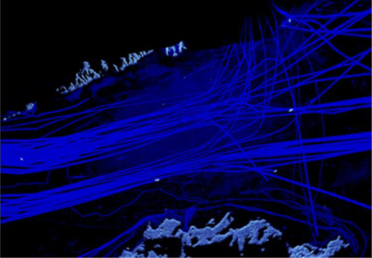
Figure 3 Example of a video capture with “snail tracks” lasting several hours and showing uninterrupted vessel traffic within the coverage area of a radar sensor

Testing Minimum detection range
Before conducting a test, a test target could be selected from:
- A controlled target, such as a small boat with an RCS of 5-20 m2, or
- A controlled and calibrated target.
Test sequence: Observe the radar detection performance on the radar display. The following steps are carried out:
1) Test target should be positioned at least two times beyond the expected minimum detection range
2) Ask the test target to move towards radar site,
3) For each antenna scan, observe whether radar video is detected or lost on the radar screen, and
4) Record the horizontal distance from the boat to the radar station when the radar echo is lost.
5) Repeat the same test several times to find the average value, the minimum detection range.

Testing Maximum detection range
Before conducting a test, a test target could be selected from:
- A target of opportunity,
- A controlled target, or
- A controlled and calibrated target,
which is compatible with the requirement using the IALA target types figure in XX.
Test sequence: Observe the radar detection performance (probability of detection) on the radar display. The following steps are carried out:
1) Test target should be positioned at the maximum range detection requirements in the actual weather conditions,
2) Observe the total number to detect the test target on the radar display and total video updates (not less than 20 times),
3) The controlled target can be moved to a position where detection performance meets the requirements to determine its distance.
4) Record the distance between the radar site to the target where detection performance meets the agreed requirement, the maximum detection range.

Continuous Coverage Test with Controlled and Calibrated Targets
The minimum and maximum detection range tests and continuous coverage test can be conducted utilizing controlled target and/or controlled and calibrated targets.
The planned test trajectory can be in a radial direction along free line of sight and extending from close to the radar to at least 10% beyond the expected detection range. An example of such a trajectory is shown in Figure 4. This includes that the test target can be asked to perform a manoeuvre, like sailing along a large circle, after traversing a certain distance. The manoeuvre shown helps to identify the controlled target in the radar video, and it show the radar echo as a function of aspect angles.
It should also be noted that is a near to impossible task to judge the RCS of a target by inspection and quantitative measurements should be carried out using controlled targets with predetermined RCS as determined per ANNEX C
Furthermore, the weather plays a significant role for target detection and conditions during testing should preferably resemble those described for the specific target type in requirements. However, tests might be scheduled to a fixed time span, implying that the test must carried out under the actual weather conditions at the given time. In this situation, the test results can be used to benchmark simulation tools which then can be used to predict range detection performance under the specified weather conditions, using t6he calculation formulas in ANNEX B.
Before any testing, ensure that the targets used meets the requirements and that radar is in normal operational mode with the receiver gain is adjusted to meet the specified false alarm probability requirements.
Record weather information at the beginning and during the test activities.

Figure 4 Example of a test trajectory for range detection testing
Test sequence: Observe the radar performance from the radar display and establish tracking of the test target. The following steps are then carried out:
1) Ask the controlled target to move along the predetermined test trajectory including the manoeuvres repeated every 1-2 NM
2) For each antenna scan, observe whether or not the target is visible and/or tracked in the radar video. Record the result
3) Re-establish tracking if target tracking is lost, e.g. as a result of increased clutter levels, shadowing effects due to large ship, or similar
4) Continue the test until target tracking is permanently lost, and until video plots of the test targets are seen in less than 3 out of 10 antenna scans
5) Repeat the test with the target sailing inbound
Maximum detection range is normally determined by the range the target is seen in e.g., 8 out of 10 scans.
The minimum detection range can be determined by the test target proceeding to the radar station. When the echo of this target is almost disappeared on the radar screen, the horizontal distance from the boat to the radar station should be measured by the radar.

Determination of Target separation
Verification of target separation, ref Figure 9, aims to determine the minimum distance, in range or bearing, being as clear separation between the returns from two small, close targets.
It is important NOT to use extended targets for the test, but rather use point targets of preferably, equal RCS and the performance figures given in this document assume the utilisation of 10 m2 point reflectors.
As the distance between the two targets must be changed during testing, at least one of the targets must be moveable. It is extremely cumbersome to perform the test at sea, as it requires floating supports for the reflectors which additionally must be moved relative to each other on the sea surface. Furthermore, if performed at sea, the test should not be performed in higher sea states than 2.
If geographical conditions allow, a much easier, but just as valid, approach is to perform the test on land e.g. at a beach or flat paved area, thus providing much better control of the positioning of the reflectors.

Range Separation
Too specific?
The range resolution means two targets are displayed as two separate radar plot on the VTS Traffic Display, where two targets are positioned in same angle from radar, but apart in distance.
Testing method: The system shall be in normal operational condition. Use two point-targets, e.g., reflectors with a radar cross section of 10m2 and a height of 1-3 meters.
Figure 5 Measurement of range separation
Test sequence:

1) The two reflectors are placed in the test area at the same bearing and with clear separation. One reflector is kept fixed throughout the test.
2) The moveable reflector is slowly moved towards the fixed reflector until separation between the two returns is achieved.
3) At this point, record the distance between the two reflectors.
The test is passed if the recorded distance is less than the range separation required.

Bearing Separation
Too specific?
The bearing separation means two targets in same distance from radar, but apart in angle are displayed as separate returns on the VTS Traffic Display
Testing method: The system shall be in normal operational condition. Use two point-targets, e.g., reflectors with a radar cross section of 10m2 and a height of 1-3 meters.
Test sequence:
1) The two reflectors are placed in the test area at the same radial distance beyond 1 NM from the radar to ensure the reflectors are placed in the far field region of the antenna radiation pattern. The distance between the two reflectors along the azimuthal direction should give clear separation of the targets. One reflector is kept fixed throughout the test.
2) The moveable reflector is slowly moved towards the fixed reflector until separation between the two returns is achieved.
3) At this point, record the angle in bearing between the two reflectors.
The test is passed if the recorded distance is less than the bearing separation stated in the requirements.

Measurement of Target Positional error
Measurement of the target positional error is a combination of the trueness (systematic error) as well as the precision (random error), ref ANNEX A.4.3.
If possible, the measurement should be done with fixed targets. The optimum is to use the centre/leading edge of physically small structures with known positions.
It is recommended to verify the maximum target position errors utilising at least two reference targets at known positions. It is normally sufficient to measure at one or two points in the distance.
Precise determination of errors can be determined by making a high number of observations and calculate as follows.

Range error
Testing method: Stationary targets should be selected. The distance of the target measured by high-precision locator (Its accuracy is at least one order of magnitude higher than radar’s accuracy) is taken as the true value. Compared that with the distance measured by radar. The range error of stationary and moving targets can be determined separately according to the following formula
（1）The range trueness (systematic error) is:
R_{i}－radar range observation value.
R_{t}－range observation value of high precision locator (true value).
n－number of observations, n≥20.
（2）The range precision error (random error) is:
（3）The root mean square error of range is
（4）The Maximum (sigma 3) range error is

Bearing error
Testing method: Stationary targets should be selected. The bearing of the target measured by high-precision locator (Its accuracy is at least one order of magnitude higher than radar’s accuracy) is taken as the true value. Compared that with the bearing measured by radar. The bearing error of stationary and moving targets can be determined separately according to the following formula.
（1）The bearing trueness (systematic error) is:
a_{i}－radar bearing observation value.
a_{t}－bearing observation value of high precision locator (true value).
n－number of observations, n≥20.
（2）The bearing precision error (random error) is:
（3）The root mean square error of bearing is
（4）The Maximum (sigma 3) bearing error is

Target tracking
Refer to IALA G1111-1 for guidance on the subject.

System Availability
Refer to IALA G1111-1 for guidance on the subject.
Specifics for radar to be added?
- VTS Radar Considerations
This section is descriptive and intended to supplement previous sections in this document and introduce the reader to common radar topics and knowledge specific to VTS radar as well as guidance on what is possible to achieve from radar configurations typical for VTS.
  - Radar Types
VTS radars could be of the following types:
- pulse radar (usually Magnetron based);
- pulse compression radar (usually Solid State);
- Frequency Modulated Continuous Wave, FMCW (usually Solid State).
A general explanation of each radar type will follow.
    - Pulse Radar
A Magnetron based pulse radar typically transmits high peak power RF pulses (10 to 50 kilowatt (kW)) of very short duration (50 to 1000 nanoseconds). The transmission is made with a pulse repetition frequency (PRF) of typically 1000 to 4000 pulses per second. Upon reception, the returned signal is amplified, demodulated, and processed.
Main characteristics include:
- it is a well-known and proven technology.
- it has fixed pulse lengths.
- increased pulse duration translates into longer-range detection, but reduced range resolution and reduced ability to penetrate precipitation due to increased backscatter.
- normally with a fixed transmission frequency (or frequencies).
- requires wide frequency band allocation for compatibility with adjacent equipment.
- the need to reduce out-of-band transmissions.
Note: ITU requirements for land-based radar are more stringent than for shipborne radar in respect to out of band emissions.
    - Pulse Compression Radar
A pulse compression radar transmits low peak power modulated chirps (typically up to 200-300 Watt (W), in some cases higher) with a typical pulse duration of up to 100 microseconds (μs). The transmission is made with a chirp repetition frequency of typically 1000 to 20000 chirps per second. Upon reception, the returned signal is amplified, pulse-compressed and processed.
The energy in the chirp of a pulse compression radar is comparable to the energy emitted in a pulse from a magnetron radar. The longer chirps are converted into short pulses upon reception by the process of pulse compression; therefore, improved range resolution can be achieved at all ranges within a single radar mode.
Main characteristics include:
- it is based on well-known and proven principles.
- no need for magnetron replacement due to solid-state power amplifier, reducing the need for periodic maintenance.
- increased ability to penetrate adverse weather conditions facilitating smaller target detection.
- transmission frequencies can be programmed.
- cleaner spectrum than magnetron radars, with reduced emissions outside the allocated frequency band(s).
Additional challenges compared to magnetron radars include:
- the need for sophisticated interference rejection due to the longer chirps transmitted.
- the need for simultaneous short- and long-range detection increases complexity.
- high-power solid-state amplifiers operate with large currents therefore requiring careful design to obtain high reliability.
- by nature, the pulse compression radar creates so-called time (or range) side lobes. Avoiding such side lobes, requires sophisticated techniques, alternatively side lobes suppression may imply a reduced detection of small targets in the vicinity of larger targets.
- additional focus on dynamic range to avoid saturation which will create very distinct sidelobes in range and reduce sensitivity in front of and behind large objects.
- inability or less sensitivity in the detection of RACONS and SART transponders.
Note: There may be legal restrictions (dual use, catch-all etc.) limiting the compression ratio and other parameters when importing (pulse compression) radars to certain countries. This may limit the availability of this technology to some VTS Authorities.
    - Frequency Modulated Continuous Wave Radar
Frequency modulated continuous wave radar transmits low peak power continuous wave forms (typically up to 50 W). The waveforms are repeated with a typical rate of 500 to 2000 per second. Upon reception, the returned signal is amplified, compressed, and processed.
The energy in a frequency modulated continuous wave radar is comparable to the energy emitted in a pulse from a magnetron radar. The waveforms are converted into pulses upon reception, therefore high range resolution can be maintained at all ranges.
Main characteristics include:
- well-known and proven principles.
- no need for magnetron replacement due to solid-state power amplifier, reducing the need for periodic maintenance.
- the ability to detect from very short range.
- transmission frequencies can be programmed.
- cleaner spectrum than magnetron radars, with reduced emissions outside the allocated frequency band(s).
Additional challenges compared to other types of radar include:
- dynamic limitations restrict the ability to handle small and large targets simultaneously and also affects long range detection.
- target revisit rate is low compared to typical VTS target kinematics.
- the need for sophisticated interference rejection, even more than for pulse compression radars.
- by nature, FMCW creates so-called time side lobes and suppressing the side lobes may reduce detection of small targets in the vicinity of larger targets.
- more complicated antenna system, 2 antennas or complicated antenna feed.
- the inability to detect RACONS and SART transponders.
  - Frequency Bands
The choose between available frequency bands will always be a compromise depending on the operational area, weather and balancing several parameters. Typical capabilities are provided later in this Annex. Frequency bands allocated for radar and suitable or VTS lie in the following range:

S-band, 2.0 – 4.0 GHz: Frequency band occasionally used for VTS Coastal radar to minimize weather on longer distance radar, e.g. for Coastal VTS– Frequency allocation (sub-bands for radiolocation and radionavigation services) predefined by ITU. However, frequency allocation is challenged by other users, e.g., Cellular phone operators aiming to expand their allocation. Weather penetration used to be superior in S-band but is for modern radar a less dominating argument as X-band radars improve in capabilities.

C-band, 4.0 – 8.0 GHz: Not used for VTS

X-band, 8.0 – 12.0 GHz: The commonly used frequency band across VTS operational areas – Frequency allocation (sub-bands for radiolocation and radionavigation services) predefined by ITU. X-band is often a good compromise for balance between resolution, weather penetration and cost across application areas.

Ku-band, 12.0 – 18.0 GHz: Frequency band occasionally used to improve resolution and minimize antenna size. Ku-band radar is generally good for detection in good weather, but more sensitive to weather than S and X-band radar.

Note: There is no Ku-band Frequency allocation for VTS predefined by ITU, meaning that frequencies shall be allocated by individual countries.
  - Antennas
The selection of antenna parameters (height, gain, side lobes, rotation rate, polarisation etc.) for a given installation, is integral to the resulting radar performance. VTS authorities are, however, advised to avoid specifying detailed antenna parameters in favour of identifying operational requirements such as:
- coverage area and range performance based on need and risk assessments
- track update rates and typical target manoeuvres in high density areas
- overlapping and redundant coverage.
The identified operational requirements will allow the radar expert some flexibility to achieve the best solution within the constraints of cost and location options.
    - Antenna Principles
Typically, the VTS radar design includes an antenna, which provides a narrow beam in azimuth and a wide beam in elevation. Thus, the VTS antenna is not designed to measure the target elevation (from which target height might be determined) or to separate targets based on elevation angle difference.
The installed antenna height is determined based on avoidance of physical obstructions, and the compromise between the need for close range coverage vs. long-range performance.
The radar designer, in his selection of antenna characteristics, needs to optimise the compromise between antenna size (and cost), track update rate, integration time on target (related to rotation rate and azimuth beamwidth and contributing to target detection range) and azimuth target separation and accuracy. In addition, the choice of transmission frequency influences the size vs. beamwidth compromise.
Flat face electronic scanning antennas (phased array) may have advantages in terms of no rotating parts, flexible beam management, and the possibility to focus attention on some key directions, however, adding to technical complexity. Variation in gain, blind coverage directions, beamwidth, and update rates at applicable scan angles need be considered when utilising this technology.
      - Polarisation
Radio waves are polarised, and objects (target and clutter) will often reflect differently for the polarisation used. This can be utilised by radar system designers, where rules of thumb are that:
- target returns from linear polarisation, (horizontal or vertical) in general will be stronger than returns from circular polarisation.
- non-metallic and natural objects, such as human beings will return linear polarised radio waves much better than circular polarised radio waves.
- most radar reflectors will be poor reflectors for circular polarised radio waves.
- distant ships with vertical masts tend to give the strongest return for vertical polarisation, whereas the opposite tends to be the case for modern ship designs without tall masts.
In addition, target detection in clutter can be affected by the polarisation. For instance:
- linear polarisation (horizontal or vertical) will result in higher rain clutter returns than circular polarisation.
- vertical or circular polarisation will result in higher sea clutter returns than horizontal polarisation, especially for lower sea states.
Complex designs are possible in which operators may select the polarisation. However, this adds to equipment costs and adds to the VTSO workload.
In general, the best cost/performance combined with ease of operation is achieved by horizontal polarisation. Circular or switchable may however be appropriate to achieve acceptable performance for operation in areas with extreme (tropical) rainfall.
Note that, in the case of a radar station also being used for oil spill detection, the preferred polarization is vertical.
  - Typical VTS radar system configurations
The examples and calculations in this document are based on simplified system characteristics and key parameters as listed in Table 7 to provide guideline on that available on the market at time om writing this document. Corresponding calculations are provided for the key parameters listed in Table 1.
Table 7 Typical VTS Radar System configurations and associated key parameters used in this document
This will, however, not, cover all VTS’s and it will often be necessary to extrapolate or extend specifications to other scenarios and system considerations. Formulas for calculations are provided in ANNEX B.
    - Radar coverage
      - Minimum detection range
Radars used for VTS will typically have a blind range depending on the pulse characteristics, the waveguide length and processing.
An addition the minimum detection range depends on antenna height and antenna vertical beam “look down angle” as illustrated by Figure 6..
The lookdown angle can as a rule of thumb be determined as the -20 dB point on the vertical antenna patten. Inverse cosecant beam techniques are used to lower the minimum detection in case of the need to look further down than that achievable from a fan beam antenna.
Antenna tilt mechanism will only have marginal influence on the minimum range and it will also have the negative effect of increasing sea clutter returns.
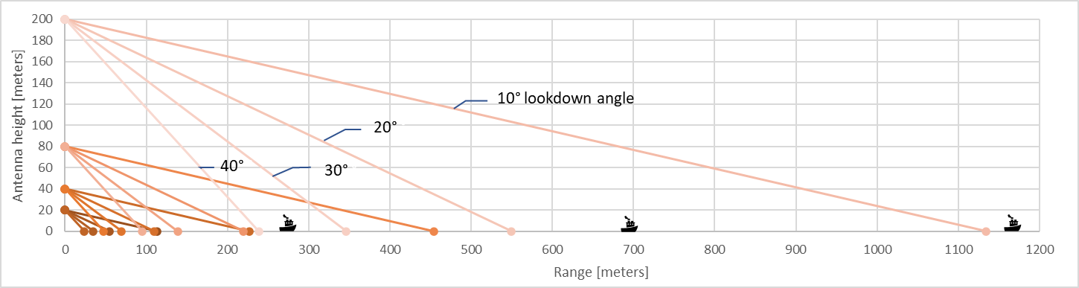
Figure 6 minimum detection range as a function of antenna height and lookdown angle.
      - Maximum detection range
Figure 7 illustrates the basic geometry associated with antenna height above sea level (ASL) in target detection and the effect of the earth curvature, determined by the following formula:
$Target Horizon=2.2×\left({h_{target}}^{0.5}+{h_{antenna}}^{0.5}\right)\left[NM\right]$.
Figure 7 Geometry, Antenna height and target height
However, the target detection range is highly dependent on several other factors including target characteristics, weather (such as fog, sea state and rain) and atmospheric propagation conditions, calculated and expressed in statistical terms as the example in given by Figure 8.
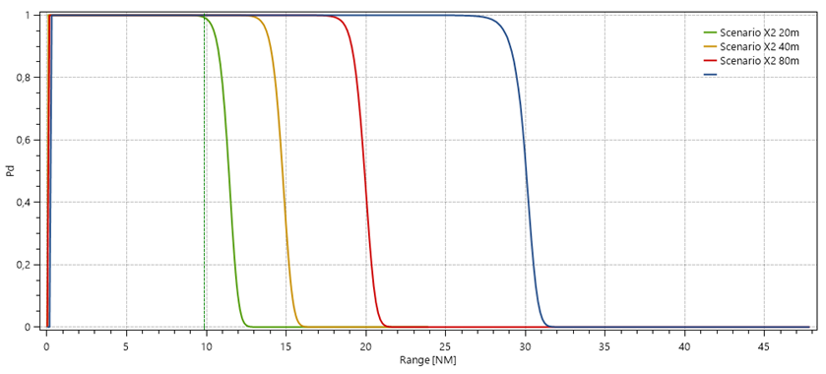
Figure 8: Probability of detection calculation for a modern radar, 20-, 40, 80 and 200-meter antenna height, IALA type 4, Sea State 3 and clear conditions
This is used to calculate range coverage taking several radar parameters, installation, and the environment into account. Formulas are provided by ANNEX B and Table 8 provides calculated detection range for typical VTS radar installations. All figures to be calculated
Table 8 Calculated range performance for typical VTS radar configurations
Antenna Height | IALA Target type | Range calculated for clear weather, sea state 3 and standard propagation conditions
20 | System  (Instrumented range) | S1  (24 NM) | S2  (48 NM) | X1  (12 NM) | X2  (24 NM) | X3  (48 NM) | Ku1  (6 NM) | Ku2  (12 NM) | Ku3  (24 NM)
20 | 1
20 | 2
20 | 3
20 | 4
20 | 5
20 | 6
20 | 7
40 | System  (Instrumented range) | S1  (24 NM) | S2  (48 NM) | X1  (12 NM) | X2  (24 NM) | X3  (48 NM) | Ku1  (6 NM) | Ku2  (12 NM) | Ku3  (24 NM)
40 | 1
40 | 2
40 | 3
40 | 4
40 | 5
40 | 6
40 | 7
80 | System  (Instrumented range) | S1  (?? NM) | S1  (?? NM) |  | X2  (?? NM) | X3  (?? NM) |  | Ku2  (?? NM) | Ku3  (?? NM)
80 | 1
80 | 2
80 | 3
80 | 4
80 | 5
80 | 6
80 | 7
200 | System  (Instrumented range) | S1  (?? NM) | S1  (?? NM) |  | X2  (?? NM) | X3  (?? NM) |  | Ku2  (?? NM) | Ku3  (?? NM)
200 | 1
200 | 2
200 | 3
200 | 4
200 | 5
200 | 6
200 | 7

    - Target separation
The ability to separate small point targets in Range and Angle is illustrated in Figure 9, where the range resolution and separation is, for traditional magnetron radars, linked to the transmitted pulse length and linked to the compressed pulse length for the pulse compression (solid-state) radars. The range separation performance is generally equal over distance.
The angular resolution and separation is given by the antenna characteristics.
For larger (non-point) targets and for separation of dissimilar sized targets, the definition of separation is highly dependent on physical size, aspect angles, relative return amplitude, pulse stretch, and other radar characteristics.
Azimuth
Resolution
in angle
Distance from radar to target
Azimuth separation in distance or angle
Range Separation

Range Resolution

Figure 9 Target separation and resolution
    - Target Positional Accuracy
Several elements of a VTS system contribute to the track accuracy and these should be appropriately budgeted for before deriving the radar sensor accuracy requirements.
The “accuracy” is characterized in accordance with ISO 5725-1 by two figures; trueness (systematic error) and precision (random error), which are illustrated in Figure 10.

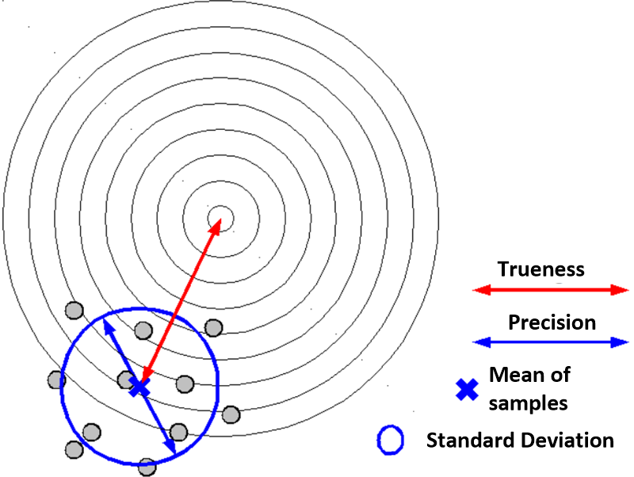
Figure 10 Definition of trueness and precision
The “Overall Accuracy” is the average deviation between sets of single measurements and the corresponding set of reference values. Overall accuracy thus equals the definition of trueness provided that enough measurements are averaged.
The overall RMS accuracy is calculated by:

$${Accuracy}_{RMS}=\sqrt{{Trueness}^{2}+{Precision}^{2}}$$

The impact of the antenna height on the measuring accuracy (slant range vs. plan range) is additional.
    - Target Positional update rate
The required radar update rate is determined by the behaviour of the expected target types. Typical update rates (antenna rotation rates) for VTS lie between 2 and 4 seconds, however, values outside this range may offer alternative benefits to the overall design.
For short range applications with requirements to follow fast manoeuvring targets, update rates of 1-2 seconds may be beneficial. Up to 10 seconds may be preferable for very long-range applications.
Note that tracking performance, especially the continuity of tracks, can be highly dependent on the radar update rate and there is a trade-off between radar sensitivity, accuracy, and the ability to follow fast manoeuvring targets.
    - Dynamic characteristics
The required dynamic range is determined by:
- The ratio between the largest nearby objects expected and the smallest distant objects to be detected.
- Target return signal fluctuations including multipath.
Requirements for the radar(s) can be determined from the characteristics of the objects in the coverage area of the individual radar. The characteristics of objects typically considered and the corresponding dynamic range, as a function of RCS and detection range, can be determined from Figure 11
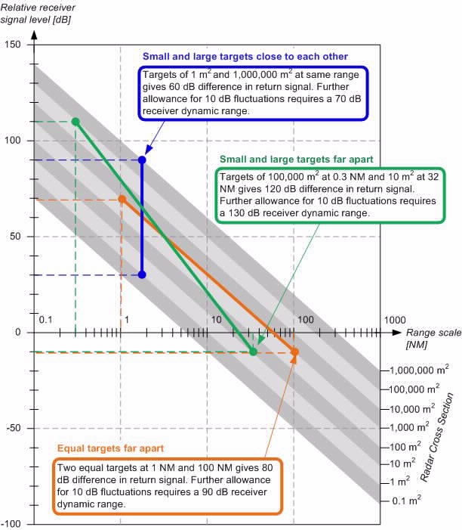
Figure 11 Dynamic characteristics of signal received versus target RCS and target range (in NM) for point targets in free space
The figure represents targets in free space. This is normally sufficient for the determination of VTS radar requirements when combined with 10 dB allowance for target fluctuations.
Notes: If more accurate determination than that from the graph in Figure 11 is deemed necessary, this can be performed using performance evaluation tools, combined with evaluations of near range effects.
Technology limitations may restrict compliance with the extreme dynamic range that could be derived from Figure 11

    - Sidelobes
Side lobes, ref. Figure 12Error! Reference source not found. are unwanted, as they will limit the size of a small Radar Cross Section (RCS) target that can be detected next to a large RCS target.
Range (time) side lobes
Antenna side lobes
Target
Target
.
Unwanted side lobes
Clean target echo
Figure 12 Range and Antenna (Azimuth) side lobe effects
The ratio between the peak level of the target and the highest side lobe is called the Peak Side Lobe Ratio (PSLR).
Typically, azimuth (antenna) side lobes are the only contributor in traditional magnetron pulse radars. FMCW and pulse compression radars are subject to range as well as azimuth side lobes.
Side lobes need to be sufficiently low to avoid masking of smaller targets in the proximity of large returns from targets or clutter. In addition, low side lobes minimise the probability of false targets arising from other large returns.
      - Antenna Side Lobes
The antenna designer uses an amplitude weighting function to control the azimuth side lobe levels to a level which recognises the requirements for close in (< 10° from the main lobe peak) azimuth side lobes and the requirements for side lobes beyond this region. Side lobes are specified as a ratio (in dB) relative to the antenna beam peak.
The antenna gain defined from a specific point in the radar system is specified as a ratio above ‘isotropic’ (dBi) and can be increased by increasing the physical size of the antenna. This will also reduce the beamwidth (azimuth, elevation or both).
Sidelobes exist in Azimuth and elevation, however, elevation side lobes are unlikely to be a major contributor to the performance of the VTS radar system. So called grating lobes are of special concern for array antennas and these should be included in consideration and measurement of side lobe levels.
Also note that structures near antennas (in some cases up to 100 metres) tend to distort wave propagation and, thereby, increase the azimuth side lobe level in the direction of such structures.
      - Range Side Lobes
Pulse compression and FMCU uses an amplitude weighting function alike that used for antennas to control the range side lobe levels to a level which recognises the requirements
  - Target caracteristics
VTS radar targets are defined by their height above sea level, their speed and manoeuvrability, their polarisation characteristics, their radar cross section (RCS) and the fluctuations in RCS.
    - Radar Cross Section
The amount of radar energy reflected by a target is proportional to its effective area called the Radar Cross Section (RCS). The RCS defined as the ratio between the power (in W) scattered by the target back towards the radar receiver and the power density (in W/m2) hitting the target. Thus, the RCS has the dimension of an area, being measured in m2. In practical terms, the RCS can be interpreted as the cross-sectional area of a perfectly reflecting metal sphere that would give rise to the same reflected energy as the target in question.
Being an effective area, the RCS of a target is not necessarily related to the physical cross-sectional area of the target, but rather depends strongly on the nature and shape of the surfaces exposed to the radar beam. Consequently, targets of similar physical sizes may exhibit vastly different RCS, and additionally, their RCS may vary drastically with aspect angle (see [2]) as the exposed surfaces change with orientation. Finally, the apparent RCS of a target is subject to fluctuate over time, for instance due to minor changes in orientation between exposures to the radar beam.
To obtain quantitative and reproducible results during performance testing, it is therefore necessary to use physically small and rather simple targets and to measure and calibrate their RCS against that of a well-known reference target. During these measurements, the dependence of the RCS on the aspect angle can additionally be mapped out. A method to perform such a measurement is described in ANNEX C.
    - Target Models versus Detailed Characteristics
The point target characteristics, ref Table 1, may be sufficient for range calculation of specific targets of interest in VTS.
However, the design of a radar system should consider the overall characteristics of all objects within coverage range of the individual radar and Table 9 provides an overview of such characterises for targets, typically of interest to VTS radar.
Table 9 Detailed Target Characteristics
Target | Typical characteristics at X-band
Target | RCS | Height | Fluctuations etc.
Aids to Navigation without radar reflector. | Up to 1 m² | 1 to 4 m ASL | Rapidly fluctuating, highly dependent on sea characteristics. Polarisation characteristics will often vary depending on wind.
Aids to Navigation with radar reflector. | 10 – 100 m² | 1 to 4 m ASL | Rapidly fluctuating, wind and currents may tilt to blind angles and lobing may cause reflectors to be in blind spots. Most radar reflectors will be poor radar targets in case of circular polarisation
Small open boat, fibreglass, wood or rubber with outboard motor and at least 2 persons on board, small speedboat, small fishing vessels or small sailing boats. | 0.5 – 5 m² | 0.5 to 1 m ASL | Rapidly fluctuating may be hidden behind waves up to 50% of the time.  Slow moving targets tend to lie lower in the water than fast moving ones and therefore RCS visible to the radar tends to increase with speed.  Humans and non-metallic targets will give poor radar return in case of circular polarisation
Inshore fishing vessels, sailing boats and speedboats, equipped with radar reflector of good quality. | 3 – 10 m² | 1 to 2 m ASL | Rapidly fluctuating.
Small metal ships, fishing vessels, patrol vessels and other similar vessels. | 10 – 100 m² | 2 to 4 m ASL | Moderately fluctuating.
Coasters and other similar vessels. | 100 – 1000 m² | 6 to 10 m ASL | RCS is highly dependent on aspect angle of the individual vessel. Rate of fluctuations is typically moderate.
Large coasters, Bulk carriers, cargo ships and other similar vessels. | 1000 – 10,000 m² | 10 to 25 m ASL
Container carriers, tankers and other similar vessels. | 10,000 – 2,000,000 m² | 15 to 40 m ASL
Buildings, cranes. Stacks of containers and other large structures. | Up to 1,000,000 m² | Depends on site | Insignificant.
Floating items, oil drums and other similar items. | Up to 1 m² | 0 to 0.5 m ASL | Rapidly fluctuating, highly dependent on sea characteristics and target movements.
Birds, floating or flying. | Up to 1 m² | Sea level and up
Flocks of birds. | Up to 3 m² | Sea level and up | Rapidly fluctuating, flight paths tend to be characteristic of given species in given areas of interest.
Jet Skis and other personal watercraft | Up to 0.5 m² | 0 to 1 m ASL | Rapidly fluctuating but virtually independent of aspect angle
Wind turbines (onshore and offshore) | Up to 10,000,000 m² | Up to 300 m ASL | Fluctuations for towers are insignificant. Rotating parts give a wide spectrum of Doppler shifts with RCS up to hundreds of m²

Data is primarily based on references [3] + [4] , supplemented by data obtained from the experiences of IALA VTS committee members.
Note: Modern warship design seeks to minimise RCS and, as a result, the above figures cannot be related to such vessels.
In case the physical size of the target exceeds the size of the resolution cell of the radar, the target gets extended into other resolution cells. In such a case, the RCS values, as mentioned above, may be incorrect (as the target reflection is now distributed across more than one resolution cell). Additionally, the extension of the target poses extra challenges on detection and tracking performance. Extension of targets and the consequences thereof should especially be considered in situations where the radar is positioned close to the targets to be detected and tracked and/or in case of high-resolution radars.
RCS on targets using S-band is typically 40% and Ku-band is typically 120% of the RCS in X-band except for small non-metallic targets where the RCS difference between the 3 bands can be much higher.
      - Target RCS Fluctuations
For VTS target types, statistical RCS fluctuations can adversely affect target detection. To predict range performance more realistically, such fluctuations can be mathematically modelled using the different Swerling cases. The radar design and the location of radars can compensate for the consequences of target RCS fluctuations.
    - Multipath Effects
      - Reflections from large objects
Multipath conditions resulting from reflections from large buildings and large vessels can still impact on VTS radar performance resulting in the possibility of target signal cancellation or enhancement. This effect is hard to predict and it is unreasonable to expect to model multipath affected performance unless a (potentially expensive) site-specific radar model is developed.
Multipath propagation where signals are reflected by objects within the radar coverage can generate so called ghost echoes as illustrated by Figure 13

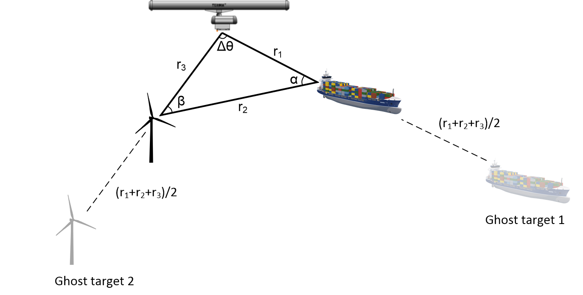
Figure 13 Multipath propagation resulting in Ghost images
To calculate the estimated amount of ghost targets, as well as the ghost targets size in RCS, there are basically three scenarios to consider, which for a wind farm situation is shown in Figure 14:
Figure 14 Possible scenarios for ghost target analysis
For scenario 1, the radar wave bounces from antenna->ship->turbine->ship->antenna. In scenario 2, the radar wave bounces from antenna->ship->turbine->antenna. In scenario 3, the radar wave bounces from antenna->ship->turbine 1->turbine[2..n]->antenna. The scenario with the least amount of wave travel length and fewest bounces is the important scenario, since that scenario has the largest returned power, leaving the others negligible. In this case, scenario 2 should be the focus, due to fewest bounces and shortest wave travel and produce the strongest ghost targets.
      - Lobing
One of the most common pitfalls during verification of radar systems is that the echo intensity from a point target can vary drastically with height. As illustrated in Figure 15, the radar signal will reach the target by travelling along different paths of which the most important ones are the direct path and the path where the radar signal has been reflected by the sea surface. The radar signals travelling along the two paths are added to form a resultant signal, a phenomenon known as multipath reflections. At some target heights, the two waves interference constructively, leading to increased signal levels, whereas the waves interference destructively leading to decreased or even vanishing signal levels at other target heights.
As a result, the coverage area exhibits a “lobed” structure where the detection probability alternates between high and low with target height. Hence, if two point-targets of equal RCS are placed at the same distance from the radar, their echoes can differ significantly if their heights happen to picked such that one is situated in a multipath peak (top left pane) while the other is at a multipath minimum (top right pane). Thus, the appearance of multipath reflections must be accounted for when selecting target heights and positioning the targets.
Multipath reflections are severe at low sea states, elevated heights, and at long ranges. Furthermore, the lobing will depend on atmospheric conditions making range detection tests with point targets, e.g., traditional radar reflectors, very difficult and in practice impossible to reproduce. The practical solution is to use targets distributed in height, such as small vessels with measured RCS.

Figure 15 The effect of multi-path reflections on the detection probability of a target.
  - Environmental Influence
There is a strong and complicated relationship between radar performance, geographical constraints and environmental conditions and it is highly recommended that individual assessments, involving radar and meteorological experts, are made for each VTS site separately. The sections below indicate typical conditions covering the majority of VTS installations.
    - Precipitation and Sea
Calculation of maximum detection ranges versus weather for IALA targets type 1-4 and defined radar types optimised to instrumented ranges as stated in parenthesis is displayed in Table 10 through Table 13, illustrating detection range of Type 1-4 target in a clear weather conditions and 4+10mm/h rain, sea states 1, 3 and 5.
Table 10 Calculated performance, typical VTS radars 20 meters ASL
Performance versus weather |  |  |  | Calculated range detection for radars elevated 20 meters ASL
 |  |  |  | Clear |  |  | 4 mm/hour uniform rain |  |  | 10 mm/hour uniform rain
 |  |  |  | SS1 | SS3 | SS5 | SS1 | SS3 | SS5 | SS1 | SS3 | SS5
System type (Instrumented range) | S1  (24 NM) | Iala target type | 1
System type (Instrumented range) | S1  (24 NM) | Iala target type | 2
System type (Instrumented range) | S1  (24 NM) | Iala target type | 3
System type (Instrumented range) | S1  (24 NM) | Iala target type | 4
System type (Instrumented range) | S2  (48 NM) | Iala target type | 1
System type (Instrumented range) | S2  (48 NM) | Iala target type | 2
System type (Instrumented range) | S2  (48 NM) | Iala target type | 3
System type (Instrumented range) | S2  (48 NM) | Iala target type | 4
System type (Instrumented range) | X1  (12 NM) | Iala target type | 1
System type (Instrumented range) | X1  (12 NM) | Iala target type | 2
System type (Instrumented range) | X1  (12 NM) | Iala target type | 3
System type (Instrumented range) | X1  (12 NM) | Iala target type | 4
System type (Instrumented range) | X2  (24 NM) | Iala target type | 1
System type (Instrumented range) | X2  (24 NM) | Iala target type | 2
System type (Instrumented range) | X2  (24 NM) | Iala target type | 3
System type (Instrumented range) | X2  (24 NM) | Iala target type | 4
System type (Instrumented range) | X3  (48 NM) | Iala target type | 1
System type (Instrumented range) | X3  (48 NM) | Iala target type | 2
System type (Instrumented range) | X3  (48 NM) | Iala target type | 3
System type (Instrumented range) | X3  (48 NM) | Iala target type | 4
System type (Instrumented range) | Ku1  (6 NM) | Iala target type | 1
System type (Instrumented range) | Ku1  (6 NM) | Iala target type | 2
System type (Instrumented range) | Ku1  (6 NM) | Iala target type | 3
System type (Instrumented range) | Ku1  (6 NM) | Iala target type | 4
System type (Instrumented range) | Ku2  (12 NM) | Iala target type | 1
System type (Instrumented range) | Ku2  (12 NM) | Iala target type | 2
System type (Instrumented range) | Ku2  (12 NM) | Iala target type | 3
System type (Instrumented range) | Ku2  (12 NM) | Iala target type | 4
System type (Instrumented range) | Ku3  (24 NM) | Iala target type | 1
System type (Instrumented range) | Ku3  (24 NM) | Iala target type | 2
System type (Instrumented range) | Ku3  (24 NM) | Iala target type | 3
System type (Instrumented range) | Ku3  (24 NM) | Iala target type | 4

Table 11 Calculated performance, typical VTS radars 40 meters ASL
Performance versus weather |  |  |  | Calculated range detection for radars elevated 40 meters ASL
 |  |  |  | Clear |  |  | 4 mm/hour uniform rain |  |  | 10 mm/hour uniform rain
 |  |  |  | SS1 | SS3 | SS5 | SS1 | SS3 | SS5 | SS1 | SS3 | SS5
System type (Instrumented range) | S1  (24 NM) | Iala target type | 1
System type (Instrumented range) | S1  (24 NM) | Iala target type | 2
System type (Instrumented range) | S1  (24 NM) | Iala target type | 3
System type (Instrumented range) | S1  (24 NM) | Iala target type | 4
System type (Instrumented range) | S2  (48 NM) | Iala target type | 1
System type (Instrumented range) | S2  (48 NM) | Iala target type | 2
System type (Instrumented range) | S2  (48 NM) | Iala target type | 3
System type (Instrumented range) | S2  (48 NM) | Iala target type | 4
System type (Instrumented range) | X1  (12 NM) | Iala target type | 1
System type (Instrumented range) | X1  (12 NM) | Iala target type | 2
System type (Instrumented range) | X1  (12 NM) | Iala target type | 3
System type (Instrumented range) | X1  (12 NM) | Iala target type | 4
System type (Instrumented range) | X2  (24 NM) | Iala target type | 1
System type (Instrumented range) | X2  (24 NM) | Iala target type | 2
System type (Instrumented range) | X2  (24 NM) | Iala target type | 3
System type (Instrumented range) | X2  (24 NM) | Iala target type | 4
System type (Instrumented range) | X3  (48 NM) | Iala target type | 1
System type (Instrumented range) | X3  (48 NM) | Iala target type | 2
System type (Instrumented range) | X3  (48 NM) | Iala target type | 3
System type (Instrumented range) | X3  (48 NM) | Iala target type | 4
System type (Instrumented range) | Ku1  (6 NM) | Iala target type | 1
System type (Instrumented range) | Ku1  (6 NM) | Iala target type | 2
System type (Instrumented range) | Ku1  (6 NM) | Iala target type | 3
System type (Instrumented range) | Ku1  (6 NM) | Iala target type | 4
System type (Instrumented range) | Ku2  (12 NM) | Iala target type | 1
System type (Instrumented range) | Ku2  (12 NM) | Iala target type | 2
System type (Instrumented range) | Ku2  (12 NM) | Iala target type | 3
System type (Instrumented range) | Ku2  (12 NM) | Iala target type | 4
System type (Instrumented range) | Ku3  (24 NM) | Iala target type | 1
System type (Instrumented range) | Ku3  (24 NM) | Iala target type | 2
System type (Instrumented range) | Ku3  (24 NM) | Iala target type | 3
System type (Instrumented range) | Ku3  (24 NM) | Iala target type | 4

Table 12 Calculated performance, typical VTS radars 80 meters ASL
Performance versus weather |  |  |  | Calculated range detection for radars elevated 80 meters ASL
 |  |  |  | Clear |  |  | 4 mm/hour uniform rain |  |  | 10 mm/hour uniform rain
 |  |  |  | SS1 | SS3 | SS5 | SS1 | SS3 | SS5 | SS1 | SS3 | SS5
System type (Instrumented range) | S1  (xx NM) | Iala target type | 1
System type (Instrumented range) | S1  (xx NM) | Iala target type | 2
System type (Instrumented range) | S1  (xx NM) | Iala target type | 3
System type (Instrumented range) | S1  (xx NM) | Iala target type | 4
System type (Instrumented range) | S2  (xx NM) | Iala target type | 1
System type (Instrumented range) | S2  (xx NM) | Iala target type | 2
System type (Instrumented range) | S2  (xx NM) | Iala target type | 3
System type (Instrumented range) | S2  (xx NM) | Iala target type | 4
System type (Instrumented range) | X2  (xx NM) | Iala target type | 1
System type (Instrumented range) | X2  (xx NM) | Iala target type | 2
System type (Instrumented range) | X2  (xx NM) | Iala target type | 3
System type (Instrumented range) | X2  (xx NM) | Iala target type | 4
System type (Instrumented range) | X3  (xx NM) | Iala target type | 1
System type (Instrumented range) | X3  (xx NM) | Iala target type | 2
System type (Instrumented range) | X3  (xx NM) | Iala target type | 3
System type (Instrumented range) | X3  (xx NM) | Iala target type | 4
System type (Instrumented range) | Ku2  (xx NM) | Iala target type | 1
System type (Instrumented range) | Ku2  (xx NM) | Iala target type | 2
System type (Instrumented range) | Ku2  (xx NM) | Iala target type | 3
System type (Instrumented range) | Ku2  (xx NM) | Iala target type | 4
System type (Instrumented range) | Ku3  (xx NM) | Iala target type | 1
System type (Instrumented range) | Ku3  (xx NM) | Iala target type | 2
System type (Instrumented range) | Ku3  (xx NM) | Iala target type | 3
System type (Instrumented range) | Ku3  (xx NM) | Iala target type | 4

Table 13 Calculated performance, typical VTS radars 200 meters ASL
Performance versus weather |  |  |  | Calculated range detection for radars elevated 80 meters ASL
 |  |  |  | Clear |  |  | 4 mm/hour uniform rain |  |  | 10 mm/hour uniform rain
 |  |  |  | SS1 | SS3 | SS5 | SS1 | SS3 | SS5 | SS1 | SS3 | SS5
System type (Instrumented range) | S2  (xx NM) | Iala target type | 1
System type (Instrumented range) | S2  (xx NM) | Iala target type | 2
System type (Instrumented range) | S2  (xx NM) | Iala target type | 3
System type (Instrumented range) | S2  (xx NM) | Iala target type | 4
System type (Instrumented range) | X3  (xx NM) | Iala target type | 1
System type (Instrumented range) | X3  (xx NM) | Iala target type | 2
System type (Instrumented range) | X3  (xx NM) | Iala target type | 3
System type (Instrumented range) | X3  (xx NM) | Iala target type | 4
System type (Instrumented range) | Ku3  (xx NM) | Iala target type | 1
System type (Instrumented range) | Ku3  (xx NM) | Iala target type | 2
System type (Instrumented range) | Ku3  (xx NM) | Iala target type | 3
System type (Instrumented range) | Ku3  (xx NM) | Iala target type | 4

    - Reduced Visibility, Fog, sand, Dust
Reduced visibility due to Fog Sand and Dust will in general have small influence on radar coverage, compared to that or clear conditions.
However, Sand and dust storms are often associated with abnormal propagation conditions as discussed in chapters A.6.3.3 through A.6.3.7
    - Air Mass (Propagation)
The performance of surface-based radar systems is strongly influenced by the electromagnetic properties of the atmosphere and the surface of the Earth. In free space, electromagnetic waves propagate in straight lines from the antenna toward the targets and back. However, radars located near the Earth’s surface should deal with, and adjust to the diffraction and refraction of the propagating wave.
Performance should, in all cases, be evaluated assuming Standard Atmospheric Conditions, combined with precipitation and sea state information for the individual location. Evaluation of the effects from adverse propagation should in addition be included for hot, dry areas of the world, e.g. the Arab Gulf.
      - Propagation in the Standard Atmosphere
An electromagnetic wave observed at a target consists of a summation of an infinite number of contributions from different paths to the target leading to constructive and destructive contributions at the target. The return path suffers from similar effects. For small low targets this results in shorter detection ranges, than the distance calculated by simple line of sight calculations.
In addition, the barometric pressure and water vapour content of the standard atmosphere decreases rapidly with height, and the temperature decreases slowly with height. This causes the electromagnetic waves to bend a little towards the Earth’s curvature.
Radar parameters, losses in transmission lines (not only waveguide), processing losses, clutter and precipitation add to the complexity and, even for the Standard Atmosphere, it is necessary to combine this with propagation factors by radar calculation tools in order to determine the predicted performance for a VTS radar sensor. This is typically modelled by increasing the radius of the Earth by a multiplier (typically 1.33) and assuming straight-line propagation.
      - Sub-refraction and Super-refraction
Sub-refraction, bending the electromagnetic waves up, and super-refraction, bending the electromagnetic waves down, exists when the atmosphere deviates from the standard.
Sub-refraction can be caused by fast reduction of temperature and slower reduction of water vapour content with height, bending the electromagnetic waves towards space. However, this phenomenon occurs rarely in nature.
Super-refraction can be caused by temperature increase with height (generally by temperature inversion) and/or rapid decrease of water vapour with height, decreasing the refractivity index (N). Decreasing the refractivity gradient will eventually cause it to reach the critical gradient, at which point an electromagnetic wave will travel parallel to the Earth’s curvature.
      - Ducts and Trapping Layers
Super-refraction will develop into trapping layers, if the refractivity gradient decreases beyond the critical gradient, at which point the electromagnetic wave will be trapped and follow the Earth’s curvature.
Ducts act like waveguides for propagating waves bordered by trapping layers or the Earth’s surface. To couple into a duct and remain in a duct, the angle of incidence must be small, typically less than 1°.
Ducting can be categorized into three main types:
- Evaporation duct:
- Weak, caused by evaporation from the sea surface, and only at low levels (maximum of 40 metres ASL).
- Generally increasing the radar horizon, especially for low mounted antennas.
- Surface-based duct:
- Surface ducts caused by low level inversion (increase of temperature /decrease of humidity with height), up to 500 metres ASL.
- Increase of radar range, depending on duct and antenna height.
- Elevated duct:
- 0.2-2 km above the surface.
- Typical no effect on surface-based antennas.
The effects are typically increased range but also increased amounts of noise and 2nd / multiple time around returns which may appear as false radar returns.
Notice that the electromagnetic waves are refracted (bent) and not reflected by the trapping layers.
      - Evaporation Ducts
Evaporation ducts exist over the ocean to some degree, almost all the time. A change in the moisture distribution without an accompanying temperature change will lead to a trapping refractivity gradient. The air in contact with the ocean surface is saturated with water vapour, creating a pressure that is decreasing to some value above the surface.
This will cause a steep refractivity gradient (trapping) near the surface but will gradually equalise towards normal refractivity gradient at a certain height, which is defined as the evaporation duct height.
Evaporation ducts are generally increasing the radar detection range and the antenna can be located above the duct and still have extended propagation strength. The effect of evaporation ducts is usually more noticeable for higher frequency radars. This means that the radar range extension caused by an evaporation duct will in general be more noticeable for a X-band radar than for a S-band radar.
For typical coastal radar installations, evaporation duct heights of 6 – 15 metres lead to the longest detection ranges. Evaporation duct heights of more than 10 metres will also introduce an increased amount of clutter, setting additional demands to clutter processing and noise reduction capabilities.
For example, investigations of weather data from the Arab Gulf area show that evaporation ducts exist all the time with typical duct heights of 5 to 25 metres, resulting in increased radar range in 80% of the time and increased clutter in 50% of the time.
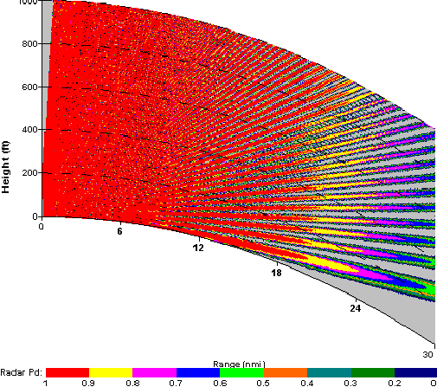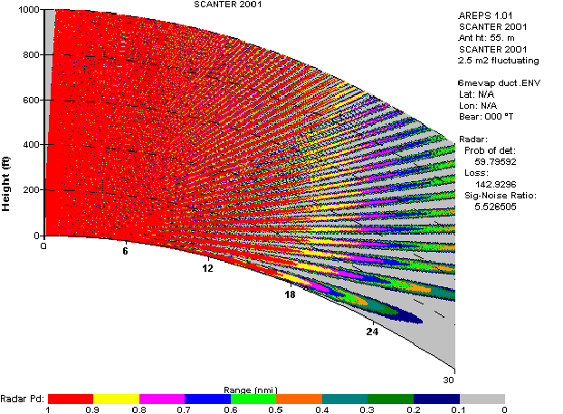
Figure 16 Coverage diagram, in normal atmosphere (left) and including an evaporation duct (right).’

      - Surface-based Duct
Surface based ducts can be much stronger than evaporation ducts. They occur when the air aloft is hot (and dry) compared to the air at the Earth’s surface. Over the ocean and near land masses, dry continental air may be advected over the cooler water surface; either directly from leeward side of continental land masses or by circulation associated with sea-breeze.
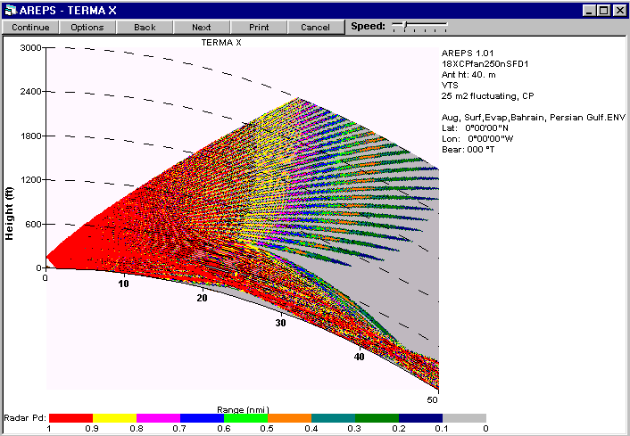
Figure 17 Example of simulated radar coverage in surface based + evaporation ducting conditions
In addition to the temperature inversion, moisture is added to the cool marine air by evaporation, increasing the trapping gradient. In coastal areas, this leads to surface trapping ducts. However, away from land, this trapping layer may well rise from the surface thereby creating an elevated duct.
The electromagnetic wave will be refracted towards the surface of the Earth and be trapped in the duct like in a waveguide. This kind of trapping condition greatly increases the surface detection range – and the amount of noise received. Note that surface detection may occur far beyond the radar horizon with a ‘dead zone’ in between.
Surface based ducts are often combined with evaporation ducts and examples of radar performance in such conditions, as illustrated by Figure 17
      - Elevated Duct
Generally, elevated ducts occur from descending, compressed and thereby heated air, from anticyclones, approaching the marine boundary layer and causing ducts. Elevated ducts may also occur from elevating surface-based ducts.
Surface detection might also occur in this case far beyond the radar horizon with a ‘dead zone’ in between, adding noise to the radar image.

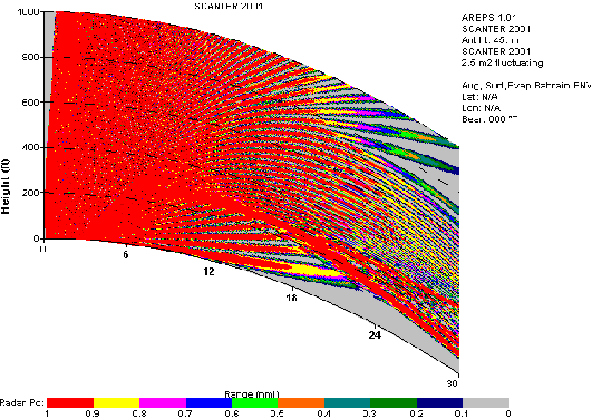
Figure 18 Coverage diagram, elevated duct
      - Severe Ducting at Coastlines Adjacent to Hot Flat Deserts
The large temperature variation between night and day in desert areas and the associated pressure differences between land and sea tend to cause very strong temperature inversion during night-time and result in strong sea breeze in the afternoons. This can result in very severe ducts. This type of duct can be very low, as little as 15 metres has been experienced
Range performance is very different for an antenna positioned inside or above these ducts, and radar systems with an antenna positioned within such a duct will have substantial increase in the detection range for surface targets. If the antenna is positioned above the trapping layer (outside the duct), the electromagnetic wave will be refracted and the detection range for surface targets will be substantially reduced.
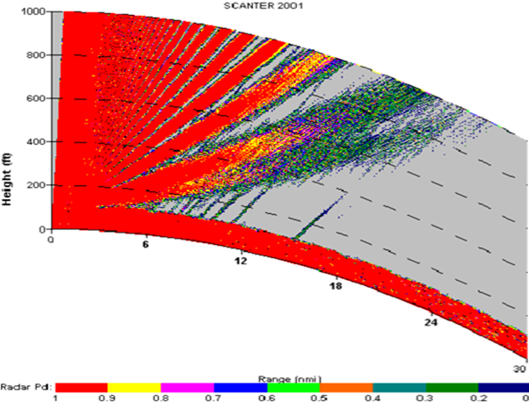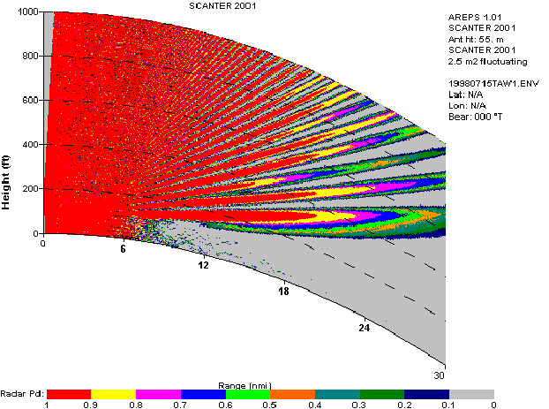
Figure 19 Coverage diagram based on a measured condition at a coastline adjacent to hot flat deserts- 15 m antenna height (left) and 55 m antenna height (right).
Note. The radar detection using antennas positioned inside the duct (left) and above the duct (right) corresponded to the simulated coverage diagram.
The sea breeze also causes eddies over the sea, forming distinctive sea clutter patterns. The eddy results in a ‘snake’ like pattern moving forth and back for a few hours in the afternoon on hot days with strong sea breezes (see 0). Of course, this may disturb display and tracking.
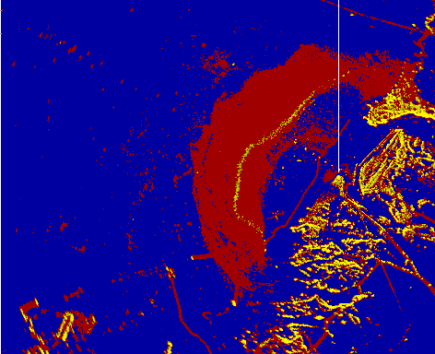
Eddy (yellow)
History (red)
Figure 20 One hour of recordings with trials (snail tracks) shown in red.
Note. The yellow ‘snake’ at sea is an eddy moving back and forth with a speed of approximately 4 knots.
  - Other Influencing Factors
Obstructions, e.g., topography, buildings and other man-made structures may block or reflect radar signals. Other radars and sources of electromagnetic radiation may cause interference.
Inland and harbour VTS will often require special considerations as the number of structures, their density and their close ranges can create very complex distortions. Additional care should be taken to assess and mitigate effects caused by natural and man-made structures such as bridges, buildings, riverbanks, sheet metal pilings, and steep bends.
    - Shadowing Effects
Radar detection may be blocked by shadowing effects that, to the extent possible, should be avoided. Such effects include:
- Targets being hidden by larger targets or other obstructions.
- Masking of small targets by the effects of range and time side lobes.
These effects can be minimised by the appropriate siting of radars and selection of equipment with low side lobes.
    - Interference
Interference can be split into susceptibility (received interference) and compatibility (transmitted interference).
To minimise interference, separation between wanted and unwanted transmissions has to be optimised – this can be achieved by a combination of frequency separation, physical separation of transmission sites, antenna directionality, sector blanking, separation by time and also by ensuring that all the systems competing for the same or adjacent spectrum do not transmit excessive and unnecessary transmit power levels or transmit time periods. The radar receiver design will typically be very sensitive (to achieve the required performance), although gain control techniques (swept gain or Sensitivity-Time Control (STC)) offers further resistance. Waveform designs incorporating staggered PRFs, and processing schemes designed to reject known interference patterns can also aid the radar receiver to suppress unwanted returns.
    - Radar Susceptibility
In the case of any radar installation, (e.g. a permanent VTS installation of a radar or of each radar in a VTS network), the performance of that radar can be detrimentally affected by received emissions from other radiating sources (physically adjacent VTS radars, maritime shipborne radars, and other users (legitimate or otherwise) of the electromagnetic spectrum. Typically, local legislative regulations and restrictions will control and minimise unwanted received signals, but elimination of such signals is likely to be impossible. National spectrum allocation authorities should always be approached by a VTS integrator when considering any changes to a VTS network (radar, microwave link, communications etc.) to enable a holistic view of the changes and how they might affect all users.
The radar design can assist in minimising the susceptibility to unwanted received interference, e.g. by utilising low antenna side lobes, avoiding large reflecting surfaces, minimising receiver front end bandwidth etc.
Note that FMCW and pulse compression radars may typically require larger front-end receiver bandwidths than conventional magnetron systems. The multi-pulse waveforms transmitted (and consequently received) by pulse compression radars have to achieve a compromise between pulse chirp bandwidth (related to range cell size and hence range resolution), use of frequency diversity (to optimise performance in clutter), unwanted pulse to pulse interaction and so on versus spectrum usage and hence unwanted susceptibility with other transmitting spectrum users. FMCW radars transmit and receive (at low levels) for 100% of the time across a swept bandwidth.
    - Radar Compatibility with Other Users
In the case of any radar installation (e.g., a permanent VTS installation of a radar or of each radar in a VTS network), the performance of adjacent systems can be detrimentally affected by transmitted emissions from the radar in question (physically adjacent VTS radars, maritime shipborne radars, and other users (legitimate or otherwise) of the electromagnetic spectrum). Typically, local legislative regulations and restrictions will control and minimise unwanted transmitted signals but elimination of the influence of such signals is likely to be impossible. As with susceptibility above, National spectrum allocation authorities should always be approached by a VTS integrator when considering any changes to the RF sub- systems within a VTS network.
The radar design can assist in minimising the impact of transmitted signals, for example by utilising low antenna side lobes, avoiding large reflecting surfaces, minimising transmit power, consideration of peak and mean power levels, sector blanking, physical location of the radar etc.
Note that conventional magnetron radars require larger peak power levels than pulse compression and FMCW radar systems. The magnetron technology can result in unnecessary wideband spectral emissions unless steps are taken to include frequency band pass filtering (which has an inherent loss to the wanted signal). However, pulse compression radars and FMCW radars, although utilising lower peak powers, use techniques, which may include frequency modulation, pulse-to-pulse frequency variation, frequency diversity etc. all of which increase the use of the spectrum and increase the chances of unwanted degradation of adjacent systems.
    - Influence from Wind Farms
Wind turbines produce large static target-like returns which, from a VTSO’s perspective, are normally easy to distinguish from vessel traffic.
The complex return from a wind turbine is made up of two key elements:
- The tower and generator housing offering a large static zero-Doppler RCS, in some cases up to 1 million m²;
- The rotating blades of the turbine offering a complex spread of non-zero-Doppler RCS, typically up to 100 m², which will vary with wind direction and speed.
This composite return will be seen as a large static target by a conventional pulse radar, whereas FMCW and coherent radars using Doppler processing will see a complex target spread across the Doppler domain.
The influence, independent of the applied radar technology, will be reflections causing unwanted ghost echoes and suppression of nearby targets. The large RCS may also result in antenna side lobe returns, resulting in reduced detectability. The symmetrical layout of wind farms may add further to the disturbances.
  - Signal Processing and Tracking
Modern radars use a variety of signal processing techniques to discriminate targets of interest from noise and clutter, often based on statistical properties of the signal. This will increase sensitivity of the radar by allowing for more noise in the incoming signal. In reverse it will also result in higher dynamic range of the incoming signals setting additional requirements to the receiver. The techniques will often include pulse compression, correlation, and automatic adaptation to the environment.
The tracking functions in VTS will often offer fully automatic target acquisition and functions to correlate with information from other sources i.e., AIS.
Tracking stationary objects or slowly moving surface objects like boats is normal done without Doppler based processing, whereas Doppler based processed video provides enhanced discrimination between moving targets and background clutter for surface targets with radial speeds significantly different from the radial speed of nearby clutter.
The tracker function may be part of the individual radar sensors, hosted as part of the overall VTS system or a combination. Please refer to G1111-1 for further discussion on the subject.
  - Analysis of Radar Detection Performance
The radar coverage and range detection performance can be evaluated by a combination of site inspections and radar system performance predictions and include:
- evaluation of the effects from propagation conditions and obstructions in the on-site environment
- calculation of range detection performance focused on the smallest targets of interest in poor weather conditions. All applicable losses should be included in calculations
- evaluation of the dynamic range requirements.
It will typically not be possible to encounter all combinations of variables, and calculations are therefore made based on a simplified model of the targets and the environment based on statistical information with associated limitations and tolerances.
Furthermore, in the design of radar systems it is very important not only to focus on maximum detection range but also on radar quality and target separation at all ranges, the ability to handle clutter, the ability to suppress interferences and the ability to simultaneous handling of defined (small and large) targets in the VTS area covered by radar.
Notes: The use of radar prediction models requires a full understanding of their validity and limitations. Radar experts should perform the calculation by a comparative tool and/or hand-calculation using radar formulas.
It should also be noted that radar performance predictions are indications and not guarantees of real-world performance. There are many variables within most known prediction tools that and the results by those can only be approximations of target, radar, and environment behaviour.
Live testing during Site Acceptance may be included to evaluate the actual performance against expectations.
Warning: Cumulative Detection seen in some modelling tools can be very misleading, if used for determination of VTS related radar detection performance.
    - Probability of Detection and False Alarm Rate
The probability of detection and the false alarm rates, used for calculations, should comply with those required to meet the operational performance. Please note the definitions of radar P_{D} and radar P_{FA}, refer to section 2.1
It should also be noted that improved system performance may be obtained by allowing a higher radar P_{FA} in combination with subsequent, enhanced plot extraction and tracking.
At specified maximum coverage ranges, the single-scan probability of detection values for VTS will typically lie in the range from 0.7 to 0.9.
It is normally desirable not to have noise and clutter spikes presented to the VTSO in each scan. Classically, optimal false alarm rates for VTS applications normally lie in the range from 10⁻⁴ to 10⁻⁵ for the radar video display. Different values may apply for the tracking, on the condition that tracking requirements are met, however, with modern high resolution technology there is a tendency to allow higher false alarm rates and let the extraction and tracking discriminate between noise and targets of interest.
The false alarms, considered in the calculations, should include unwanted information from noise and clutter, as presented to the VTSO or to the tracker (after signal processing), but not signals from other unwanted objects.

- Performance calculation
  - Symbols
The followings symbols are used in the document to represent mathematical quantities. SI units are used throughout.

 | Symbol |  | Symbol
P_{t} | Transmitter peak power | $$ϕ$$ | Incidence angle
τ | Chirp duration | $${ A}_{i}$$ | Interference term
L_{t} | Transmitter loss | $$A_{u}$$ | Upwind term
L_{r} | Receiver loss | $$A_{w}$$ | Wind term
L_{p} | Processing loss | $$σ_{HH}^{0}$$ | Surface clutter cross-section
λ | Wavelength | $$η$$ | Volume clutter cross-section
G | Antenna gain | P_{n} | Received noise power
k_{B} | Boltzmann constant | P_{sc} | Received power from surface clutter
T | Receiver temperature | P_{vc} | Received power from volume clutter
N | Receiver noise figure | x | Signal to (noise + clutter) ratio
σ | Radar cross section | N_{b} | Number of incoherently integrated pulses
r | Slant range | Y | Normalized detection threshold
F_{p} | Propagation factor | P_{d} | Probability of detection
α | Attenuation factor | P_{r} | Received power from target
B | Chirp Bandwidth | r_{r} | Rain rate [mm/h]
  - received powers
    - Received power from target
The power received from a given target, for a pulse compression radar, is computed from the following
$$P_{r} = \frac{P_{t}BτL_{t}L_{r}L_{p}λ^{2}G^{2}}{4π} \frac{σ}{{\left(4π\right)}^{2}r^{4}} \left|F_{p}^{4}\right|e^{-2αr}$$

And for a pulse radar, such as a magnetron-based radar, the power received is
$$P_{r} = \frac{P_{t}L_{t}L_{r}L_{p}λ^{2}G^{2}}{4π} \frac{σ}{{\left(4π\right)}^{2}r^{4}} \left|F_{p}^{4}\right|e^{-2αr}$$

The antenna gain depends on the angle, considering that both a direct path and an indirect, reflected path exists between transmitter antenna and target. The propagation factor (F_{p}) is a coherent addition of the phase terms between the direct path between target and antenna, and the reflected path, where the reflected path includes the reflectivity of the Earth surface. For observations of targets over sea, the reflection coefficient depends on the water salinity and sea state. For target ranges exceeding the radar horizon, a linear transition is used from the optical to the diffraction region. The target return power will be a function of target altitude and slant range. The radar cross section is a function of the radar wavelength as described elsewhere in this document, refer to Table 1 and Table 9.
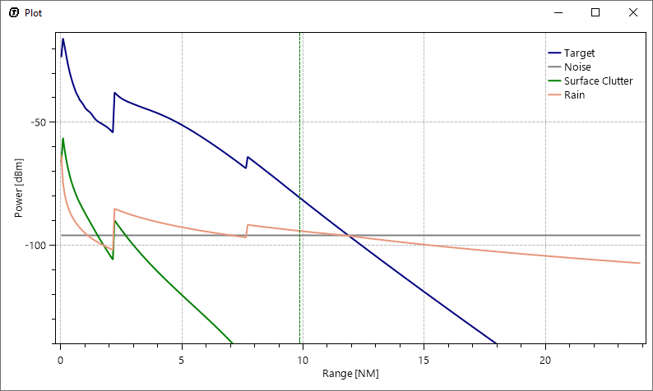
Figure 21 Example of received power versus range from a modern radar, X2 system, 20-meter antenna height, IALA type 4 target, Sea State 3 and 4 mm/hour uniform rain
    - Received power from sea clutter
The power received from surface clutter is computed using the de-facto industry standard model of sea clutter from Georgia Institute of Technology (GIT) [13]. Based on the size of the illuminated area and wind speeds, the total received power from sea clutter is calculated using a radar equation similar to that of the target. The model uses a surface clutter cross section (in m² / m²) of
$σ_{HH}^{0}= 10log\left[3.9∙{10}^{-6}λ{ ϕ}^{0.4}{ A}_{i}A_{u}A_{w}\right]$ [1-10 GHz] (S and X-band)
$σ_{HH}^{0}= 10log\left[5.78∙{10}^{-6}λ{ ϕ}^{0.547}{ A}_{i}A_{u}A_{w}\right]$ [10-100 GHz] (Ku-band)
The illuminated area depends on the antenna beam width and the duration of the pulse (for pulse compression radars it is the duration of the compressed pulse). The exact shape of the Interference term, Upwind term and Wind terms are different in the two frequency ranges.
    - Received power from land clutter
The power received from land clutter is computed using the constant-gamma model of [16] and the illuminated area. The total received power from land clutter is calculated using a radar equation similar to that of the target and a surface clutter cross section (in m² / m²) of
$$σ_{HH}^{0}=γ sin⁡(ϕ)$$
    - Received power from volume clutter
The power received from volume clutter (rain) is computed from the radar equation and the illuminated volume based on the antenna beam width in azimuthal and elevation plane. The radar cross section of rain is taken from [12], Chapter 19. The clutter is modelled as stratiform rain resulting in a volume clutter cross section (in m² / m³) of
$$η=\frac{π^{5}}{λ^{4}}1.86∙{10}^{-14}∙r_{r}^{1.6}$$
Valid from S-band to Ku-band. The power received depends on the clutter cross section and the illuminated column of rain, the size of which is given by the antenna beam width and height of the rain cloud ceiling.
    - Thermal noise
The thermal noise contribution in the received power is given by the simple thermal noise term
$$P_{n}=k_{B} TBN$$
    - Attenuation
The radar signals are attenuation by the atmospheric air and any potential water in the shape of droplets. Many highly detailed studies of attenuation exist, and the exact values of attenuation for both atmosphere and rain must be read of from a curve or table such as those given in [12]. In particular, the atmospheric attenuation does not have a simple dependence on wavelength due to molecular absorption bands in the Ku band.

Approximate values for VTS-radar relevant frequencies are given in Table 14 below.
Table 14 Attenuation from atmospheric air and additional attenuation from rain for various radar frequencies.
Frequency [GHz] (Band) | Atmospheric loss [dB/km] | Rain rate 1 mm/h, loss [dB/km] | Rain rate 2 mm/h, loss [dB/km] | Rain rate 4 mm/h, loss [dB/km] | Rain rate 8 mm/h, loss [dB/km]
3 (S) | 0.008 | 0.000 | 0.001 | 0.001 | 0.003
9.5 (X) | 0.016 | 0.008 | 0.018 | 0.045 | 0.108
14 (Ku) | 0.019 | 0.028 | 0.062 | 0.138 | 0.307
17 (Ku) | 0.060 | 0.048 | 0.103 | 0.220 | 0.473
To be aligned with precipitation rates used in the rest of the document
  - Detection probability
From the computed power terms, the final ratio of signal to noise and clutter at a given target position (slant range and altitude) is
$$x=\frac{P_{r}}{P_{n}+P_{sc}+P_{vc}}$$

This is converted to a probability of detection using the statistical models first developed by Swerling [14]. The choice of Swerling case depends on the target geometry as well as the decorrelation from sweep to sweep.
Large complex targets such as ships are classically modelled as Swerling case 1 targets with a large number of reflectors and small variation from sweep to sweep, with only variation from scan to scan. A complex target with fast variation is represented by Swerling case 2. Small point targets (missiles etc) are modelled as Swerling case 3 targets, with a single dominant reflector and little variation from sweep to sweep.
However, using modern radars with multiple frequencies, each frequency hitting the target more than once, leads to a partial decorrelation over the sweeps hitting the target. Swerling case 3 can be used as an approximation for complex surface targets when multiple carrier frequencies are used by the radar, since the curve for Pd versus signal-to-noise for Swerling case 3 lies between Swerling cases 1 (perfect correlation, many roughly identical scatterers) and 2 (perfect decorrelation, many roughly identical scatterers) For single frequency radars, complex surface targets are represented by Swerling case 1.

Target type | Single carrier frequency radar (magnetron or similar) | Multiple carrier frequency radar
Large complex targets (larger ships, aircraft etc) | Swerling case 1 | Average between Swerling case 1 and 2 (represented by Swerling case 3)
Small point targets (buoy) | Swerling case 3 | Swerling case 3

A false alarm rate is specified, and the false alarm rate and number of incoherently integrated pulses determines the detection threshold from
$$P_{fa}=1-Γ(N_{B},Y)$$

After determining the detection threshold, an intermediate term, c, is first defined as

$$c=\frac{1}{1+{\left(N_{B}x\right)}/2}$$

The probability of detection can subsequently be calculated as

$$P_{d}=1-Γ\left(N_{B}-1,Y\right)+c\frac{Y^{N_{B}-1}}{\left(N_{B}-2\right)!}e^{-Y}+$$
$$\frac{e^{-cY}}{{\left(1-c\right)}^{N_{B}-2}}\left(1-\frac{c\left(N_{B}-2\right)}{1-c}+cY\right)Γ\left(N_{B}-1,Y(1-c)\right)$$

This is the final output of the model providing a probability of detection for given target, antenna, and weather conditions

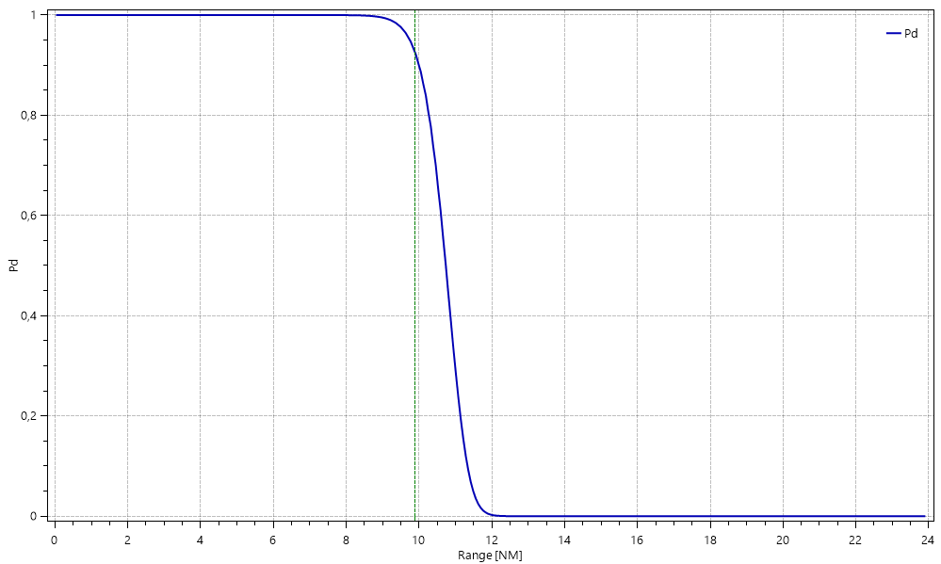
Figure 22 Example of detection probability versus range for a modern radar, X2 system, 20-meter antenna height, IALA type 4 target, Sea State 3 and 4 mm/hour uniform rain

- Test Targets and their Callibration
Test targets, also referred to as the controlled target, is assumed to be a small vessel which typical for test of VTS systems.
The RCS of the test targets is needed to obtain quantitative and reproducible results during testing of range performance, and it is necessary to calibrate the RCS of the test targets against a known reference reflector.
A prerequisite for performing RCS calibration is furthermore that the radar receiver characteristics is known, or more specifically that the relationship between the received power and the output video level is known. If not, the characteristics must first be mapped out.
The calibration procedure must be performed in calm weather with a low sea state and a well-known reference reflector must be at hand. An example of a reliable reference reflector is a calibrated Luneberg reflector mounted on a floating support as shown in Figure 23. It is important that the height of the reference reflector resembles that of the test target to be calibrated. If not, the measurements can be influenced by lobing as discussed in section 0 which leads to erroneous RCS estimates for the test targets.

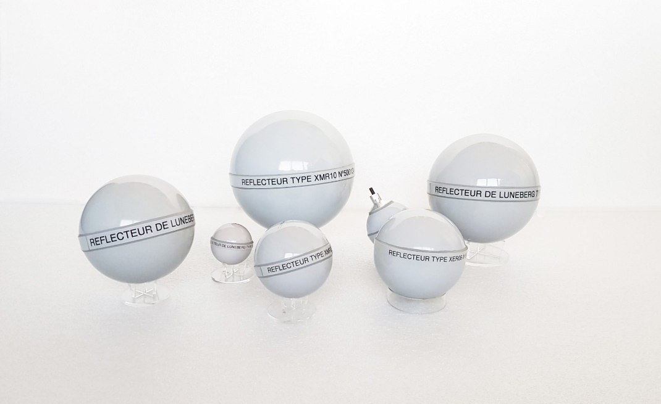
Figure 23 Luneberg reflectors

Calibration sequence:
The controlled target and the reference reflector should be placed within 2 NM from the radar sensor and preferably within 0.5 to 1 NM. Moreover, the targets should be positioned within free line of sight of the radar sensor and away from objects yielding intense radar echoes.
With the reference target on board, the controlled target is positioned in the test area where the following steps are carried out:
1) The reference reflector is placed in the water on its floating support.
2) The controlled target moves away from the reflector until the two targets are clearly separated on the radar display.
3) The radar gain is adjusted to obtain a clear picture of the test area with the test and reference targets clearly visible and stable in the water, both in azimuth and range. Make sure that any automatic gain adjustment is disabled such that the gain will remain constant throughout the calibration procedure.
4) Record the intensity of the reference target echo during at least 30 consecutive scans. Convert all recorded intensities to received power levels using the receiver characteristics. Calculate the average value and variance of the received echo power.
5) The controlled target is then positioned with its stern pointing the direction of the radar, see Figure 24.
6) Record the intensity of the controlled target echo during at least 30 consecutive scans. Convert all recorded intensities to received power levels using the receiver characteristics. Convert the received power, to an RCS value. Calculate the average value and variance of the measured RCS.
7) The controlled target changes its orientation in steps of 45 degrees and after each orientation change, the measurement in 6) is repeated. The last measurement is performed with the controlled target seen from astern.
8) Let the controlled target move in a circle cantered at the reference target and with a radius of approximately 100 meters. In each scan, record the intensity of the controlled target echo. Convert all recorded intensities to received power levels using the receiver characteristics and further to RCS values. Calculate the average value and variance of the measured RCS.
The RCS of the target has now been measured for several different orientations (step 6 and 7), and in addition a value for the overall RCS (the RCS averaged over all orientations) has been obtained in step 8.

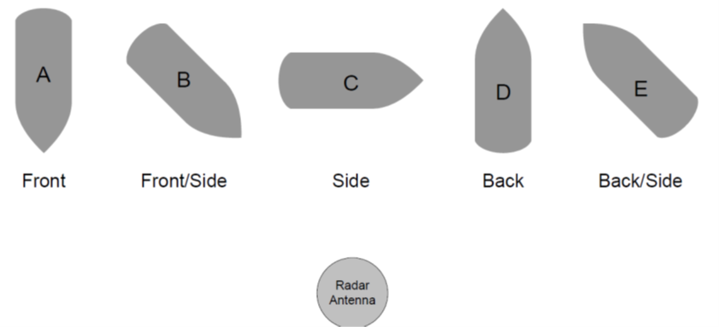
Figure 24 Target aspect angle relative to the radar antenna

------------------ END ---------------------

