Information paper: XXXX-n.n.n

Input paper for the following Committee(s): Purpose of paper:
(Select as appropriate)
☐ ARM ☐ ENG ☐ PAP ☐ Input
☐ ENAV ☒ VTS ☒ Information

Agenda item n.n
Technical domain/ Task number ² …………………………………
Author(s)/Submitter(s) Korea Coast Guard and Korea Maritime Institute

proposal FOR VTS DATA exchange USING CLOUD VTS CONCEPT

Summary
The purpose of this paper is to introduce the Cloud VTS development project conducted by the Korea Coast Guard and to discuss the progress achieved hitherto. For cloud VTS development, user requirements analysis, radar data transmission, and image compression were performed, and a real-time VTS system was developed. Additionally, a test bed was installed to operate the VTS system. In the future, information from a cloud server will be extracted and applied to the real-time VTS system. When exchanging VTS information, the Inter-VTS exchange format (IVEF) service will be used, and the results will be provided after execution.

Purpose of document
The purpose of this document is to introduce the cloud VTS development project conducted by the Korea Coast Guard and to introduce the contents developed hitherto. The data for cloud VTS performance are intended for providing service improvement suggestions based on the IVEF standard.

Related documents
IALA RECOMMENDATION R0145(V-145) THE INTER-VTS EXCHANGE FORMAT (IVEF) SERVICE

Background
After the successful completion of the IALA Recommendation R0145–Inter-VTS Exchange Format (IVEF) Service, the next important step is to apply it to actual service. Discussions pertaining to the IALA Recommendation R0145, which had not been held since 2011, were resumed by the 51st VTS committee. The Korea Coast Guard introduced the Cloud VTS concept to VTS 51, which is an IVEF service. The task group recognized the necessity to revise the current IVEF service recommendations. The Korea Maritime Institute conducted a survey regarding the IVEF service among VTS operators and suggested to update the IVEF recommendation such that information regarding radar screen and VHF voice data can be disseminated. The purpose of this paper intends to discuss the progress of the Cloud VTS project introduced at the 51st IALA VTS committee based on the requirements of VTS operators.

Discussion

Data exchange using cloud concept
In the case of Republic of Korea, data exchange between closed VTSs can use the IVEF service. The vessel position, track, and tagged item can be exchanged through the IVEF service. However, the IVEF service cannot share radar screens or VHF data when performing control. These two data are essential data for control. In addition, since Radar, CCTV, AIS, VHF, weather information, etc. transmit information to the VTS system using the manufacturer's own protocol, information collection is highly dependent on the manufacturer.
Cloud VTS concept is to exchange additional data required for control using the cloud platform. It also collects information according to standards and stores it in the cloud, so it is not dependent on the manufacturer. The manufacturer processes and displays the data provided according to a set standard.
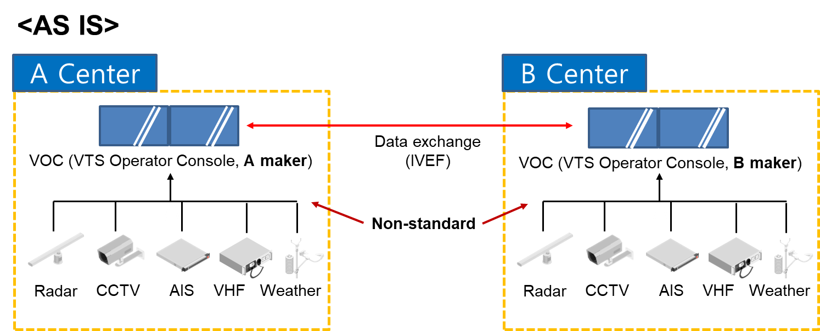
VTS operators have so far been able to exchange limited data via IVEF service with nearby VTS centers. However, although there is a data exchange standard (IVEF), the standard for collecting data as VTS system differs from manufacturer to manufacturer. Therefore, the radar site and VTS system are inevitably influenced by each other's manufacturers. In addition, the VTS system used for control in other areas to respond to emergency situations such as the closure of the VTS center due to COVID-19 is inevitably affected by the radar site manufacturer. For the safe and efficient operation of vessel traffic, the VTS area is gradually expanding, and it is expected that a lot of data will be generated at sea with the advent of autonomous ships(MASS). Therefore, the exchange of various data became necessary for the VTS operator's quick and accurate decision-making.
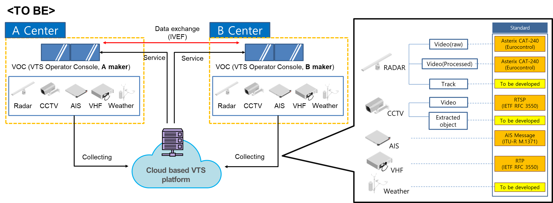
The smooth exchange of data is essential for monitoring a large area by connecting the VTS center and monitoring the area connected between countries. The cloud concept was proposed for a seamless and scalable data exchange that is not dependent on the manufacturer. When the cloud VTS system is completed, various data from the radar site are collected to the integrated cloud operation center, and after data processing, the data can be shared with the connected VTS center and an approved external platform (Other agency, Control center, Patrol vessel). External agency services will be provided as Open API. VTS operators can use existing local data and can also use data from the cloud. In other words, from the VTS operator's point of view, even if the system is added, local data can be used the same as before, and data from other centers can be received through the cloud. Korea Coast Guard plans to expand to National VTS through cloud VTS.
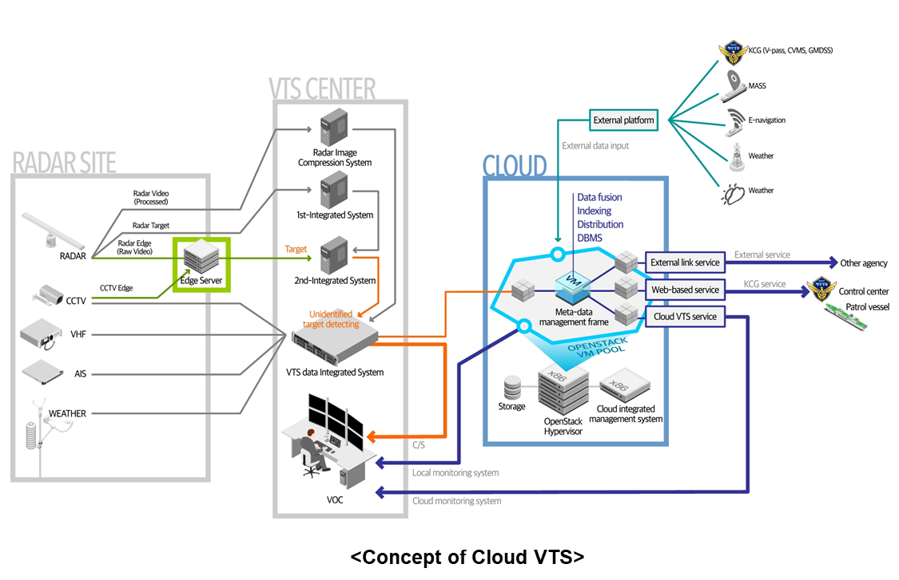
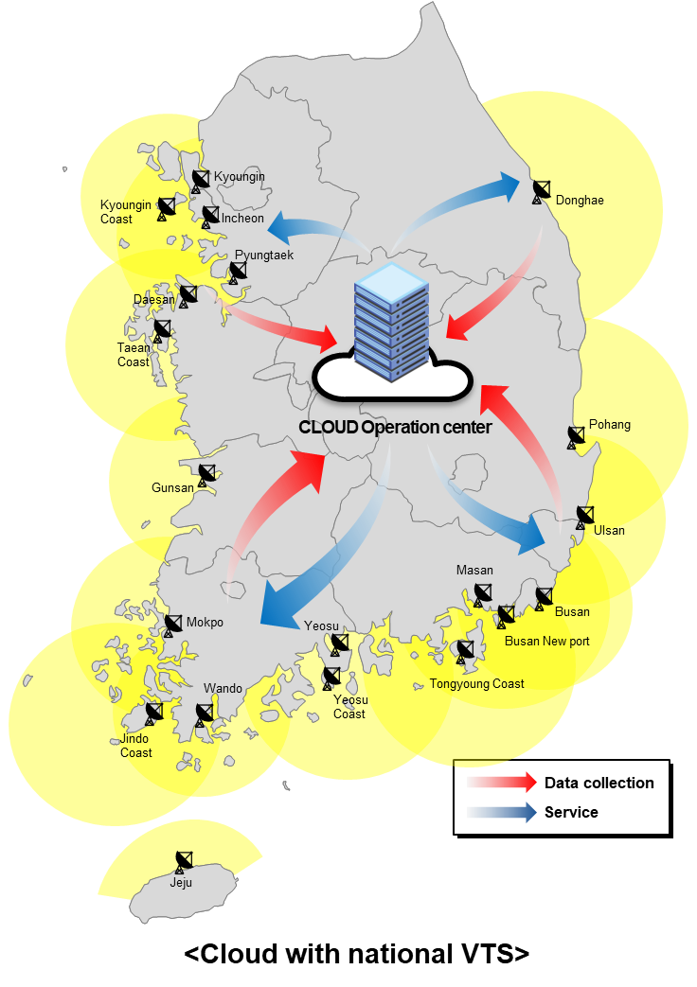
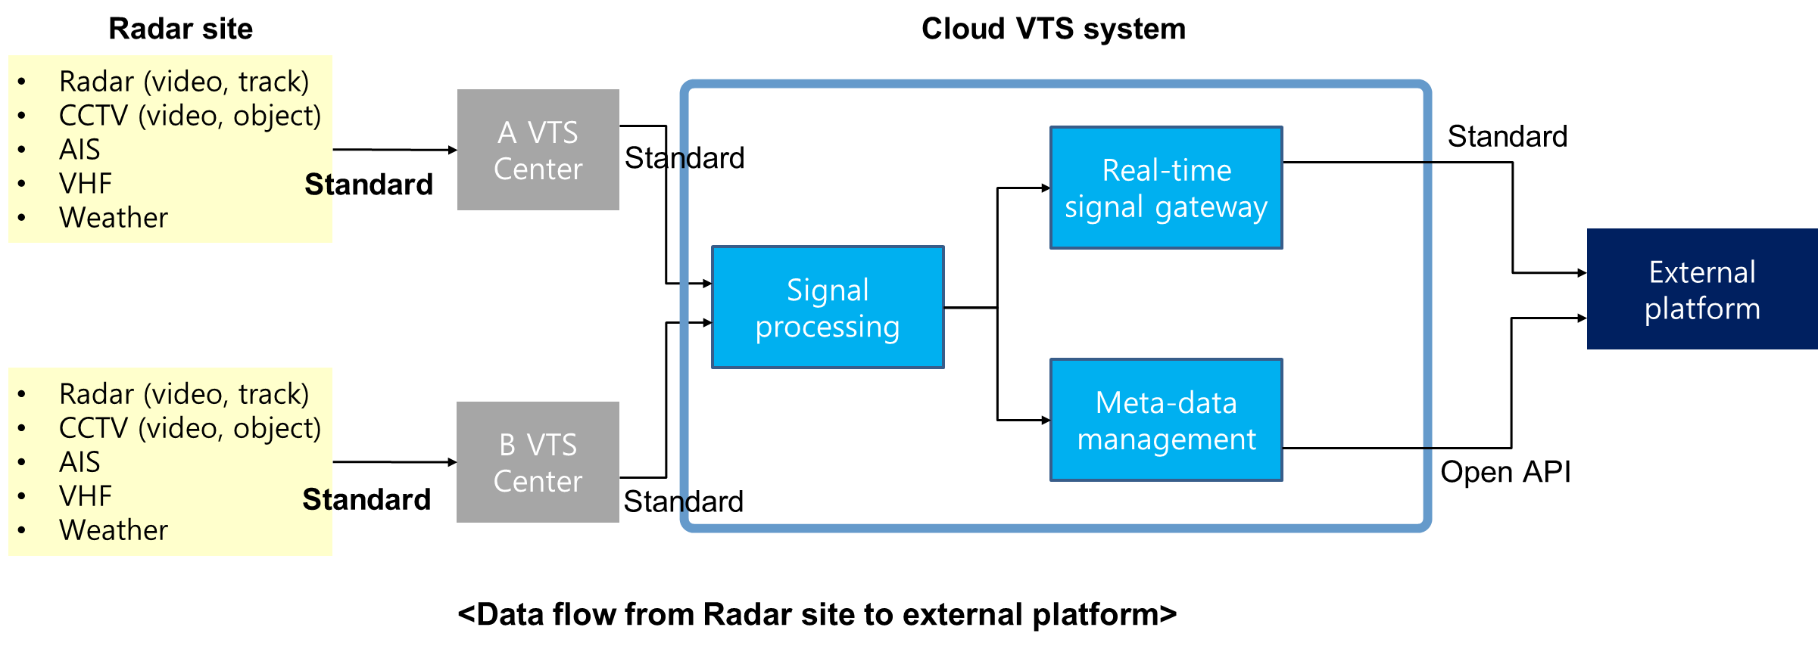

project development process

User requirement
To develop the cloud VTS system, the service requirements for the VTS operator were derived. The user requirements connected the VTS function for each collection equipment required for control and identified data that must be disseminated accordingly. Because the VTS data include sensitive information, they are classified into internal and external data.

 | Equipment | VTS function | Required information
Internal data | Radar | Target detection, tracking, route prediction, traffic situation | Target information, prediction, deviation, etc.
Internal data | Radar | Sea surface information | Wave height, direction, frequency
Internal data | Radar | Raw data acquisition | Radar raw data
Internal data | CCTV | Understanding ship movement | CCTV image
Internal data | CCTV | Target identification | Unidentified target information
Internal data | ECDIS | Geographic information | VTS area
Internal data | VHF telephone | Voice communication | Voice communication (send and receive)
Internal data | VHF DSC | Safety/Emergency/Distress communication | DSC information
Internal data | VHF DSC | Safety/Emergency/Distress communication | DSC Message (send and receive)
Internal data | AIS | Static data (ship specification) collection | Static data
Internal data | AIS | Dynamic data (target tracking) collection | Dynamic data (position, course, speed, etc.)
External data | Weather center  Meteorological Administration  Weather information | Weather information collection/transmission | Weather information
External data |  | Verify weather warning | Warning information
External data |  | Verify weather warning | Marine meteorological information
External data | Marine environment information  (Hydrographic and Oceanographic agency) | Marine environment information collection and transmission | Tide, depth, wave height
External data |  | Marine spatial information collection and transmission | Fishing area, Military area, submarine information, etc.
External data |  | Navigational warning information | Military service area
External data | Pilot | Checking pilot information | Pilot schedule, destination, and tug information

Radar data integration function and transmission
For continuous monitoring, it is necessary to track a specific vessel. A function that recognizes the target tracked in the overlapping section between the radar sites as the same vessel was developed. Integrating into the same target and the integrated radar image is transmitted to the cloud according to the Asterix CAT240 standard. The radar image of the cloud server is provided to the connected VTS across the country.
A real-time conversion and compression module of radar video was implemented to send the radar image, which is required for control, to the cloud server. In this case, the radar image standard was Asterix CAT240. Real-time transmission of the converted radar video was tested and verified.

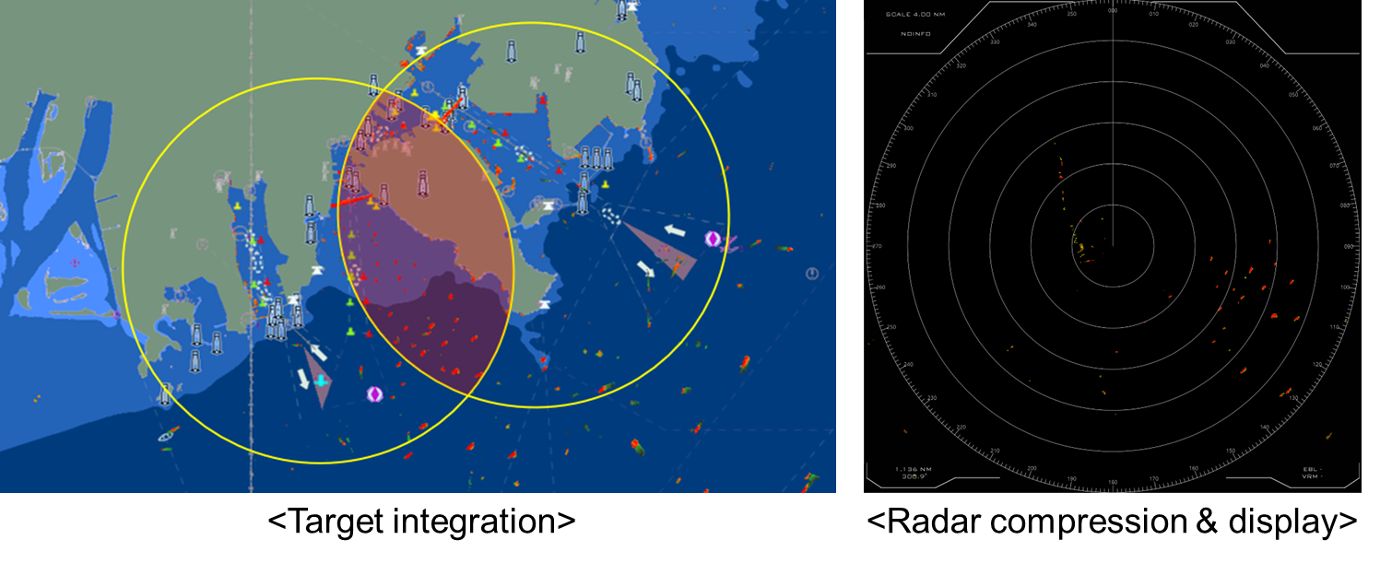

target identification function
A function was developed to link the real-time target with the vessel displayed on the CCTV screen. Consequently, the target data can be displayed and matched to the vessel displayed on the CCTV screen. In the future, a function that can merge and display the detected object recognition data is to be developed.
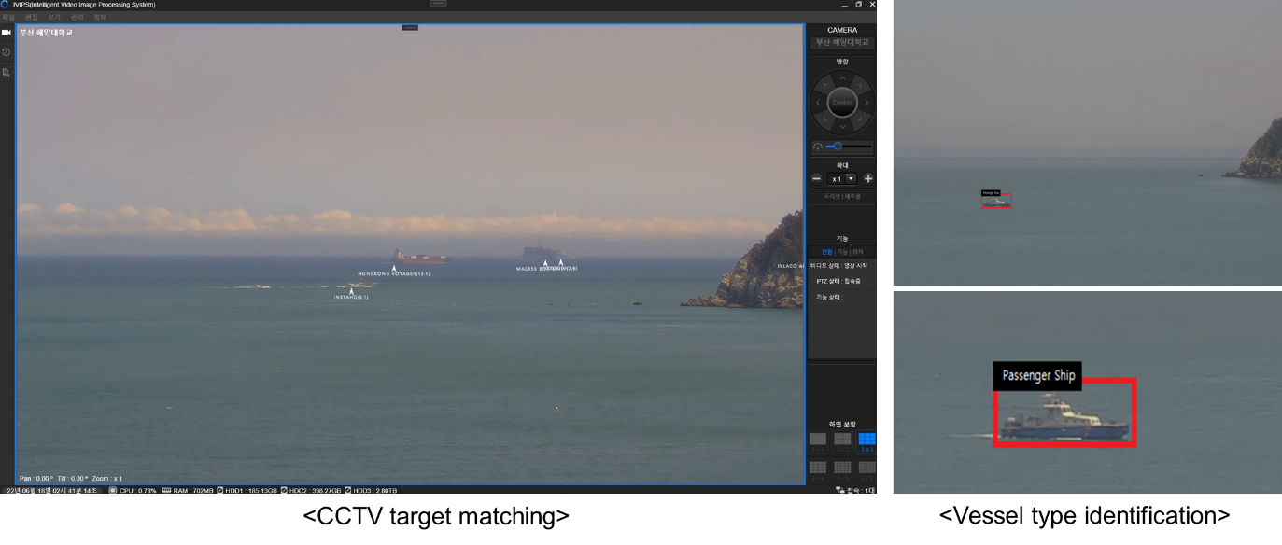

The Korea Coast Guard plans to use satellite data for VTS in the future. Therefore, a module using deep learning was developed to detect the position of a vessels using satellite images. As a result of testing using the module, the average accuracy was 88.45%, and the lower the ship's speed, the higher the detection accuracy.
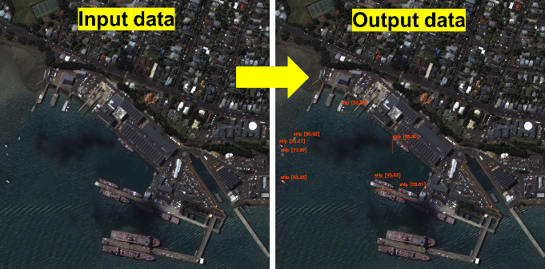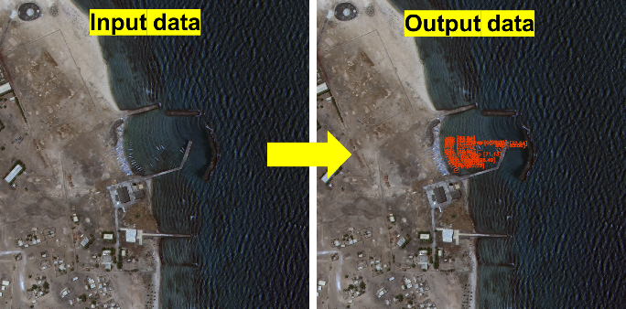

Real-time vts system development
Based on user requirements, a real-time control system to be used by the VTS operator was developed. The real-time control system receives data from the cloud server and monitor the vessel. it includes functions necessary for control (ship inquiry, radar image overlay, CPA/TCAP calculation, distance measurement, coordinate movement, area management, route prediction, etc.). Furthermore, it can use the replay function to recall past data.
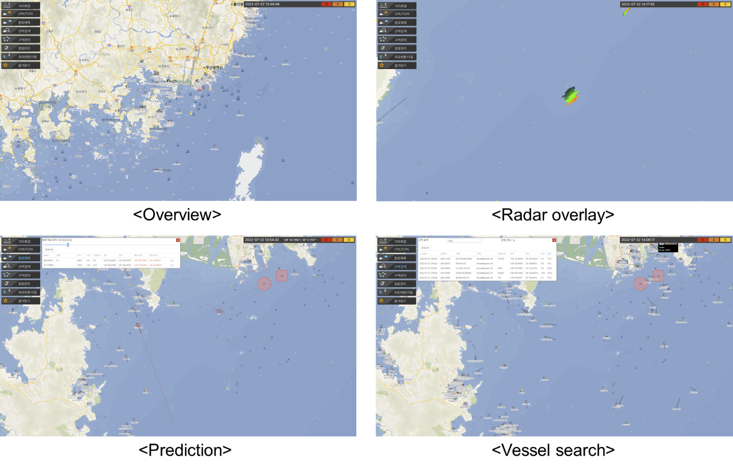

Route guidance based on big data
Various standard routes were created using AIS big data of vessels passing through the VTS area. The created standard route is displayed on the VTS system screen, and the VTS operator can easily identify abnormal vessels (acceleration & rapidly deceleration change, etc.). Vessels with many abnormal situations are listed and shared, and an alarm is generated the next time the VTS area approaches.
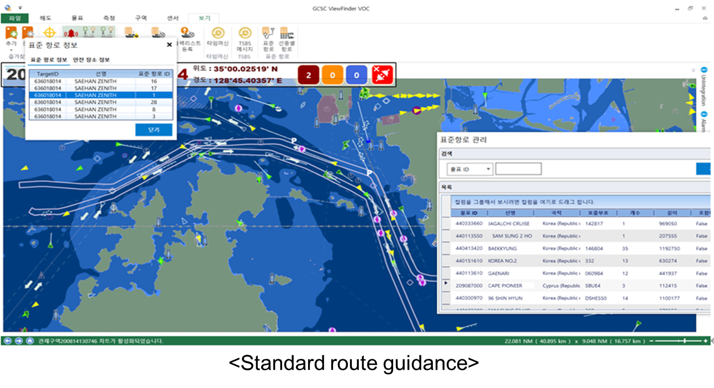

Test bed
The concept of cloud VTS is to gather VTS information obtained from other centers or external organizations via a cloud server, and to access services from VTS centers or other organizations. Hence, a test bed was installed prior to actual operation. The test bed comprised a radar site, an AIS receiver, a VHF system, a meteorological equipment system, and a CCTV system, which were installed in a nearby building to obtain information regarding the waters near Busan Port. Information was received from the cloud operation server through the Internet network; subsequently, the information was processed and displayed in a temporary VTS center (test bed).
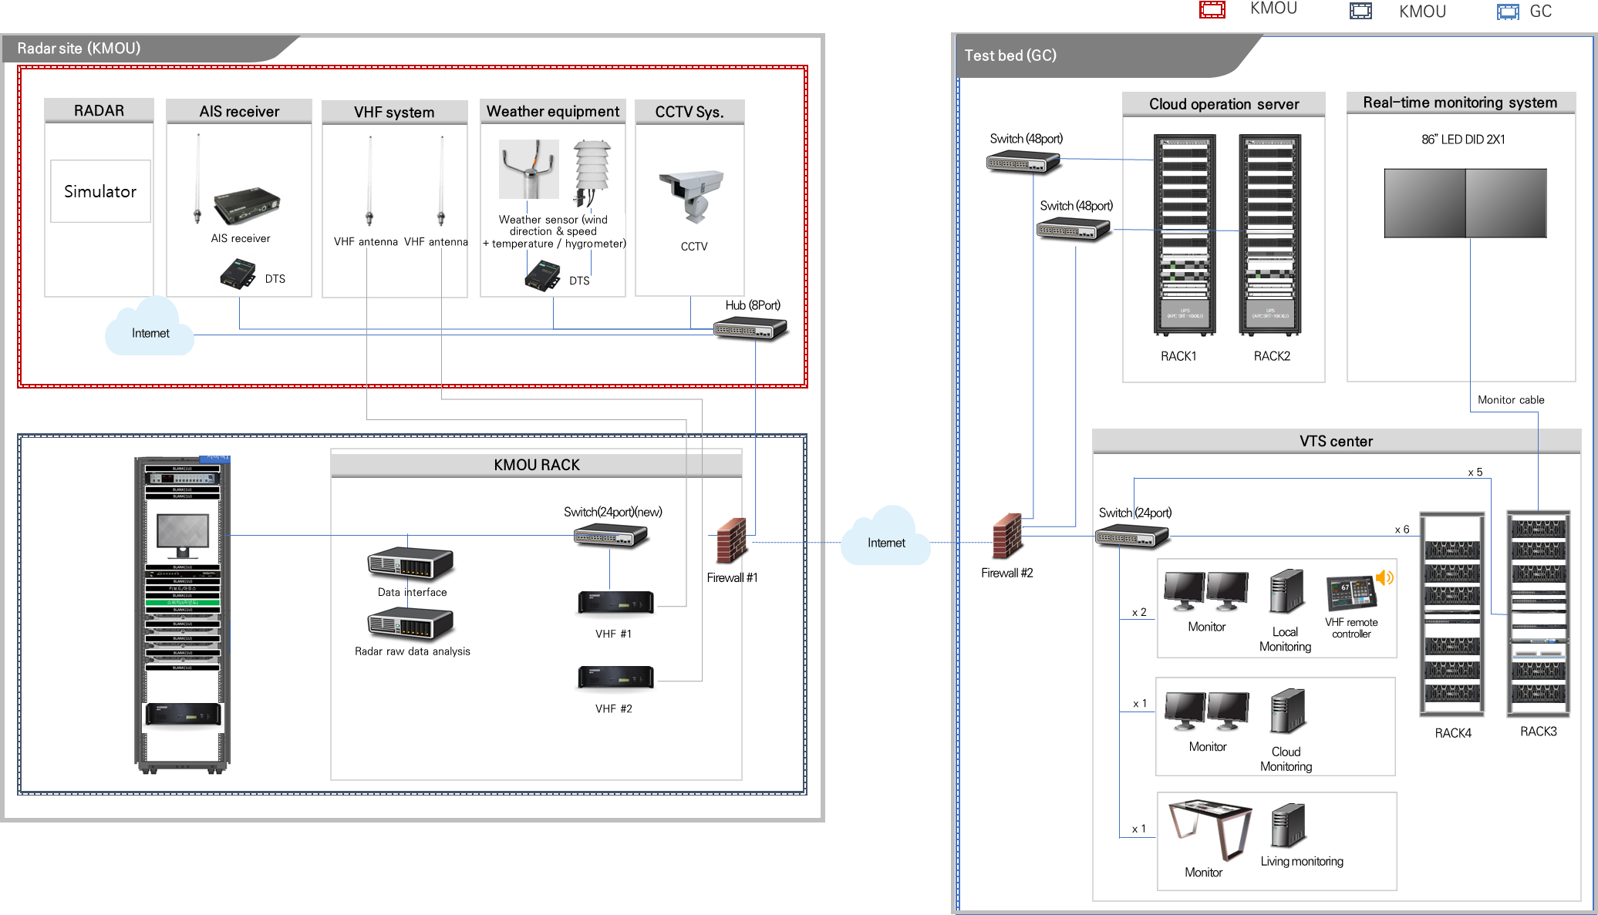
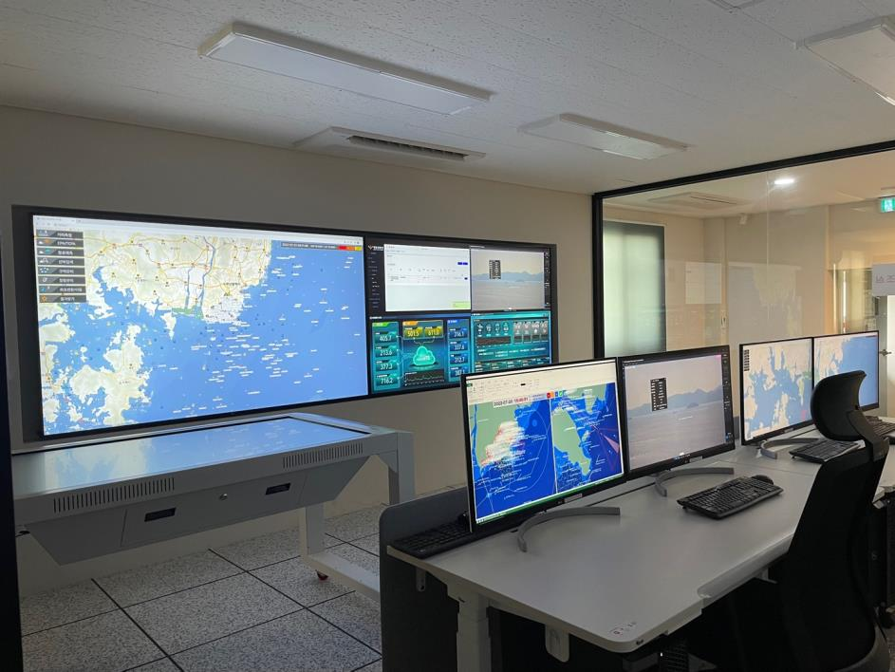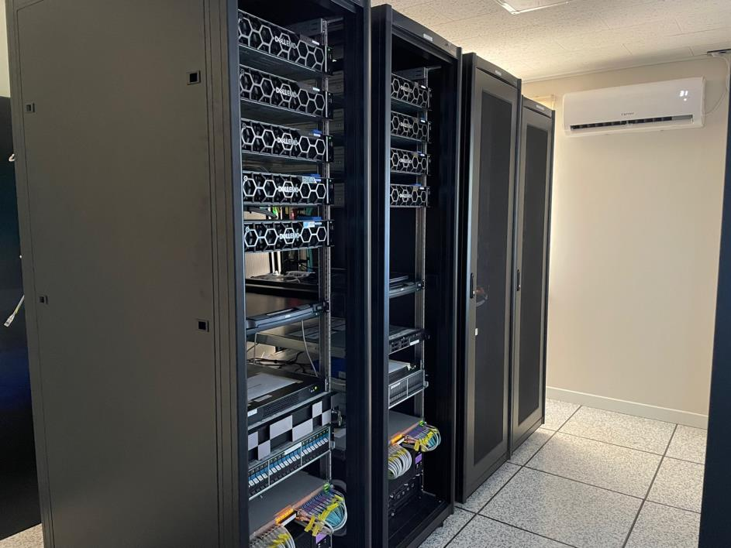

Next step
In the future, the VTS information distributed from the cloud server in the installed test bed will be operated on a VTS system. At this time, the information exchange of VTS system will be based on the IVEF standard and Cloud VTS system, whereas the radar image information and VHF voice communication will be based on their respective protocols owing to the absence of an exchange standard. The results of VTS data exchange and VTS system operation using the cloud system and IVEF standard will be presented to the committee later.

- IALA RECOMMENDATION R0145(V-145) INTER-VTS EXCHANGE FORMAT (IVEF) SERVICE
- IALA VTS MANUAL 2021 - EDITION 8

Action requested of the Committee
The VTS committee is invited to note the application of this technology and consider it when updating the “IALA Recommendation R0145(V-145) The inter-VTS exchange format (IVEF) service.”

Input document number, to be assigned by the Committee Secretary
Leave open if uncertain

