Input paper: VTS56-8.3.1

Input paper for the following Committee(s): Purpose of paper:
□ARM □ENG □PAP X Input
□DTEC XVTS □ Information

Agenda item 8.3
Technical Domain / Task Number² 1.3.1
Author(s) / Submitter(s) China Maritime Safety Administration

Proposal to Modify the Draft Guideline on VTS Digital Communications

Summary
According to the VTS Committee 2023-2027 Work Programme, the Task 1.3.1 that is “Develop guidance on VTS digital communications (operational aspects)” should be finished at VTS57. The Draft Guideline on VTS Digital Communications for the task is still under ongoing development, which aims at specifying how to implement the interaction between VTS and ships by digital means. By reviewing the provisions of IMO A.1158 (32), IALA G1089 and G1141, and considering actual VTS operations, China MSA believes that the currently identified VTS specific Technical Services in the draft guideline are not complete. This proposal proposes modifications to the Draft Guideline on VTS Digital Communications by adding the Scheduling and Allocation Service.

Purpose of the document
The document aims at providing input paper for VTS Committee to advance the task of “Develop guidance on VTS digital communications (operational aspects)” and to modify the Draft Guideline on VTS Digital Communications.

Related documents
IMO Resolution A.1158 (32) Guidelines for Vessel Traffic Services
IALA Guideline G1089 Provision of a VTS
IALA Guideline G1141 Operational Procedures for Delivering VTS
VTS55 WP Draft GL on VTS Digital communications for VTS56
VTS55-12.3.6 Technical Service Specification for VTS Traffic Clearance_1.3
VTS54-8.3.2 Draft of Service Specification for digital VTS Anchorage Assignment Service_V0.5.0

Background
During the session of VTS55, the task group of 1.3.1 further developed the guideline, but also focused on producing operational use-cases with task groups of 2.5.2 and 2.8.1, together which will contribute to the Draft Guideline on VTS Digital Communications.
China MSA continues to track the progress of this task and studies the content of VTS technical services such as the Traffic Clearance Service. After having reviewed the provisions of VTS from IMO A.1158 (32), IALA G1089 and G1141 documents, it was found the lack of VTS technical services concerning to “organizing space allocation” and “establishing a system of voyage or passage plans”. While in actual operations, the method of scheduling and allocation has being widely used to ensure the safety and efficiency of ship movements, for example, developing a schedule for ships waiting to pass through confined waterway, lock, etc. Therefore, the proposal proposes the addition of Scheduling and Allocation Service in the Draft Guideline on VTS Digital Communications.

Discussion

Provisions of Normative Documents
The relevant documents require VTS authority(s) to provide service of Scheduling and Allocation.
IMO Resolution A.1158 (32) Guidelines for Vessel Traffic Services states VTS:
“monitoring and managing ship traffic to ensure the safety and efficiency of ship movements. This may include:
- organizing space allocation
- establishing a system of voyage or passage plans”.
IALA Guideline G1089 Provision of a VTS states:
"The monitoring and management of ship traffic to ensure safety and efficiency of ship movements may include:
- Organizing space allocation.
- Establishing a system of voyage or passage plans."
and provides examples such as
- “Planning lock and bridge passages”.
IALA Guideline G1141 Operational Procedures for Delivering VTS states:
“Procedures for the monitoring and management of vessel traffic should be established. These may include:
- Organizing space allocation
- Establishing a system of voyage or passage plans".
Scheduling and Allocation refer to the pre-planning of time and/or spatial resources for specific water areas.

Requirements of Actual Operations
Due to the limitations of geographical condition and VTS serviceability, the vessel traffic capability (including passage capacity, accommodation capacity, etc.) of critical water areas where port entrances, locks, confined waterways, anchorages, etc. are located, is also limited.
- When the traffic flow is mild, traffic demand ≤ traffic capability:
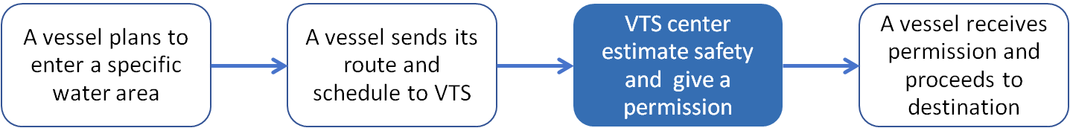
- When the traffic flow is intense, traffic demand ≥ traffic capability:
When the traffic flow is intense, the VTS centre will adopt a method of scheduling and allocation on critical water areas for vessel direction and coordination to reduce navigation congestion and disorder nearby.
The following are two practical cases of Scheduling and Allocation. Figure 1 shows an entrance passage schedule. The vessels first need to obtain passage applications from VTS centre, and then the VTS centre makes an arrangement of passage sequence, where Vessel X was appointed to follow Vessel D, at fifth.
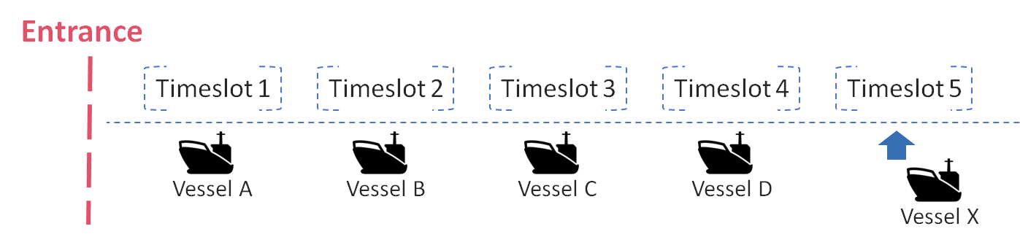
- Entrance passage schedule
Figure 2 shows an anchorage allocation schedule. Vessel B has obtained the pre-allocation of anchorage in advance from VTS center, and it can anchor at position 1 of the anchorage after 19:00 on September 1st, while vessel A must leave the anchorage before on September 1st.
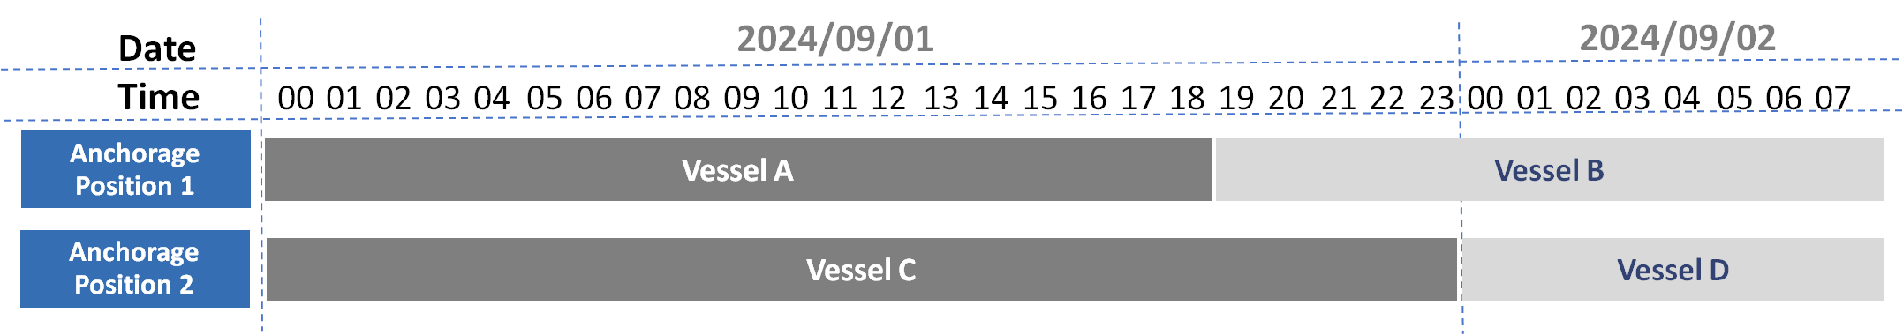
- Anchorage allocation schedule
Scheduling and Allocation also contributes to improve navigational efficiency. The vessel can optimize its voyage route and schedule based on the arrangement of Scheduling and Allocation. The VTS centre can improve the passage efficiency of critical water areas and the utility of anchorage and other spaces by Scheduling and Allocation.

Add a New Technical Service
Implement of VTS Scheduling and Allocation by digital information means that there should be a corresponding Scheduling and Allocation Service in VTS digital services. The proposal proposes to add a new Scheduling and Allocation Service in “VTS SPECIFIC TECHNICAL SERVICES” (Para6.1.) of the Draft Guideline on VTS Digital Communications. The modified diagram of VTS digital services is shown in Figure 3, with "Scheduling and Allocation Service" marked in dark red.
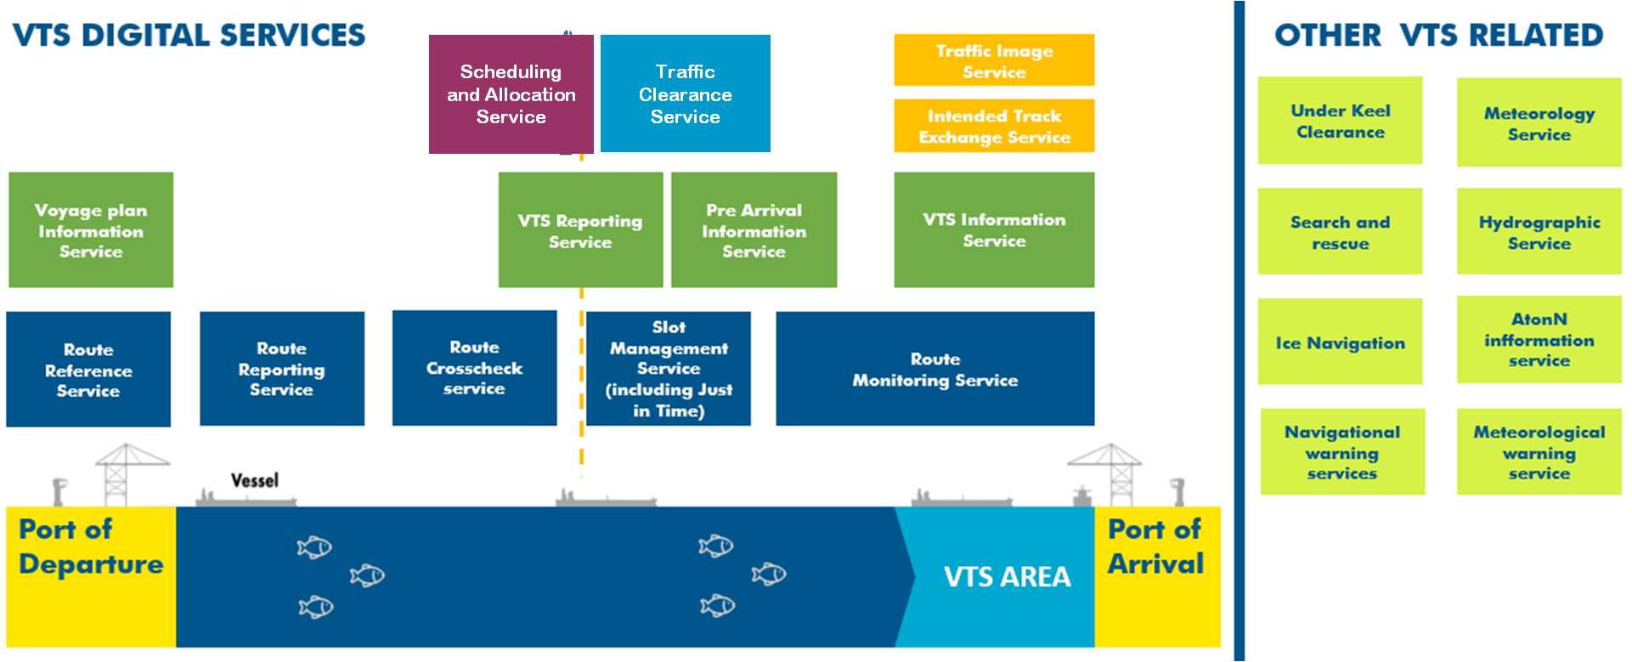
- The Modified Diagram of VTS Digital Services
Scheduling and Allocation Service provides ships the applications and pre-arrangements for time and/or space in critical water areas. Within this technical service, the VTS centre is responsible for developing plans and allocating resources in accordance with traffic demand and traffic capability.

Relationship with Other VTS Technical Services
The Scheduling and Allocation Service could be combined with other VTS technical services.
When combined with the Traffic Clearance Service, the Scheduling and Allocation Service should be operated first. The process of combining these two services are:
- The first step is to use Scheduling and Allocation Service. Vessels apply for passage or allocation to the VTS centre. The VTS centre makes schedule for the applied vessels by considering the comprehensive factors of navigation safety. The applied vessels receive the arrangement from the VTS centre.
- The second step is to use Traffic Clearance Service. The vessel is prepared to pass or enter the pre-allocated location according to the arrangement. The VTS centre verifies vessel’s identity with the schedule as well as the navigation safety status, and then gives an approval of release.

Action requested of the Committee
The Committee is requested to:
- Consider the addition of Scheduling and Allocation Services in the Draft Guideline on VTS Digital Communications.
- Develop a technical service specification for Scheduling and Allocation Service.

Input document number, to be assigned by the Committee Secretary
Leave open if uncertain

