Input paper: VTS56-9.1.1

Input paper for the following Committee(s): check as appropriate Purpose of paper:
□ ARM □ ENG □ PAP X Input
□ DTEC X VTS □ Information

Agenda item
Technical Domain / Task Number² 2.5.2
Author(s) / Submitter(s) China Maritime Safety Administration

Proposals on the “Service Specification for VTS Traffic Clearance Edition 1.3” and “Service Design for VTS Traffic Clearance Service Edition 1.0”

Summary
This proposal proposes revisions to Service Specification for VTS Traffic Clearance Edition 1.3 and Service Design for VTS Traffic Clearance Service using SECOM Edition 1.0 from the aspects of improving ETA/ETD, S-100&ECDIS and editorial changes related contents.

1.1 Purpose of the document
The purpose of this document is to provide input document for the VTS committee to update the Service Specification for VTS Traffic Clearance Service and VTS Traffic Clearance Service using SECOM.

Related documents
IALA VTS55-6.1.1 VTS Task Plan 2023-2027
IALA VTS55-12.3.6 Service Specification for VTS Traffic Clearance_V1.3
IALA VTS55-12.3.5 Service Design for VTS Traffic Clearance Service using SECOM_V1.0
IALA VTS53-6.3.2 Development of technical service specifications for digital data exchange between VTS and other entities - primarily ships
IALA VTS54 8.3.2 Draft of Service Specification for digital VTS Anchorage Assignment Service_V0.5
IALA VTS55-9.1.1 Proposals on the “Service Specification for VTS Traffic Clearance Service_V1.0”

background
2.1 The IALA VTS Committee Work Plan 2023-2027 raises the task "Development of technical service specifications for digital data exchange between VTS and other entities - primarily ships” (task 2.5.2), and aims to finalize the pioneer technical service specifications before VTS57. Service Specification for VTS Traffic Clearance Edition 1.3 and Service Design for VTS Traffic Clearance using SECOM Edition 1.0 had been finalized at VTS55 and the intersessional meeting. At the intersessional meeting, the task 2.5.2 indicated that all contents of the Service Specification for VTS Traffic Clearance and Service Design would be open for discussion and welcome suggestions for revision.
2.2 As the co-author of the new work task proposal (VTS 53-6.3.2) at VTS53, China MSA continued to submit " Proposals on the New Work Task of Developing Technical Service Specifications for Digital Data Exchange between VTS and Other Entities ”(VTS54 9.1.3) and " Draft of Service Specification for digital VTS Anchorage Assignment Service_V0.5" (VTS54 8.3.2 ) at VTS54，and “Proposals on the Service Specification for VTS Traffic Clearance Service_V1.0” (VTS55-9.1.1) at VTS55.

PROPOSAL

3.1 Proposals on updating ETA/ETD related contents

3.1.1 Standards for timestamps (aligned with IMO Compendium)
1.Definitions for "Estimated/Requested/Planned/Actual Time of Departure (Abbreviations: ETD, RTD, PTD, ATD)"are listed in IMO Compendium by data numbers: IMO0066, IMO0236, IMO0237, IMO0065.
2.Definitions for "Estimated/Requested/Planned/Actual Time of Arrival (Abbreviations: ETA, RTA, PTA, ATA)"are listed in IMO Compendium by data numbers: IMO0064, IMO0234, IMO0235, IMO0063, such as below:
(1) Date and time of arrival – estimated: The date and time the ship is estimated to arrive at a specified location, ETA. (IMO 0064)
(2) Date and time of arrival - requested: The date and time the ship is requested to arrive at a specified location, RTA. (IMO 0234)
(3) Date and time of arrival – planned: The date and time the ship plans to arrive at a specific location, PTA. (IMO 0235)
(4) Date and time of arrival – actual: The date and time the ship arrives at a specified location, ATA. (IMO 0063)

3.1.2 Sequence of timestamps
According to the IMO GIA Just in Time Arrival Guide and IMO FAL.5/Circ.52 Guidelines for harmonized communication and electronic exchange of operational data for port calls, arrival and departure times of ships and starting and completion times of services all follow the same sequence of “Estimated”, “Requested”, “Planned”, “Actual”, It should be noted that each timestamp has one owner, as below:
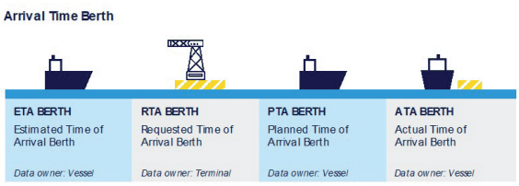
1.Estimated Time of Arrival (ETA): The vessel digitally communicates the ETA to the VTS（terminal）, indicating when the vessel is expected to arrive at the berth.
2.Requested Time of Arrival (RTA): Upon receiving the ETA, the VTS（terminal） verifies berth availability and responds with the RTA, confirming their readiness to accommodate the vessel.
3.Planned Time of Arrival (PTA): The vessel confirms the RTA as a handshake agreement and sends the Planned Time of Arrival (PTA). The PTA is always the same as the RTA and represents the most up-to-date arrival time shared with all stakeholders.
4.Confirmation and Communication: Any changes to the ETA or RTA trigger a new cycle until a new PTA is established and communicated. Once the vessel arrives, the Actual Time of Arrival (ATA) is communicated to confirm its arrival.

3.1.3 Analysis
Many timestamps are shared by one-to-one communication means. This makes the sharing of timestamps prone to error and very labour intensive.
Although the timestamps (and corresponding locations) have all been identified by the industry in the port call business process, these definitions are not systematically and consistently applied in the technical service specification. For example, instead of the “Requested Time of Departure” (RTD) ，often a “revised ETD” is used as terminology which creates confusion. Strengthening the implementation of clear timestamps can prevent confusion, greatly streamline port planning and hence reduce unnecessary waiting times.

3.1.4 Proposals
1. Review and update ETA/ETD related contents in all user cases and sequence diagrams according to the sequence of timestamps.
2. Review and update ETA/ETD related contents in “3.2.1 Functional requirements” according to the sequence of timestamps，description of PTA/PTD and ATA/ATD related functional requirements should be added if necessary.

3.2 Proposals on improving S-100&ECDIS related contents

3.2.1 Analysis
1. IHO had released the S-100 Edition 5.2.0 in June 2024.
2.In support of IALA G1128 applications and the implementation of digital maritime services (MS), in December 2022, MSC106 approved the Revised Electronic Chart Display and Information System (ECDIS) Performance Standard (MSC.530(106)) ,which introduced the concept of electronic Navigation Data Services (ENDS) and online transmission updates for the first time. In May 2023, IMO NCSR10 had adopted the new revision of ECDIS performance standard, and approved by IMO MSC108 in June 2024. The revision had supported planned route exchange and secure online data exchange in compliance with S-421/IEC 63173-1 and /IEC 63173-2 SECOM (including ETA/ETD of route schedule).

3.2.2 Proposals
1. It is recommended to update the S-100 edition and URL related information in sections 3.3.1,7 in Service Specification for VTS Traffic Clearance Service, and sections 3.3,8 in Service Design for VTS Traffic Clearance Service.
2.Considering the S-100 ECDIS will serve as an important carrier for the landing of MS1:VTS and G1128 at the end users of the ship, the first recommendation is to update the following ECDIS related words in page 7 of Service Specification for VTS Traffic Clearance ( " ECDIS PS does not support the exchange of ETA/ETD timestamps”), the second is to add relevant industrial standards such as MSC.530(108)Rev.1 and IEC 63173-2 SECOM to “3.3.1Relevant Industrial Standards”.

3.3 Proposals on editorial changes

3.3.1 G1128 related editorial changes
It is recommended to optimize the relevant wording “G1128 Error: Reference source not found” in 1.1 in Service Specification for VTS Traffic Clearance.

3.3.2 Use cases related editorial changes
1. It is recommended to update the wording of UC 1-6 in 3.1, to keep the wording context consistent with the name of Use Cases 1-6.
2. It is recommended to update the wording related to planned routes in Use Cases 1-6 to maintain the consistency of context.

3.3.3 Requirements related editorial changes
1. It is recommended to unify the relevant wording of TCSF003, TCF004 and TCF006, to unify the description of data flow direction (preposition) to maintain context unity, and to discuss the combination of the following three similar functional requirements
TCSF003: Send ETA proposal to vessel from VTS
TCSF004: Send ETD proposal to vessel from VTS
TCSF006: Send ETA / ETD proposal from VTS to vessel
2. It is recommended to update the wording related to location and geometry type, one is to change the "named locations" to "specified locations", in order to be consistent with the definition in the IMO Compendium. The second is to remove the wording "referred to with a point, polygon or rectangle,"so as to avoid the omission of geometric types such as circle and sector anchorage.

3.3.4 Service Design for VTS Traffic Clearance Service related editorial changes
1. It is recommended to update edition information in 2 Service Identification, to keep consistency.
2. It is recommended to update edition information in 8 Reference, to keep consistency.
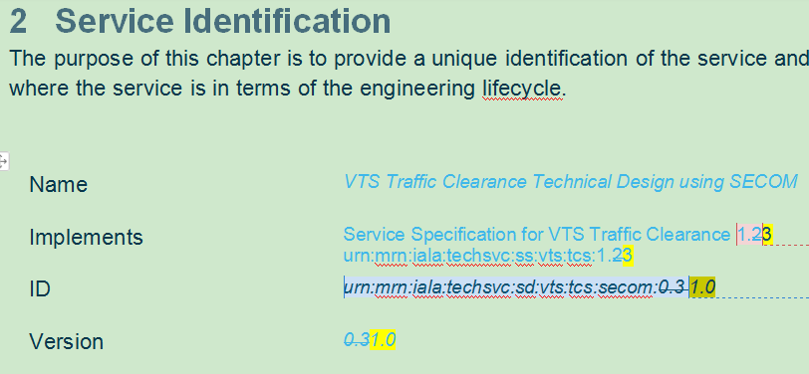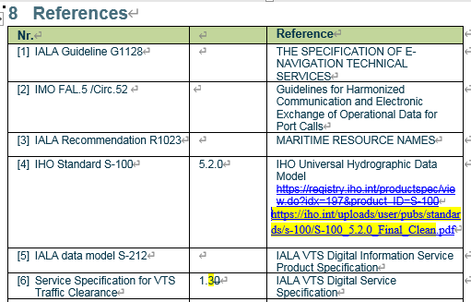

References
[1] IMO Compendium 2024
[2] IMO GIA Just in Time Arrival Guide 2020
[3] IMO FAL.5 /Circ.52 the Guidelines for Harmonized Communication and Electronic Exchange of Operational Data for Port Calls March 2023
[4] IMO Resolution MSC.530(106) Rev.1 ECDIS Performance Standard

ACTION REQUESTED OF THE COMMITTEE
The Committee is requested to consider the proposals in this document and take actions as appropriate.

Input document number, to be assigned by the Committee Secretary
Leave open if uncertain

