IALA Guideline

Gnnnn
VTS Interaction with a Mix of Conventional, Automated and Autonomous Ships

Edition 1.0
December 2024

urn:mrn:iala:pub:gnnnn:ed1.0

Revisions to this document are to be noted in the table prior to the issue of a revised document.
Date | Details | Approval
Dec 2024 | 1st issue | Transition Council 3

1. introduction 4
2. document purpose 4
2.1. Using this Guideline 4
2.2. Relationship to other documents 5
3. IMO regulatory framework 6
4. PROVISION OF VTS with A MIX OF CONVENTIONAL, AUTOMATED AND AUTONOMOUS SHIPS 6
4.1. SITUATIONAL AWARENESS 7
4.1.1. VTS 7
4.1.2. Participating Ships 8
4.2. INTERACTION 8
4.2.1. Introduction 8
4.2.2. VTS 9
4.2.3. Participating Ships 9
4.3. MANAGING A MIX OF CONVENTIONAL, AUTOMATED AND AUTONOMOUS SHIPS 9
4.3.1. VTS 9
4.3.2. Emergency Response for MASS 10

introduction

Interaction between VTS and ships is transitioning from being primarily by VHF voice towards more digital means. With the increasing use of automation and autonomy in how ships are navigated, controlled, and operated a new approach will be required as to how interaction and situational awareness is achieved by both VTS and participating ships (i.e., Master, Master of a MASS or Remote Operation Centre (ROC)).

document purpose

The purpose of this document is to assist VTS providers prepare for interacting with ship traffic comprising a mix of conventional, automated and autonomous ships.
The interaction should be in a manner that ensures VTS achieves its purpose of contributing to the safety of life at sea, improves the safety and efficiency of navigation and supports the protection of the environment within a VTS area by mitigating the development of unsafe situations through:
- providing timely and relevant information on factors that may influence ship movements and assist onboard decision-making.
- monitoring and managing ship traffic to ensure the safety and efficiency of ship movements.
- responding to developing unsafe situations.
Specifically, the document addresses practices to be considered when managing ship traffic and responding to developing unsafe situations in a VTS area with increasing automated, remote control, or autonomous operation of on-board functions that are not adequately or fully addressed in other IALA recommendations and guidelines.
Guideline XXXX describes additional desirable practices for interacting with ship traffic comprising a mix of conventional, automated and autonomous ships. It is not necessary to conform with this Guideline in order to claim compliance with Recommendation R0119.

Using this Guideline
IALA standards, recommendations and guidelines specifically related to the establishment and operation of VTS have historically been developed on the basis that:
- Ships have at least a minimum level of manning on board to carry out the various tasks required to ensure safe, secure, and environmentally sound ship operations; and
- The interaction between VTS and ships is by VHF voice and, as a result, all traffic and VTS maintain situational awareness by being aware of each interaction between VTS and individual ships.
The increasing use of automation in the operation of ships, along with the anticipated increase in the use of remote control and autonomous operation of key functions will most probably require a different approach. Changes to the accepted norms for interaction to provide information, or issue advice, warnings, and instructions to manage ship traffic and respond to developing unsafe situations are therefore required.

This Guideline has been prepared in a manner that:
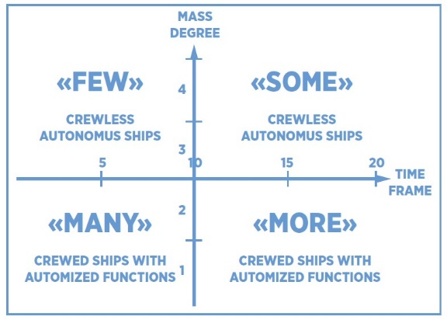
- Noting the distinction between automation and autonomy in the context of ship operations identified in IALA document Future of Maritime Autonomous Surface Ships (MASS) – Future Scenarios Regarding the Development and Evolution of MASS, IALA, 2024.
- Recognizes the evolution of automation and autonomy in the context of how ships are navigated, controlled, and operated over the next twenty years.
- Recognizes that operational requirements to manage ship traffic comprising a mix of conventional ships, automated and autonomous ships may not be adequately addressed in existing IALA standards and associated recommendations and guidelines, and that additional guidance is required to achieve a level of safety that is equivalent to that traditionally expected.
- Recognizes that certain operational functions associated with a ship’s operation may be controlled automatically/autonomously, either onboard or from a location, or locations remote from the ship.
- Recognizes that VTS often has more information and better situational awareness than an individual ship in the VTS area, regardless of its type.
- Recognizes that the operation of unmanned ships may be subject to national law by some countries and may not be permitted to VTS areas.
- Identifies additional desirable practices to interact and manage ship traffic comprising a mix of conventional, automated and autonomous ships insofar as they are not adequately or fully addressed in other IALA recommendations and guidelines.
- Provides a framework for VTS providers to adapt their processes and systems to ensure interaction continues to facilitate situation awareness both within the VTS and between VTSs, allied services, automated systems, Master or Master of a MASS.

Relationship to other documents
This Guideline should be read in conjunction with:
- IALA Standard 1040 Vessel Traffic Services - extensive guidance is provided on practices for the day-to-day operation of VTS, interacting with ship traffic and situational awareness in:
- VTS operations - Recommendation R0127 – VTS Operations, including:
- Guideline G1089 - Provision of a VTS.
- Guideline G1141 - Operational Procedures for Delivering VTS.
- Guideline G1110 - Use of Decision Support Tools for VTS Personnel.
- VTS Communications - Recommendation R1012 – VTS Communications. In particular:
- Guideline G1132 VTS Voice Communications and Phraseology.
- VTS Technologies - Recommendation R0128 - VTS Systems and Equipment. Specifically:
- Guideline G1111 - Establishing Functional and Performance Requirements for VTS Systems and Equipment.
- VTS Data and Information Management - Recommendation R0125 - VTS Portrayal. Specifically:
- Guideline G1177 - Portrayal of VTS Information.
- The Future of Maritime Autonomous Surface Ships (MASS) – Future Scenarios Regarding the Development and Evolution of MASS, IALA, 2024.
- IMO Road Map for Developing a Goal-Based Code for Maritime Autonomous Surface Ships (MASS), MSC 108/WP.7).
- IALA document Frequently Asked Questions - VTS with a Mix of Conventional, Automated and Autonomous Ships.

IMO regulatory framework

To ensure that the IMO regulatory framework for shipping keeps pace with rapidly evolving technological developments associated with MASS, IMO is preparing a goal-based instrument (the MASS Code). Specifically, the Code will:
- supplement other IMO instruments such as SOLAS; and
- provide a regulatory framework for the performance of remote control and autonomous operation of key functions, as applicable.
IMO aims to have a non-mandatory MASS Code adopted in the first half of 2025, with a mandatory Code entering into force on 1 January 2032.
Key milestones remaining to achieve this include:
MSC 109  Second half 2024 | MSC 110  First half 2025 | 1 July 2026 | 1 January 2032
Finalization and adoption of the new non-mandatory MASS Code  Finalization and approval of amendments to existing instruments necessary for the entry into force of the new instrument | Adoption of a mandatory MASS Code and associated Convention(s) giving effect to the new MASS Code | Deadline for adoption for entry into force date of 1 January 2028 | Entry into force of Mandatory Code

PROVISION OF VTS with A MIX OF CONVENTIONAL, AUTOMATED AND AUTONOMOUS SHIPS

IMO Resolution A.1158(32) Guidelines for Vessel Traffic Services states that “To achieve their purpose, VTS should provide information or issue advice, warnings and instructions, as deemed necessary”.
Implicit in achieving its purpose is the capability to:
- maintain situational awareness through:
- Information and reports from individual ships such as route information, course and speed, attributes, cargo, and communication methods.
- Information and reports from allied services associated with ship movements and other factors influencing the waterway.
- Sensors (for example radar, AIS).
- The use of decision support tools to manage identified risks, support VTS personnel providing timely and relevant information, monitor and manage ship traffic, and respond to developing unsafe situations.
- interact with individual ships as deemed necessary, on request from a ship or as a matter of procedure; and
- broadcast information to all ships.
Key considerations in the transition to a mix of VHF voice communication and digital communications include:
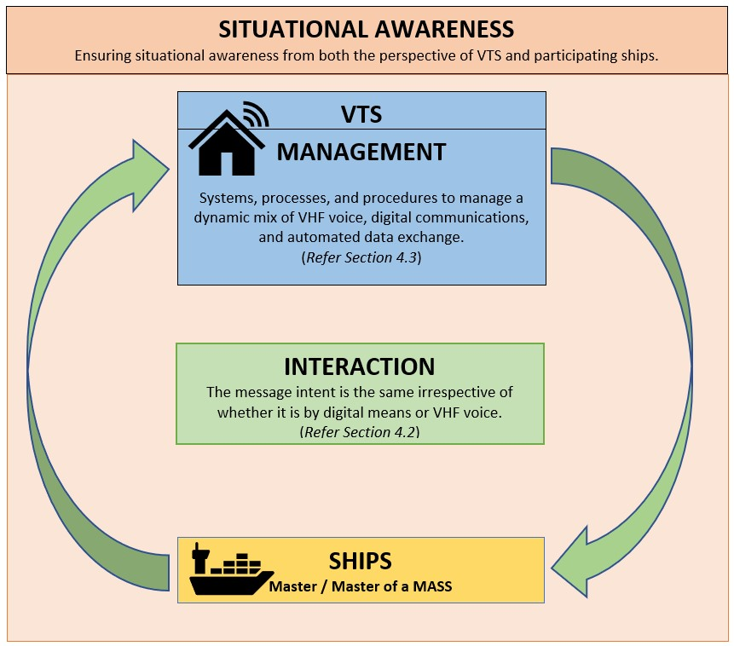
- Situational Awareness - ensuring situational awareness from both the perspective of VTS and participating ships (i.e., the Master, Master of a MASS) is achieved.
- Interaction – interaction between the VTS and participating ships is undertaken in a manner that the intent of messages conveyed to participating ships is the same, irrespective of whether the communications is by VHF voice, digital means, or both.
- Management - systems, processes, and procedures to ensure capability to interact by VHF voice, digital means, or both when managing ship traffic and responding to developing situations.
These considerations are interrelated and are critical to monitor and manage ship traffic comprising a mix of conventional, automated and autonomous ships to ensure the safety and efficiency of ship movements through the provision of information or issue advice, warnings, and instructions.

SITUATIONAL AWARENESS

A key factor in maintaining the safety and efficiency of navigation and support the protection of the environment within a VTS area is for both the VTS and individual ships (conventional, automated and autonomous) to maintain situational awareness.
The International Dictionary of Marine Aids to Navigation (IALA Dictionary) defines situational awareness as:
Situational awareness refers to the ability to identify, process, and comprehend the critical elements of information about what is happening in the surrounding environment at any given time.
It involves being aware of what is happening around you and understanding how that information, events, and your own actions will impact your goals and objectives, both immediately and in the near future.
Transitioning to interaction between VTS and ships being by both traditional VHF voice and digital means needs to be managed in a way that ensures situational awareness is effectively achieved from both the perspective of VTS and participating ships (i.e., the Master, Master of a MASS). Refer to Section 4.3.

VTS
In addition to sensors (e.g., radar, AIS, etc) to monitor transiting ships (position, course, etc), VTS has traditionally achieved situational awareness through:
- Voice communications to:
- Receive information and reports from individual ships such as route information, course and speed, attributes, cargo, and communication methods.
- Receive information and reports from allied services associated with ship movements and other factors influencing the traffic.
- Decision support tools to manage identified risks, support VTS personnel provide timely and relevant information, manage ship traffic, and respond to developing unsafe situations.
Key considerations to maintain situational awareness with a mix of conventional, automated, and autonomous ships include the capability to:
- Receive information and reports from participating ships as required by the VTS such as route information, course and speed, attributes, cargo, defects, and communication methods by VHF voice, digital means or both.
- Maintain real time awareness of and acknowledge information about:
- who is in command of the ship; and
- communications technology / medium to interact with the ship at all times.
With the increasing use of automation and autonomy in how ships are navigated, controlled, and operated, there will be a need to interact with ships by both by traditional VHF voice and digital means (See Section 4.2).

Participating Ships
Traditionally, VTS has contributed to the situational awareness of ship masters / bridge team by providing timely and relevant information on factors that may assist onboard decision-making through VHF Voice communications.
The use of simplex VHF channels has ensured that all participants are able to monitor exchanges between each other and the VTS centre. That is, both sides of any exchange are heard by all other ships.
It is vital to ensure all parties receive relevant information on factors that may influence onboard decision-making. Information should be in a timely manner with the increasing use of automation and autonomy in how ships are navigated, controlled, and operated and should require careful consideration (See Section 4.2).

INTERACTION

VTS and participating ships should have the capability to interact with each other by VHF voice, as well as digital means.

Introduction
Significantly, interaction by digital means will include system-to-system, person-to-system, and system-to-person communication.
This requires not just embracing individual technologies but implementing systems, processes, and procedures to manage dual communication means. All communication should be undertaken in a manner that ensures the interaction achieves the same meaning and intent to all participating ships and supports situational awareness.
With the transition to digital interaction, it is important to recognise the use of the term’s ‘interaction’ and ‘communication’, noting the IMO resolution for VTS uses the term ‘interaction’ in the definition of VTS. That is:
‘the capability to interact with vessel traffic and respond to developing situations’
It is accepted that:
- Communication - refers to the act of sharing information.
- Interaction - refers to acting in such a manner to affect the other.
The key difference between ‘communication’ and ‘interaction’ is that ‘interaction’ is a broader term while ‘communication’ is a part of the ‘interaction’.

VTS
VTS should have the capability to interact with participating ships by both traditional VHF voice and digital means to:
- facilitate clear, concise, and unambiguous interactions that are efficient, effective, and timely;
- ensure the same meaning and intent of interactions is communicated to all participating ships;
- acknowledge information and data received;
- receive reports or information from ships as required;
- provide ships with information on factors that may influence ship movements and assist “onboard” decision making; and
- issue advice, warnings, and instructions to manage traffic and respond to developing situations.
The capability should include interaction activities such as those described in Annex A.

Participating Ships
Participating ships should, as stated in IMO Resolution A1158(32), provide reports or information required by VTS and to take into account the information provided, or advice, warnings and instructions issued by VTS.
Participating ships should therefore have the capability to interact both by traditional VHF voice and digital means with the VTS.

MANAGING A MIX OF CONVENTIONAL, AUTOMATED AND AUTONOMOUS SHIPS

The increasing use of automation and autonomy in how ships are navigated, controlled, and operated, will probably require VTS to have the capabilities to interact with ships by both VHF voice and digital means to monitor and manage ship traffic and respond to developing situations.

VTS
Key considerations for VTS in interacting with a mix of mix of conventional, automated and autonomous ships include:
- System Capabilities - to support interaction and situational awareness. This includes receiving, processing and sending information and data
- Managing a mix of VHF voice, digital communications, and automated data exchange, including:
  - Interacting by both conventional means and digital means with individual ships
  - Managing interaction with one or more ROC’s.
- Capability to receive reports and information from ships digitally and in a manner that is assimilated within the VTS system and assimilated within the VTS operational picture. This should also include sharing this with relevant stakeholders.
- Knowing when a ship may be controlled from more than one ROC.
- Capability to identify if the ship is conventional, automated or autonomous.
- Capability to receive and display information received from a ROC where there is a communications failure between the ship and the ROC.
- The Decision Support Tool should have the capability to display the command status of ships at any point in time (e.g. Master, Master of a MASS or ROC), and the associated communications means (voice, digital).
- Processes and Procedures - to support interaction, situational awareness, and system capabilities.
- Managing interaction to and from participating ships to ensure the message and intent is delivered to all ships as would be the case by VHF voice. This may include interacting both by voice and in parallel by digital means.

Emergency Response for MASS
Consideration should be given to ensuring internal emergency response procedures reflect the mix of conventional, automated and autonomous vessels.

DEFINITIONS

The definitions of terms used in this Guideline can be found in the International Dictionary of Marine Aids to Navigation (IALA Dictionary) and were checked as correct at the time of going to print. Where conflict arises, the IALA Dictionary should be considered as the authoritative source of definitions used in IALA documents.

Abbreviations

MASS Maritime Autonomous Surface Ships
ROC Remote Operation Centre
VTS Vessel traffic Services

The traditional concept of the Master being in command of a vessel is changing with the advent of MASS. For example, the draft MASS Code refers to: 4.28 Master/master of a MASS Master [of a MASS] means the person having command of a MASS ship (STCW) Remote Master Remote Master means a master who is in a Remote Operations Centre outside the MASS 4.40 Remote Master Remote Master means a master who is in a Remote Operations Centre outside the MASS

