Input paper: VTS57-9.1.1

Input paper for the following Committee(s): check as appropriate Purpose of paper:
□ ARM □ ENG □ PAP X Input
□ ENAV X VTS □ Information

Agenda item 9.1
Technical Domain / Task Number ² 2.5.2b
Author(s) / Submitter(s) China Maritime Safety Administration

Proposals on the “Service Specification for VTS - Vessel Route Exchange Edition 0.3”

Summary
This proposal proposes revisions to Service Specification for VTS - Vessel Route Exchange Edition 0.3 from the aspects of consistency analysis of relevant industrial standards, such as S-421, optimization and improvement of use cases in the VTS and operation service dimensions, and editorial changes.

Purpose of the document
The purpose of this document is to provide input document for the VTS committee to update the Service Specification for VTS - Vessel Route Exchange Edition 0.3.

Related documents
[1] VTS56-6.1.1 VTS Task Plan 2023-2027
[2] VTS56 intersessional meeting Draft of Service Specification for VTS - Vessel Route Exchange Edition 0.3(working paper)
[3] VTS53-6.3.2 Development of technical service specifications for digital data exchange between VTS and other entities - primarily ships
[4] VTS54-9.1.3 Proposals on the New Task of "Developing Technical Service Specifications for Digital Data Exchange between VTS and Other Entities - Primarily Ships"
[5] VTS55-9.1.1 Proposals on the “Service Specification for VTS Traffic Clearance Service_V1.0”
[6] VTS56-9.1.1 Proposal on the "Service Specification for VTS Traffic Clearance Service Edition 1.3” and "Service design"
[7] VTS56-12.3.3 Liaison Note to ARM on Roadmap for the S-200 Implementation Decade (2024-2034)

Background
2.1 The IALA VTS Committee Work Plan 2023-2027 raises the task” Development of technical service specifications for digital data exchange between VTS and other entities - primarily ships” (task 2.5.2), and aims to finalize the pioneer technical service specifications before VTS57. Service Specification for VTS Traffic Clearance Edition 1.4, Service Design for VTS Traffic Clearance using SECOM Edition 1.1, and Draft of Service Specification for VTS - Vessel Route Exchange Edition 0.3(working paper) had been finalized at VTS56 and the intersessional meeting. Task 2.5.2 indicated that all the content of the Service Specifications would be open for discussion and welcome suggestions for revision.
2.2 As the co-sponsor of the new work task proposal (VTS 53-6.3.2) at VTS53, China MSA continued to submit " Proposals on the New Work Task of Developing Technical Service Specifications for Digital Data Exchange between VTS and Other Entities (VTS54 9.1.3) " and " Draft of Service Specification for digital VTS Anchorage Assignment Service_V0.5" (VTS54 8.3.2 ) at VTS54, “Proposals on the Service Specification for VTS Traffic Clearance Service_V1.0” (VTS55-9.1.1) at VTS55, and “Proposals on the Service Specification for VTS Traffic Clearance Service_V1.3 and Service design" (VTS56-9.1.1) at VTS56.

Discussion

Proposals on updating use cases for VTS perspective
- According to VTS56-9.1.3 Liaison letter from IEC TC80-WG17 on the revision of the Route Plan (S-421, IEC 63173-1) and its exchange, IEC TC80/WG17 provides the guidelines for the shipborne user perspective. The guidelines for VTS (shore-side) perspective may be provided by IALA VTS committee.
- China MSA has reviewed the existing use cases of the service specification from VTS perspective, and proposes to modify and update them as follows:
- Example of modification to User case 1 “Initial Sharing of the route from Vessel to VTS”:
  - Delete the contents in the typical sequence that are relevant to the ship-side perspective, i.e. “‘1. the route is planned in the planning station by the mariner; ‘ and ‘2.Planning station crosschecks the route and upload route to the ECDIS/ECS. ‘”
  - Update the content of typical sequence 3 to VTS perspective, i.e. “3.The on-board systems should send the route to the “Route Exchange Service” before departure, but the route must be shared at latest according to local rules should be updated as ” The 'route exchange service' receives the shared routes from the on-board systems and automatically performs validity checks such as route timeliness and compliance”;
  - Update the flowchart according to the new typical l sequence, delete the roles related to ship-side such as “Marine”, “Planning station”, “ECDIS”, etc., adjust the operational description of the use cases according to the VTS perspective, simplify the operation details of the ship-side, and avoid the duplication of or even confusion and inconsistency with the contents related to the IEC TC80/WG17 Ship-side Route Exchange Operation Guidelines as far as possible.
It is recommended that use cases 2-6 be updated with reference to use case1, “Initial Sharing of the route from Vessel to VTS.”

Proposals on updating use cases for operational service perspective
- In accordance with VTS56-12.3.3, Liaison Note to ARM on Roadmap for the S-200 Implementation Decade (2024-2034), the VTS Committee created the Technical Services based on operational input, but those are a pre-requisite to starting the work on the Technical Services, and not something they would create as a separate service layer in the development process. They understood the service levels are defined by IMO in MSC.467(101), those are Maritime Services, Technical Services and Product Specifications. Adding operational service descriptions as a new service level will complicate the whole process for the development of S-200 services and relevant specifications. However, a new operational service level had been added into the VTS Technical Services use cases Annex (below) updated at the December intersession meeting in 2024, and five types of use cases for route exchange operational services are proposed, i.e., route reference service, route crosscheck service, route monitoring service, route reporting service, and slot management service.
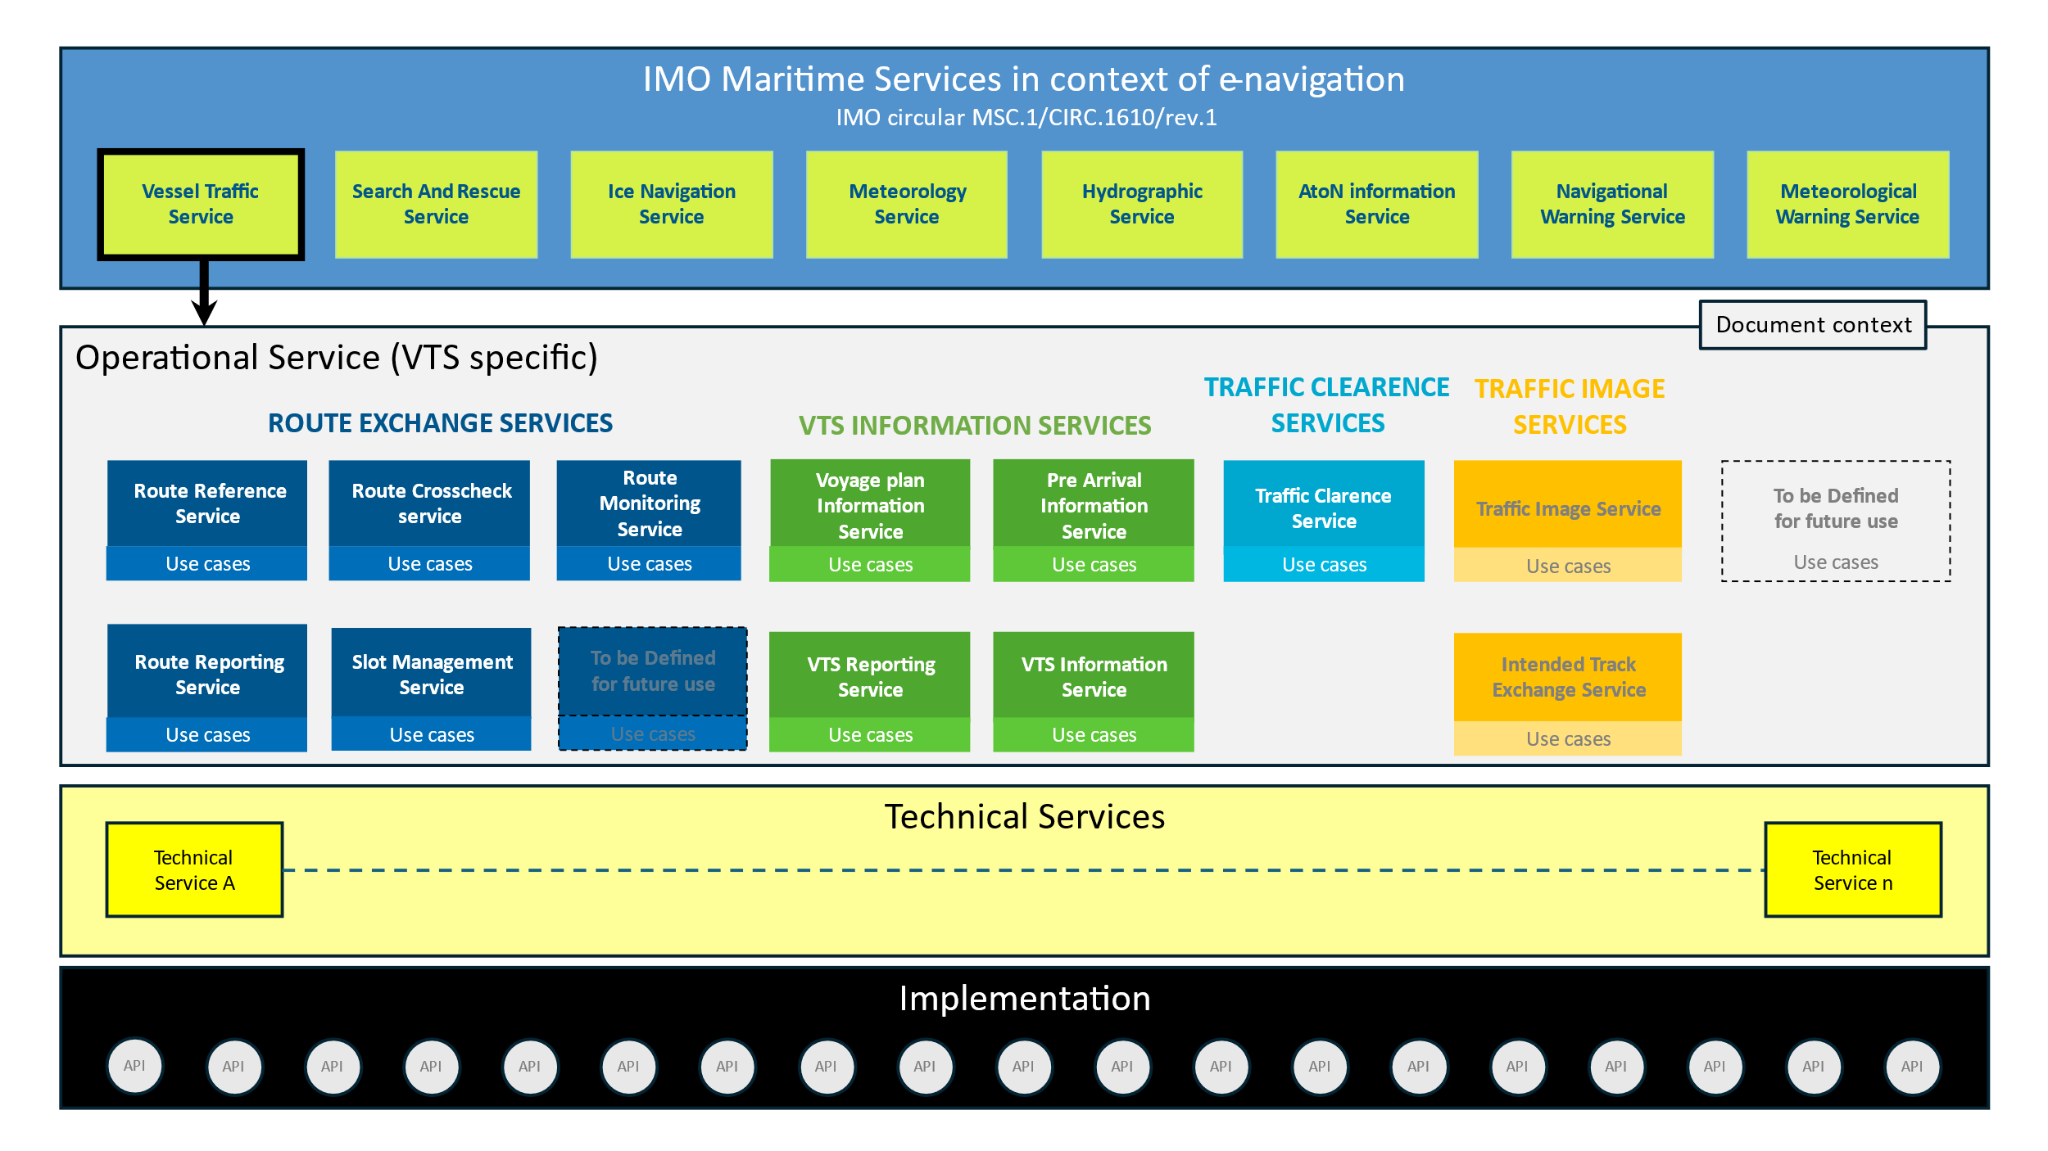
- The working paper has proposed 10 use cases, including Initial Sharing of the route from Vessel to VTS, VTS gives route recommendation to vessel within a geographically defined area, VTS REQUESTS ROUTE from vessel, Vessel´s route changes, Vessel does not arrive to VTS area as planned, VTS approves the route, etc. Only “route crosscheck” operational level service had been referenced.
- Considering that operational level services such as route reference service, route crosscheck service, route monitoring service, route reporting service, and slot management service are carried through the typical sequence of each use case, e.g. “VTS gives route recommendation to vessel within a geographically defined area” would refer to the route reference service, and use case of “Vessel´s route changes” would refer to the route monitoring service. It is recommended to update the descriptions of all the use cases with reference to the latest operational service level according to the intersessional meeting on December 19, 2024.

Proposals on updating functional requirements and key attributes according to IEC S-421
- With reference to the descriptions of S-421 7.2.8 on turn radius and leg of waypoints, it is recommended the description of radius in RESF007 of this working paper, i.e. “All waypoints must have a non-zero turn radius”, should be added “Except for the first and last waypoints, which can be zero (0,0)”, in order to take into account the special case of the first and last waypoints.
- With reference to S-421, the description of ETA in use cases 3.1.2 “Changing the ETA to a specific waypoint” might inaccurate, and the nautical practice is likely to change the attributes such as ETD or SOG, etc.as well. It is recommended that ETA should be changed to “schedule” in the working paper.
- With reference to S-421, it is recommended that this working paper should update the descriptions of the functional requirements RESF001, RESF002 and RESF005 as follows:
  - It is recommended to update the following four descriptions of “receive or send route” to “receive or send route/update route/route cancellation” in RESF001;
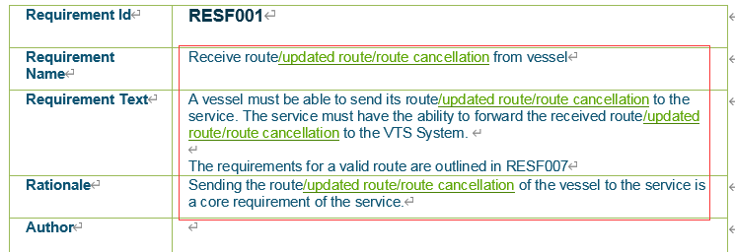
  - It is recommended to update the following three descriptions of “recommendation” to “recommendation or/and comments” in RESF002;
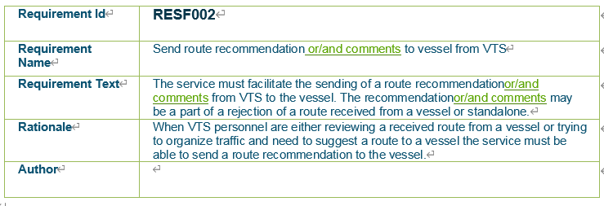
  - It is recommended to add the following four descriptions in RESF005;
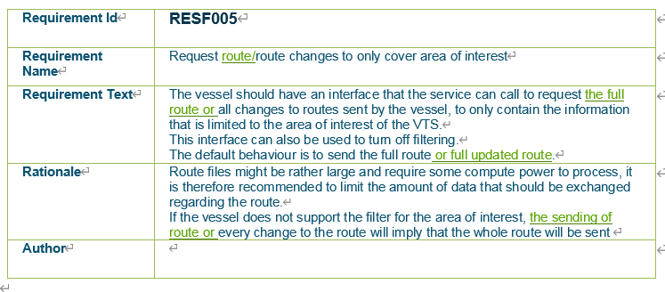

Proposals on editorial changes
- China MSA had reviewed the working paper and recommended the following editorial changes to the text:
  - Version 0.2 should be updated to 0.3 in “2 Service Identification”;
  - “It its envisioned” should be updated to “It is envisioned” in 3.1 User cases;
  - “service specification” should be updated to “Service Specification”, according to the appendix A of the technical service specification template of the October 2024 output G1128 version 1.6.
- The following updates are proposed for the “7 references”:
  - G1128 has been updated to version 1.6 at the October 2024 DTEC3;
  - It is recommended to add references to IMO MSC.530(106)REV.1 and MSC.1CIRC.1610REV.1.
- “RTA/RTD” and “UUID” in “8.1 Acronyms” are not found in the body of the working paper, they are proposed to be deleted.

References
- IALA G1128 Revised G1128 Specification of e-Navigation Technical Services Ed1.6
- IMO Resolution MSC.530(106) REV.1 ECDIS Performance Standard
- IMO MSC.1CIRC.1610REV.1 DESCRIPTIONS OF MARITIME SERVICES IN THE CONTEXT OF E-NAVIGATION
- IEC 63173-1:2021 Maritime navigation and radio communication equipment and systems – Data interface – Part 1: S-421 route plan based on S-100

Action requested of the Committee
The Committee is requested to consider the proposals in this document and take actions as appropriate.

Input document number, to be assigned by the Committee Secretary
Leave open if uncertain

