Input paper: VTS57-9.1.2

Input paper for the following Committee(s): check as appropriate Purpose of paper:
□ ARM □ ENG □ PAP X Input
□ ENAV X VTS □ Information

Agenda item 9.1
Technical Domain / Task Number ² 2.5.2a
Author(s) / Submitter(s) China Maritime Safety Administration

Proposals on the “Service Specification for VTS Traffic Clearance Edition 1.4”

Summary
This proposal proposes revisions to Service Specification for VTS Traffic Clearance Edition 1.4 from the aspects of ETA/ETD related expressions modification and references update.

1.1 Purpose of the document
The purpose of this document is to provide input for the VTS committee to update the Service Specification for VTS Traffic Clearance Edition 1.4.

1.2 Related documents
[1] VTS56-6.1.1 VTS Task Plan 2023-2027
[2] VTS53-6.3.2 Development of technical service specifications for digital data exchange between VTS and other entities - primarily ships
[3] VTS54-9.1.3 Proposals on the New Task of "Developing Technical Service Specifications for Digital Data Exchange between VTS and Other Entities - Primarily Ships"
[4] VTS55-9.1.1 Proposals on the “Service Specification for VTS Traffic Clearance Service_V1.0”
[5] VTS56-9.1.1 Proposal on the "Service Specification for VTS Traffic Clearance Service Edition 1.3” and "Service design"

Background
2.1 The IALA VTS Committee Work Plan 2023-2027 raises the task” Development of technical service specifications for digital data exchange between VTS and other entities - primarily ships” (task 2.5.2), and aims to finalize the pioneer technical service specifications before VTS57. Service Specification for VTS Traffic Clearance Edition 1.4, Service Design for VTS Traffic Clearance using SECOM Edition 1.1, and Draft of Service Specification for VTS - Vessel Route Exchange Edition 0.3(working paper) had been finalized at VTS56 and the intersessional meeting. Task 2.5.2 indicated that all the content of the Service Specifications would be open for discussion and welcome suggestions for revision.
2.2 As the co-sponsor of the new work task proposal (VTS 53-6.3.2) at VTS53, China MSA continued to submit " Proposals on the New Work Task of Developing Technical Service Specifications for Digital Data Exchange between VTS and Other Entities " (VTS54 9.1.3) and " Draft of Service Specification for digital VTS Anchorage Assignment Service_V0.5" (VTS54 8.3.2 ) at VTS54, “Proposals on the Service Specification for VTS Traffic Clearance Service_V1.0” (VTS55-9.1.1) at VTS55, and “Proposals on the Service Specification for VTS Traffic Clearance Service_V1.3 and Service design" (VTS56-9.1.1) at VTS56.

Discussion

3.1 Standards for timestamps (aligned with IMO Compendium)
- Definitions for "Estimated/Requested/Planned/Actual Time of Departure from a specified location (Abbreviations: ETD, RTD, PTD, ATD from a specified location)" are listed in IMO Compendium by data numbers: IMO0066, IMO0236, IMO0237, IMO0065.

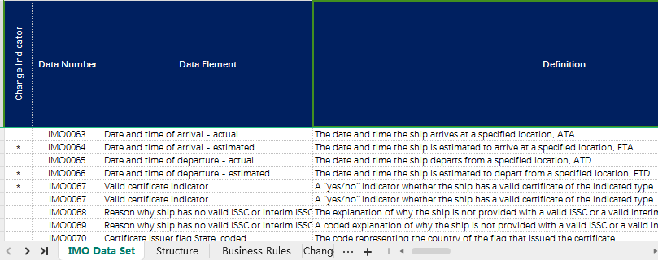
- "Estimated/Requested/Planned/Actual Time of Arrival at a specified location (Abbreviations: ETA, RTA, PTA, ATA at a specified location)" are listed in IMO Compendium by data numbers: IMO0064, IMO0234, IMO0235, IMO0063, such as below:
  - Date and time of arrival – estimated: The date and time the ship is estimated to arrive at a specified location, ETA. (IMO 0064)
  - Date and time of arrival - requested: The date and time the ship is requested to arrive at a specified location, RTA. (IMO 0234)
  - Date and time of arrival – planned: The date and time the ship plans to arrive at a specific location, PTA. (IMO 0235)
  - Date and time of arrival – actual: The date and time the ship arrives at a specified location, ATA. (IMO 0063)

3.2 Standards for timestamps (aligned with IEC S-421)
- IEC S-421 standard lists the RouteScheduleElement information type, which includes: two mandatory attributes of routeScheduleElementETD and routeSchedulelElementETA, and four time uncertainty window optional attributes (see Table 18 and Table B.27): routeScheduleElementETDWindowBefore, routeScheduleElementETDWindowAfter, routeScheduleElementETAWindowBefore and routeScheduleElementETAWindowAfter. The four optional attributes need to be set (7.3.5)，if the values of the two mandatory attributes routeScheduleElementETD and routeSchedulelElementETA are changed.

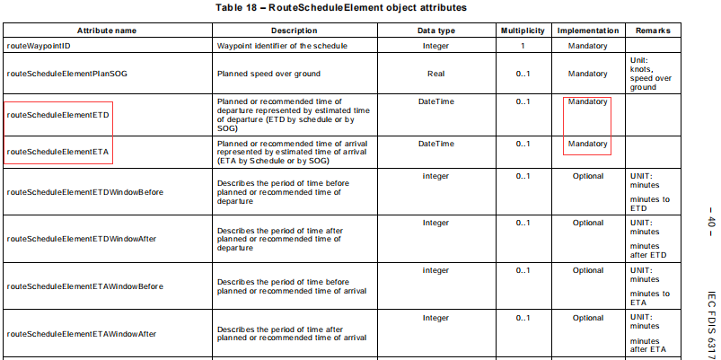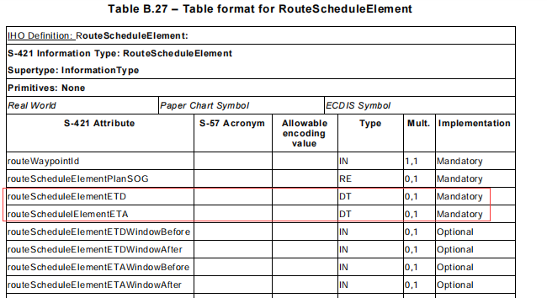
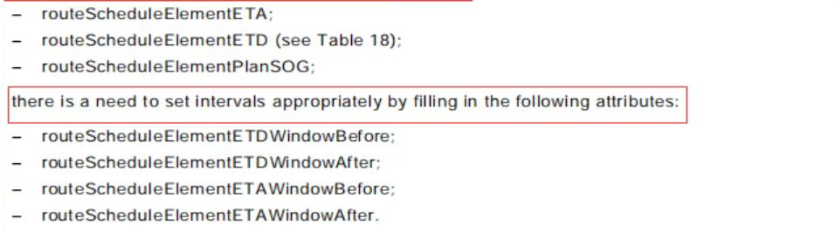
- The RouteScheduleElement information type element can be used as a sub-element of the RouteScheduleManual, RouteScheduleCalculated and RouteScheduleRecommended composite information elements. The routeScheduleElementETD is mandatory for “Planned time of arrival from ship”, and routeSchedulelElementETA is mandatory for “Recommended time of arrival to ship”, as shown in the following figure (Table A.1).
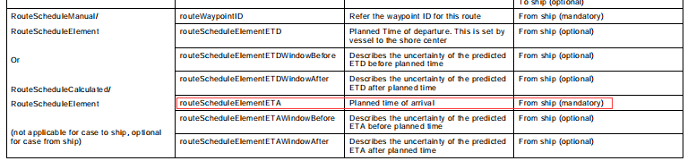
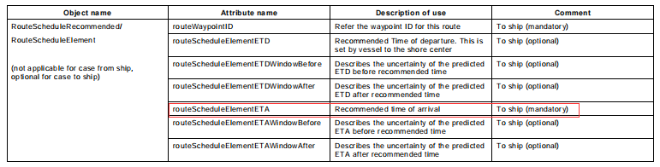
- All of the above information type elements have been registered in the IHO Geographic Information(GI) Registry as early as 2022, the screenshot below shows the registration information for the routeScheduleElementETD mandatory attribute, which is officially defined as “Planned or recommended time of departure represented by estimated time of departure (ETD by schedule or by SOG”(Table A.11 – Objects and attributes used by fleet route planning)”.
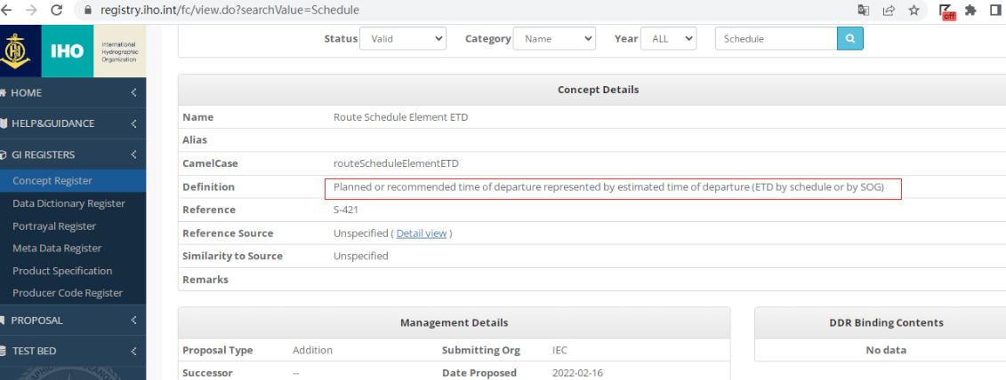

3.3 Content and technical feasibility of time-stamp exchange in the Service Specification
- According to “3 Operational Context”, For effective Traffic Clearance Service, VTS requires the knowledge of vessels intentions. The primary means to share vessels ETA and ETD would be the sharing of vessels route plans, which always includes a schedule. If the vessel is not capable of sharing a route plan, the alternative mean would be sharing only ETA and ETD and destination of vessel. It should be ensured that the times in the different systems are aligned. But ECDIS PS does not support the dynamic exchange and modification of ETA/ETD timestamps, which limits the use of only timestamp-based systems to back bridge systems on-board. this service specification reminds“that in the actual messages there is no concept of planned, estimated or requested time. The timestamp is passed in a more neutral effectiveTime field with the context of the time being conveyed by the subjectOf Communication field and the type of request in the messageStatus field.”
- In accordance with IMO MSC108, NCSR11 and MSC109, IMO has placed the development of operational guidelines for route exchanges and real-time exchange of ECDIS-based S-100 series data on the committee's work item, as shown below.
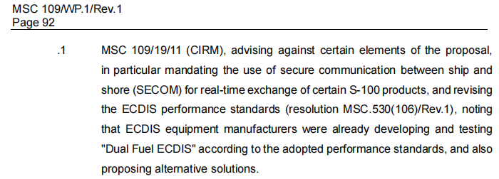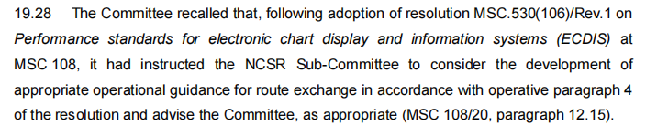

3.4 Analysis
- IEC S-421 states that the object RouteWaypoints shall have at least two RouteWaypoints including starting point and destination point ( Table B.17). It is also clear that “routeScheduleElementETA” is “Mandatory for the schedule element of the last waypoint”;“routeScheduleElementETD” is ‘Mandatory for the schedule element of the first waypoint’( Table A.11). “routeScheduleElementETD” is mandatory for “Planned time of arrival from ship”, and “routeSchedulelElementETA” is mandatory for “Recommended time of arrival to ship”( Table 18- RouteScheduleElement object attributes ).
- Considering ECDIS and other on-board system do not support the technical implementation of a single ETA/ETD timestamp exchange outside of the S-421 standard, and comparing the definitions of ETD/RTD at a specified location and ETA/RTA at a specified location in the IMO Compendium, the mandatory attribute of RouteScheduleManual/RouteScheduleElement/RouteScheduleElementETA in the IEC S-421 standard can be used as a data model and technical implementation of ETA at a specified location in the IMO Compendium. RouteScheduleRecommended/RouteScheduleElement/ routeScheduleElementETA can be used as data model and technical implementation for RTA at a specified location in IMO Compendium. Similarly, RouteScheduleManual/RouteScheduleElement/routeScheduleElementETD and RouteScheduleRecommended/RouteScheduleElement/routeScheduleElementETD in the IEC S-421 standard can be used as data models for ETD/RTD at a specified location in the IMO Compendium. And the optional attributes of the four time uncertainty windows, namely, routeScheduleElement ETDWindowBefore, routeScheduleElementETDWindowAfter, routeScheduleElementETAWindow Before, routeScheduleElementETAWindowAfter can be used as a more scientific supporting technical implementation method.

3.5 Proposal
- In summary, it is proposed that the ETA/RTA/ETD/RTD in TCSF001/TCSF002/TCSF003/TCSF004/ TCSF005/TCSF006/TCSF007 in the functional requirements of 3.2.1 of the service specification should be replaced by routeScheduleElementETA, routeScheduleElementETD and its upper level composite element instead, where the example before and after the modification of TCSF001 is as follows:
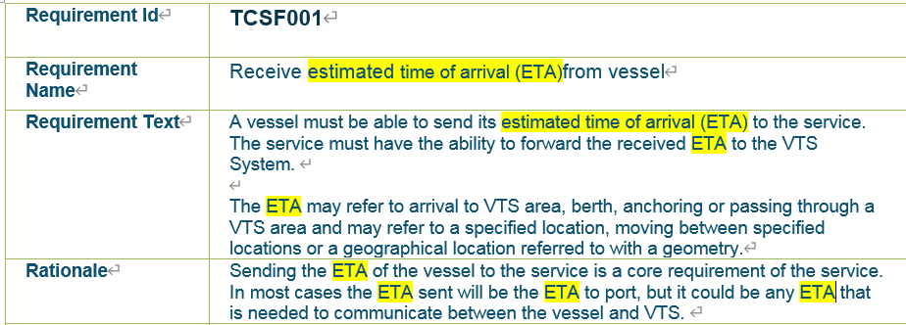
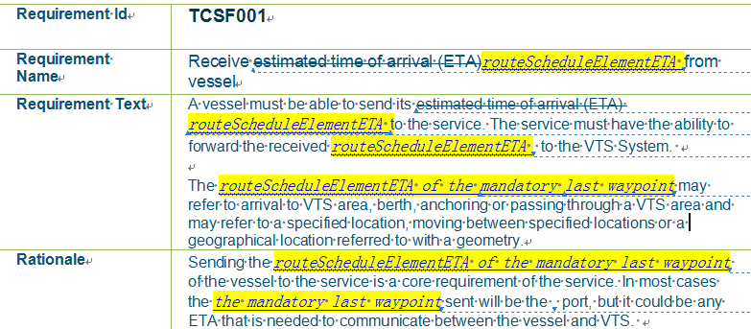
- In addition, it is recommended that
  - Review the need to replace the other ETA/RTA/ETD/RTDs of this Service Specification with routeScheduleElementETA, routeScheduleElementETD and their upper level composite element in order to be more in line with the Specification of e-Navigation Technical Services;
  - Update the following content of the “3 Operational Context” in accordance with the latest version of the IMO ECDIS Performance Standard and its subsequent work plan:
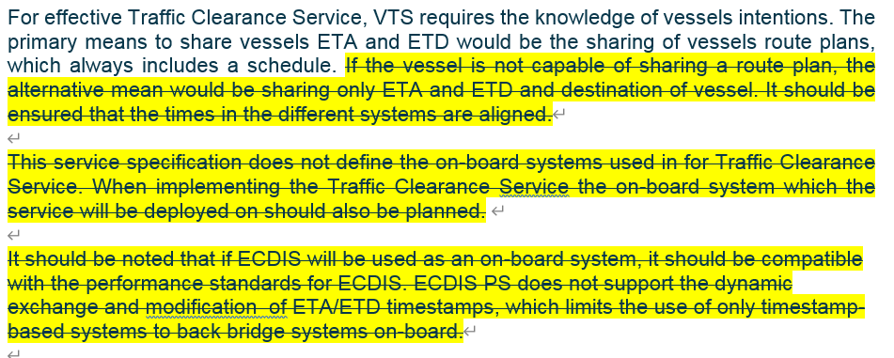
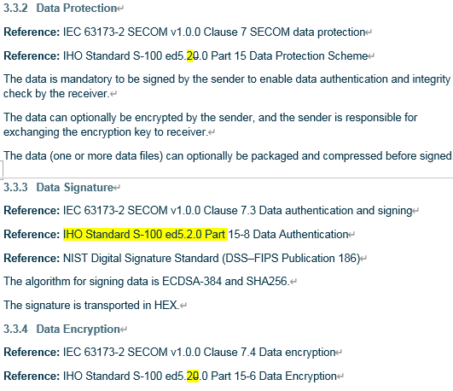
- Finally, the following updates to the “7 references” are recommended:
  - G1128 has been updated to version 1.6 at the October 2024 DTEC3;
  - It is recommended to add references to MSC 108 (MSC.530(106) REV.1) and IEC S-421 standard.

References
- IALA G1128 Revised G1128 Specification of e-Navigation Technical Services Ed1.6
- IMO Resolution MSC.530(106) REV.1 ECDIS Performance Standard
- IMO MSC.1CIRC.1610 REV.1 DESCRIPTIONS OF MARITIME SERVICES IN THE CONTEXT OF E-NAVIGATION
- IEC 63173-1:2021 Maritime navigation and radio communication equipment and systems – Data interface – Part 1: S-421 route plan based on S-100

Action requested of the Committee
The Committee is requested to consider the proposals in this document and take actions as appropriate.

Input document number, to be assigned by the Committee Secretary
Leave open if uncertain

