ialA Technical service

SSXXXX
Service Specification for VTS Under keEl clearance Service


Edition 0.1
September 2025

urn:mrn:iala:techsvc:ssXXXX:0.1

Date | Details | Approval
September 2025 | Initial draft for input to VTS58

1 introduction 5
1.1 Purpose 5
1.2 Intended readership 5
1.3 Input from other sources 5
2 Service Identification 6
3 Operational context 7
3.1 Use cases for VTS UKC Information Service 7
3.1.1 Use case 1 – Vessel requests UKC maximum allowed draught information from a VTS area (pre-plan) 9
3.1.2 Use case 2 – Vessel requests UKC tidal window information from a VTS area (pre-plan) 10
3.1.3 Use case 3 – Vessel requests UKC information from a VTS (actual plan) 10
3.1.4 Use case 4 – Vessel requests UKC information from a VTS (actual plan) after a route change 11
3.1.5 Use case 5 – Vessel provides detailed stability parameters to get a detailed UKC information from a VTS (actual plan) 11
3.1.6 Use case 2 – Vessel cancels subscription 12
3.2 Data flows 13
3.3 Functional and non-functional requirements 13
3.3.1 Functional requirements 13
3.3.2 Non-functional requirements 13
3.4 Other constraints 14
3.4.1 Relevant Industrial Standards 14
3.4.2 Operational nodes 16
4 Service Overview 17
4.1 Logical operations 17
4.1.1 Search Service Registry 18
4.1.2 Service registry updates 19
4.1.3 System status 19
4.1.4 Send and receive acknowledgment 19
4.1.5 Send message 19
4.1.6 Receive message 19
4.1.7 Subscribe to information 19
4.1.8 Discovering service functionality 19
4.2 Logical parameters 19
4.2.1 Callback 19
4.2.2 Geometry 20
4.2.3 Message identifier 20
4.2.4 Service discovery 20
5 Service Data Model 21
5.1 Container type 21
5.2 End-to-end verification of data 21
5.3 Message markers 21
5.4 Coordinate systems 22
6 Service Dynamic Behaviour 23
6.1 Acknowledgement messages 23
6.2 Service discovery 23
7 Definitions 25
8 Abbreviations 26
9 References 27

List of Tables
Table 1 Operational Nodes 17
Table 2 Logical interfaces 18

List of Figures
Figure 1 High-level view of VTS Information use cases 8
Figure 2 VTS Information Business Process 14
Figure 3 Abstract object model of the VTS information data 22
Figure 16 Service discovery flow 25

introduction

This document was produced as part of the work of IALA VTS task group on development of technical service specifications for VTS. The document is structured according to the IALA Guideline G1128 The Specification of e-Navigation Technical Services [1].

Purpose

The purpose of this Service Specification is to provide an overview of the information that VTS may provide or request from vessels via VTS Information in a technology-independent way, according to the guidelines given in G1128. It describes a well-defined baseline of the service by clearly identifying the service version.
The aim is to document the key aspects of the VTS Information Service at the logical level, including:
- the operational and business context of the service:
- requirements for the service (e.g., information exchange requirements);
- involved nodes: which operational components provide/consume the service;
- operational activities supported by the service; and
- relation of the service to other services.
- the service description:
- service use cases;
- service operational sequence;
- logical operations;
- logical data model; and
- dynamic behaviour.

Intended readership

This Service Specification is intended to be read by service architects, system engineers and developers in charge of designing and developing an instance of the VTS Information Service.
Furthermore, this Service Specification is intended to be read by enterprise architects, service architects, information architects, system engineers and developers in pursuing architecting, designing and development activities of other related services.

Input from other sources

N/A

Service Identification

This section provides a unique identification of the Service and describes where the Service is in the engineering lifecycle.

Name | VTS UKC Service
ID | urn:mrn:iala:techsvc:ssXXXX:0.1
Version | 0.1
Description | The VTS UKC Information Service specification describes a standardized service implementing the communication between ship and VTS used to request and deliver UKC information from vessel to VTS (and vice versa) in a standardized format.
Keywords | VTS, MS1, UKC Service, Ship Traffic Management, S-212, S-129, S-421
Architect(s)
Status | Draft

Operational context

- The aim of a VTS UKC Information Service is to contribute to the safe and efficient navigation of vessels by delivering relevant information from VTS perspective. The service can be implemented to deliver all the UKC information, or it can fulfil and/or enrich the data from other S-100 services. VTS UKC Service contains structured messages. The content of the message field is structured or unstructured. All messages must start with message markers information, request, question or answer. The message can be sent to one or multiple vessels.
- VTS providers should define which UKC information will be provided via VTS UKC Information Service based on for example risk assessment.

The VTS UKC Service is intended to contribute to the safe and efficient navigation of vessels by delivering UKC information that VTS determines is relevant. The aim is to reduce the amount of broadcasted information via VHF to all vessels in the area and utilize digital tools to deliver timely and relevant UKC information to relevant parties.

In addition to delivering information, VTS can use the service to request information from vessels that is not covered in other reporting requirements.

WG1 to contribute more on operational context, could include text on e.g.
- Information delivered,
- What is a request
- What is a question
- What is an answer
There are no requirements that a VTS must use the UKC information service for any given use. All of the above are examples and a VTS may choose to not use VTS UKC Information Service in day-to-day operations.

Use cases for VTS UKC Information Service

The use cases below describe an attempt of describing how and what types of uses there may be for the service. Not all the use cases are expected to be relevant to all VTSs and service implementations may ignore any of the use cases deemed unnecessary.
Consumer implementations must implement support for all of the use cases.
In all use cases the VTS system must be capable of receiving information from the service on the delivery status of the message to the vessel.

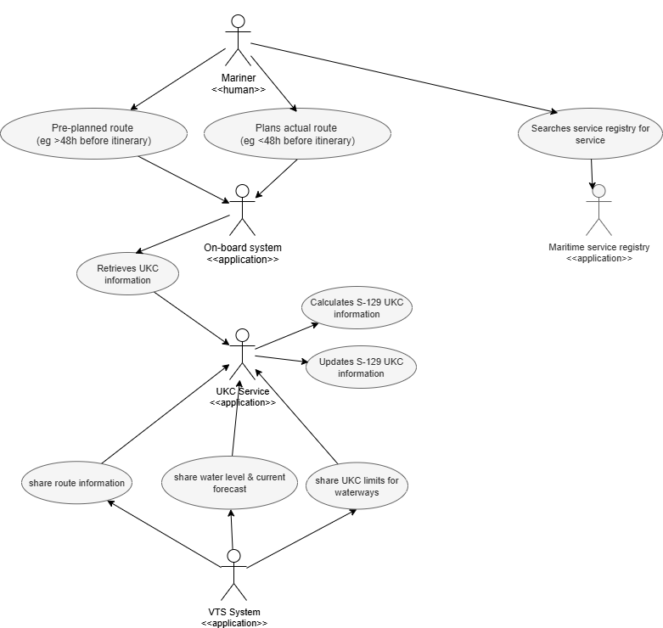

Figure 1 High-level view of VTS UKC information use cases

S-129 datasets are typically intended to be overlays to S-101 ENC and always displayed with S-101 ENC data in the background. Systems that support the display of S-129 datasets should provide the user with simple functions to turn the display of S-129 datasets on and off.
Optionally, S-129 datasets can be viewed as overlays to a combination of S-101 ENC and S-102 (Bathymetric Surface) datasets, with S-104 (Water Level Information for Surface Navigation) datasets incorporated where applicable. The same requirements to allow the user to easily toggle the S-129 dataset on/off persist.
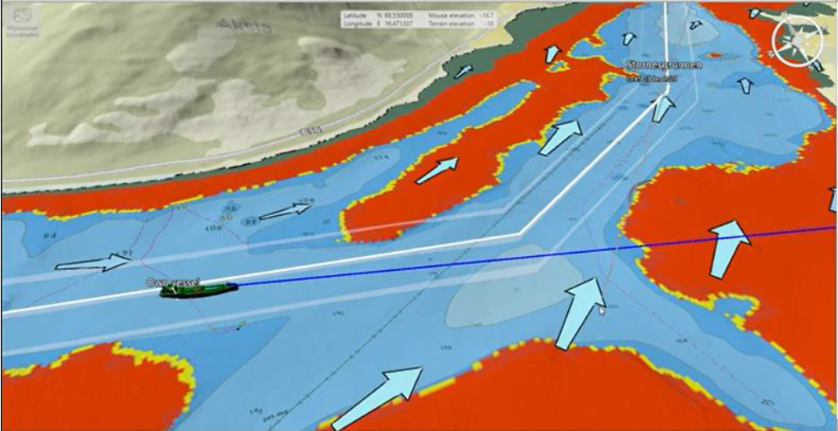
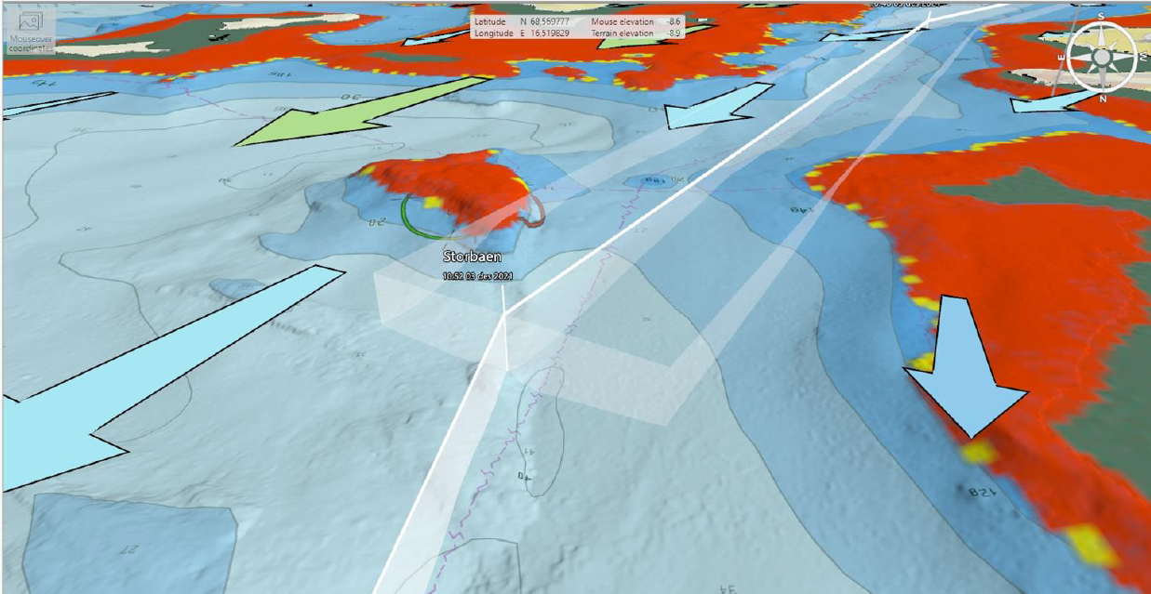

Use case 1 – Vessel requests UKC maximum allowed draught information from a VTS area (pre-plan)
Description – Vessel fetches pre-planning UKC information from VTS. In the pre-planning use case, a ship requests a maximum allowed draught for an arrival/departure port or waterway, typically days or weeks in advance. In this case, the VTS will compute a maximum allowed draught based on predicted tides, to forecast navigable depths, including safety/manoeuvrability margins, speed and squat predictions (default value), other forecast environmental conditions and the route provided by the vessel. In this scenario, the VTS UKC Service could return a single Pre-plan dataset, and generally no updates are required.
Typical sequence:
- The vessel sends the route to the UKC service, with at least waypoints and a schedule
- The UKC service calculates the pre-plan by using route, waterlevel (astronomical) and UKC waterway limits
- UKC service sends UKC pre-plan including:
  - UKC purpose: pre-plan
  - Under Keel Clearance Calculation Requested: Max allowed draught
  - Geometry for non-navigable areas [optional]
  - Geometry for almost non navigable areas, including distance above UKC limit [optional]

Use case 2 – Vessel requests UKC tidal window information from a VTS area (pre-plan)
Description – Vessel fetches pre-planning UKC information from VTS. In the pre-planning use case, a ship requests a tidal window for an arrival/departure port or waterway, typically days or weeks in advance. In this case, the VTS will compute the tidal window based on predicted tides, expected vessel maximum draught, to forecast navigable depths, including safety/manoeuvrability margins, speed and squat predictions (default value), other forecast environmental conditions and the route provided by the vessel. In this scenario, the VTS UKC Service could return a single Pre-plan dataset, and generally no updates are required.
Typical sequence:
- The vessel sends the route to the UKC service, with at least the maximum draught, waypoints and a schedule
- Vessel requests tidal window for the acknowledged route
- VTS sends UKC pre-plan including:
  - UKC purpose: pre-plan
  - UKC time window with fixed time ranges start and end global time tidal windows
  - Geometry for non-navigable areas [optional]
  - Geometry for almost non navigable areas, including distance above UKC limit [optional]

Use case 3 – Vessel subscribes to UKC information from a VTS (actual plan)
Description – Actual Plan datasets are produced closer to the arrival/departure (for example, 48-24 hours prior) and provide the mariner (crew and/or pilot) with a more detailed passage plan. This plan is generated from more frequent and/or precise weather forecasts/observations. Closer to the time of a ship entering the VTC Operational Area, the ship will need a more detailed UKC plan. This Actual Plan usually considers more up to date information and will typically need to be updated more frequently. In this case, the non-navigable and almost non-navigable areas, any tidal windows (via Control Points), and some metadata will have changed. Depending on the variability of the met-ocean conditions, the update frequency could vary, for example between 10 and 60 minutes.
Typical sequence:
- Vessel queries the VTS Service registry
- Vessel subscribes to the VTS UKC Service
- Vessel provides an update link to exchange UKC Service details

Use case 4 – Vessel requests UKC information from a VTS (actual plan)
Description – Actual Plan datasets are produced closer to the arrival/departure (for example, 48-24 hours prior) and provide the mariner (crew and/or pilot) with a more detailed passage plan. This plan is generated from more frequent and/or precise weather forecasts/observations. Closer to the time of a ship entering the VTC Operational Area, the ship will need a more detailed UKC plan. This Actual Plan usually considers more up to date information and will typically need to be updated more frequently. In this case, the non-navigable and almost non-navigable areas, any tidal windows (via Control Points), and some metadata will have changed. Depending on the variability of the met-ocean conditions, the update frequency could vary, for example between 10 and 60 minutes.
Pre-conditions:
- Vessel has subscribed to the VTS UKC Information Service and the vessel is able to display geometries from received messages as a layer on an ENC.
- The route is shared with the route exchange service (including schedule and draught) is known upfront by the VTS.
Typical sequence:
- VTS uses route, draught information, waterlevel and current forecast, UKC waterway limits to calculate an actual UKC plan
- UKC service sends actual UKC Plan to the vessel including:
  - UKC purpose: actual plan
  - Under Keel Clearance Calculation Requested: Time Window
  - vessel max draught used in calculation
  - UKC time window with fixed time ranges start and end time tidal windows
  - Geometry for non-navigable areas [optional]
  - Geometry for almost non navigable areas, including distance above UKC limit [optional]
  - Control points details with
    - Distance above UKC limit
    - Expected passing speed
    - Expected passing time
    - Fixed time ranges start and end time local tidal window

Use case 5 – Vessel requests UKC information from a VTS (actual plan) after a route change
Description – a vessel has subscribed to the UKC service and changes its route (geometry and/or timing) and requests an update on the UKC plan.
Pre-conditions:
- Vessel has subscribed to the VTS UKC Information Service
- The UKC plan has been shared to the vessel for a previous route
- The changed route has been shared between ship and VTS by using e.g. the Route Exchange Service
Typical sequence:
- VTS uses route, draught information, waterlevel and current forecast, UKC waterway limits to calculate an update of the actual UKC plan
- UKC service updates the UKC plan to the vessel(s)
  - Each update must refer to the original message that is being updated
UKC purpose: actual plan
  - Under Keel Clearance Calculation Requested: Time Window
  - vessel max draught used in calculation
  - UKC time window with fixed time ranges start and end time tidal windows
  - Geometry for non-navigable areas [optional]
  - Geometry for almost non navigable areas, including distance above UKC limit [optional]
  - Control points details with
    - Distance above UKC limit
    - Expected passing speed
    - Expected passing time
    - Fixed time ranges start and end time local tidal window

Use case 6 – Vessel provides detailed stability parameters to get a detailed UKC information from a VTS (actual plan)
Description – Actual Plan datasets are produced closer to the arrival/departure (for example, 48-24 hours prior) and provide the mariner (crew and/or pilot) with a more detailed passage plan. This plan is generated from more frequent and/or precise weather forecasts/observations. Closer to the time of a ship entering the VTC Operational Area, the ship will need a more detailed UKC plan. This Actual Plan usually considers more up to date information and will typically need to be updated more frequently. In this case, the non-navigable and almost non-navigable areas, any tidal windows (via Control Points), and some metadata will have changed. Depending on the variability of the met-ocean conditions, the update frequency could vary, for example between 10 and 60 minutes.
Pre-conditions:
- Vessel has subscribed to the VTS UKC Information Service and the vessel is able to display geometries from received messages as a layer on an ENC.
- The route is shared with the route exchange service (including schedule and max draught) is known upfront by the VTS.
Typical sequence:
- Vessel shares or updates ship details and stability parameters:
  - Length
  - Beam
  - Front, mid, end vessel draught [optional]
  - Deadweight [optional]
  - Metacentric Height (GM) [optional]
  - Waterdisplacement [optional]
  - Free fluid correction (GG’) [optional]
  - Ship roll period [optional]
  - Centre of Buoyancy, KB [optional]
  - Centre of Gravity, KG [optional]
  - Block Coefficent, Cb [optional]
- VTS uses route, draught information, waterlevel and current forecast, UKC waterway limits and available stability parameters to calculate an actual UKC plan
- UKC service sends actual UKC Plan to the vessel including:
  - UKC purpose: actual plan
  - Under Keel Clearance Calculation Requested: Time Window
  - vessel max draught used in calculation
  - UKC time window with fixed time ranges start and end time tidal windows
  - Geometry for non-navigable areas [optional]
  - Geometry for almost non navigable areas, including distance above UKC limit [optional]
  - Control points details with
    - Distance above UKC limit
    - Expected passing speed
    - Expected passing time
    - Fixed time ranges start and end time local tidal window

Use case 7 – Vessel cancels subscription
Description – a Vessel has subscribed to the UKC service and wants to end this subscription. This is not implying that the route to the VTS area is cancelled.
Pre-conditions:
- Vessel has subscribed to the VTS UKC Information Service
Typical sequence:
- Vessel sends subscription cancellation to the service
- UKC service is no longer required to publish the UKC planning

Use case 8 – Sharing critical UKC planning information to VTS
Description – The UKC service has made an actual UKC plan for which the UKC clearance is not meeting the fairway design draughts.
Pre-conditions:
- The route is shared with the route exchange service (including schedule and draught) is known upfront by the VTS.
- An actual UKC plan has been calculated
Typical sequence:
- UKC service detects the UKC plan is not meeting the fairway design draughts
- An alert is sent to the VTS operator to notify UKC plan risk

Data flows

Figure 2 gives an overview of the dataflows for the VTS Information Service as described in the use cases.

Figure 2 VTS Information Business Process

Functional and non-functional requirements

Functional requirements
Requirement ID | RESF001
Requirement Name | TODO
Requirement Text | TODO
Rationale | TODO
Author

Non-functional requirements
Requirement ID | TCSNF001
Requirement Name | Integrity
Requirement Text | It must be clear to both service provider and consumer whether changes have been made to the information after the dataset was created. All messages must be signed with the correct certificates so that the contents of a message can be validated. The technical designs must describe how this is managed.
Rationale
Author

Requirement ID | TCSNF002
Requirement Name | Availability
Requirement Text | The actual SLA of the service must be defined by instance owner. The service should be highly available and be considered a critical component of the VTS system.
Rationale | In IALA G1111 Section 3.1 [8] the availability requirements for VTS systems are defined. As the service is required for successful digital exchange of VTS information and such exchange may occur at any time of the day the service should be available whenever VTS system is available.
Author

Requirement ID | TCSNF003
Requirement Name | Performance – timeliness
Requirement Text | The service must provide a technical response to an incoming request instantly. This response is by necessity a technical delivery acknowledgement and not a business process response. This applies both to requests coming from vessels and VTS System. The technical designs must describe how this is managed.
Rationale | Especially from a vessel’s point of view it is important to get an acknowledgement that the service has received a request so that the vessel’s system does not need to try resending the request.
Author

Requirement ID | TCSNF004
Requirement Name | Uniqueness
Requirement Text | TODO
Rationale | TODO
Author

Other constraints

Relevant Industrial Standards
- IALA Guideline G1128 1.6 The Specification of E-navigation Technical Services
- IALA Guideline G1143 3.1 Unique identifiers for maritime resources (MRN)
- IHO Standard S-100 5.2.0 IHO Universal Hydrographic Data Model https://iho.int/uploads/user/pubs/standards/s-100/S-100_5.2.0_Final_Clean.pdf
- IALA Guideline G1183 1.1 Provision of MCP Identities
- IEC 63173-2 Committee Draft 80/1149/CD Secure communication between ship and shore (SECOM)
- IEC 63173-1 Committee Draft 80/1148/CD S-421 Route Plan based on S-100
- IACS UR E26/27 Rev1 International Association of Classification Societies https://iacs.org.uk/resolutions/unified-requirements/ur-e
- IALA Guideline G1111 2.0 Establishing Functional Performance Requirements

Operational nodes
Table 1 Operational Nodes
Operational node | Remarks
Route plan or route | Route plan is the common definition of what is being shared. For brevity, route is used as a synonym for route plan throughout this specification.
Vessel | Participating ship that is required to participate with vessel traffic services and is sailing or expected to sail in a VTS area where there is coverage of technical service.
Mariner | In this document mariner means a person who is part of the bridge team that is responsible for the navigation of the vessel.
VTS | Vessel traffic services (VTS) means services implemented by a Government with the capability to interact with vessel traffic and respond to developing situations within a VTS area to improve safety and efficiency of navigation, contribute to the safety of life at sea and support the protection of the environment.
VTS centre | VTS centre responsible for a one or several VTS Areas for which the VTS provider is authorized to deliver vessel traffic services. A VTS centre is responsible for VTS information service within its coverage area.
VTS operator | The personnel of the VTS centre, means persons performing tasks associated with vessel traffic services, trained in vessel traffic services operations and appropriately qualified.
VTS system | The VTS system is the VTS software, hardware, communications and sensors. This excludes personnel and procedures.
Service | Implementation of the VTS Information Service. This is used to differentiate the service from a server as there may be multiple servers capable of accepting incoming requests / data.
Consumer | The vessel system interacting with the service. There may be a proxy server between the consumer and the service to facilitate data exchange but the consumer can always be understood as the on-board system(s) used to interact with the service.

Service Overview

Logical operations

The following logical operations must be provided in the designs that follow this specification ((x = required, o = optional):
Table 2 Logical interfaces
Operation | Description | Required
Operation | Description | [Node X] | [Node Y]
Send information | TODO | x | x
Receive information | TODO | x | x
Send acknowledgement | An operation that allows sending of an acknowledgement that VTS information has been delivered to end system or opened by end user. | x | x
Receive acknowledgement | An operation that allows the reception of an acknowledgement. | x | x
Subscribe to changes | VTS system must have a way to inform the vessel of what kinds of changes to the information they want to receive automatically.  The consumer must have a way to subscribe to the results of long running processes or processes that require human interaction and thus an asynchronous response. | x | x
Request information | The consumer must support the service requesting a information (see Error! Reference source not found.).  The service may support the consumer requesting a specific information or searching for information (see Error! Reference source not found.) | x | o
Discover service capabilities | The consumer must have way to discover if the service supports requesting a specific piece of information or searching for information. | x
System status | For service registries and service consumers to be able to check if service is up an interface must be defined that allows the checking of service without sending a valid message. | x | x
Service registry updates | The service must be able to update its own metadata in the service registry according to the service registry definitions. This is required to maintain updated certificates in the service registry as well as to allow other automatic updates to service information. | x | x
Search service registry | The consumer must have a way to search a maritime service registry for VTS information services that it is compatible with its area of interest.  The service must have a way to search a maritime service registry for the consumer endpoint if it is registered. | x | x

In this table the requirement that a vessel has an interface means that the vessel must have access to an interface that ensures that the incoming data is transported to the vessel’s on-board systems. It does not mean that the vessel must have connectivity all the time or that the vessel must accept random incoming connections. However, the vessel systems must have a way to send data to the service and get the technical sign-off of a successful transmit in a synchronous call.
What this means is that the end-to-end acknowledgment that is described in use cases and sequence diagrams differs from the technical acknowledgment that signals a successful end of transmission. This service and others that work between shore and vessel are often components of a more complex system. As such, the technical ok of a single transmission being complete does not indicate that a message has been delivered end to end. Thus, a separate mechanism for acknowledging delivery of end-to-end transmission is required. This is done by adding a method for acknowledging when the VTS information has been delivered to the end system and opened by a recipient and visualizing this acknowledgement in the sending systems to facilitate e.g. operational acknowledgment.

Search Service Registry
Service discovery is a required functionality of both the service and its consumers.
The consumers must be able to search for valid VTS information exchange services that the consumer supports and cover its area of interest. For this functionality to work, the following parameters are expected:
- The technical service design MRN and version number that the service implements that the consumer supports.
- Geometry of the area of interest. See 4.2.1
If the service has not received a callback parameter, the service must be able to search the service registry for the consumer to discover valid endpoints for the consumer. The following parameters are expected in this case:
- The technical service design MRN and version number that the service implements.
- The MRN of the consumer.
The actual method and logic of service discovery is outlined in G1191.

Service registry updates
The service should be able to update the supported versions of the technical service design, its certificates and endpoint automatically to the service registry. The service must also define the geometry of the area that the service covers to allow for service discovery.
If registered in a service registry, the consumer should also be able to update the supported versions of the technical design, its certificates and endpoint automatically to the service registry.
The actual method and logic of service discovery is outlined in G1191.

System status
Both the service and consumer endpoints must support a way of checking that the endpoint is available via e.g. a ping interface without sending a valid message.

Send and receive acknowledgment
Both the service and consumer must have a method of sending and receiving acknowledgments of delivery to end systems. As many of the operations are asynchronous and may depend on multiple intermediate systems there is a need to be able to show to the end users of the systems the status of message delivery that exceeds the technical status of the initial message transfer. This interface must require the presence of the message identifier (see 4.2.3).

Send message
TODO

Receive message
TODO

Subscribe to information
TODO

Discovering service functionality
The consumer must have the ability to discover all of the interfaces provided by the service. The service must provide an interface that supports the discovery of available functionality.

Logical parameters

Here we will cover the abstract logical parameters that are common for multiple interfaces. Actual parameter structures, response structures or error handling is not specified. These will be defined in more detail in the technical design documents.

Callback
For most operations initiated by the consumer a callback parameter is expected that defines how or where the service may respond to the consumer. This parameter is not required, but if it is not present, the consumer must be available in a service registry for discovery (see 4.1.1). The actual method of the callback depends on the service design.

Geometry
When sharing geometries as a search parameter the geometry may either be an actual representation of the route with all waypoints and legs represented or a simplified representation of the geometry that can be any of the following (non-inclusive)
- List of waypoint coordinates
- A simplified polygon of the route
- A simplified version of the route

Any padding that is needed for the geometry when creating the geometry (e.g. for searches of services along a route) must be added by the creator of the query. Recipients can use the incoming geometry as is.

Message identifier
In all operations where an acknowledgment is requested, a unique identifier of the message must be present that the acknowledgment can refer to. This is typically referred to as a transaction identifier, correlation id and so on.

Service discovery
The typical parameters used in service discovery are defined in 4.1.1. It is important to note that searching for multiple versions of a service design that can be used is possible to ensure that the search returns all compatible versions and not just a single version.
It is also important to note that from a service discovery point of view the version of the actual implementation should not have any significance.

Service Data Model

The basis of the data model used in this service is S-212. TODO

Figure 3 Abstract object model of the VTS information data

Message can contain
Geometry
Time
Pictures
Symbols
Form (eg questions that require structured answer)
Free text
Time frame
Attached file

Container type

As both the service and consumer of the service are expected to create the S-212 messages that are sent and neither typically has an IHO producer code only the use of plain S-212 messages as payload is supported. The service and its consumers must not expect to receive the message in an S-100 exchange set or dataset.
The rationale for this is that there is no need to create a globally unique filename and/or path combination for the message that is required in both the S-100 exchange set and dataset metadata. The message being shared in this service can be considered ephemeral and the S-212 format of the message does not need to be kept in storage for either the consumer or service.

End-to-end verification of data

Because the VTS information shared in conforming applications do not have the full set of metadata and external structures of an S-100 exchange set, the signature of the message required in TODO must accompany the message in other means. In normal direct communication between consumer and service this is normally handled by communication headers and may be provided by the protocol. The service design must specify how the signature is transmitted.

Message markers

TODO explain message markers
Message markers are denoted in S-212 by the attribute XXX and may contain the following values:
  - Question
  - Information
  - Request
  - TODO

Coordinate systems

The coordinate system used must be defined. It should be EPSG:4326 according to S-100 and the coordinate order when using EPSG:4326 must always be latitude longitude. Service and consumer are not required to ensure correct handling of other coordinate systems or coordinate orders.
It is adequate to define the used coordinate system for the bounding box of the message. All subsequent geometries must default to the coordinate system defined for the root bounding box unless another coordinate system is explicitly defined for that geometry.

Service Dynamic Behaviour

TODO

Acknowledgement messages

The sequence diagrams shown have multiple references to acknowledgments being sent of delivery to end systems (ship or VTS system) or opening of the message. This is due to the asynchronous and multi-hop nature of the communication where the technical transmission of a message from one component to another does not always signify the successful transmission of the message from one end system to another.
Thus, the sequence diagrams show and prescribe when acknowledgments must be sent either on the successful delivery of the information to the end system or of the opening of the information by a user. If the received information is automatically displayed on VTS or ship systems, the opened acknowledgment can only be sent after the user has in some way interacted with the information.

Service discovery

The method for service discovery using maritime service registries (MSRs) is described in more detail in G1128.
To allow service discovery in the maritime domain, the service must be registered in a maritime service registry that participates in the global search.
If the consumer allows automated requesting of information, it must be discoverable in a MSR that participates in global search.
The consumer must support searching for compatible instances of the service in MSRs by using the geometry of the route and an applicable version of a service design based on this specification. The geometry of the route may be simplified if required.
The service must support searching for consumers based on the vessel’s MRN; or IMO or MMSI number.
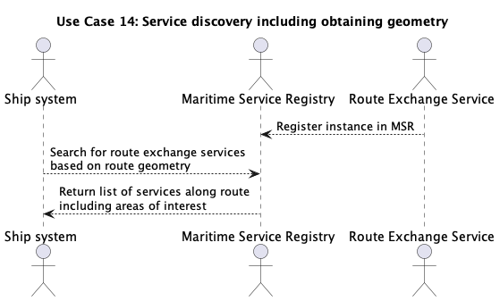
Figure 4 Service discovery flow

TODO

Definitions

Operational Node | A logical entity that performs activities. Note: nodes are specified independently of any physical realisation.  Examples of operational nodes in the maritime context are: Maritime Control Centre, Maritime Authority, Ship, Port, Weather Information Provider, etc.
Service | The provision of something (a non-physical object), by one, for the use of one or more others, regulated by formal definitions and mutual agreements. Services involve interactions between providers and consumers, which may be performed in a digital form (data exchanges) or through voice communication or written processes and procedures.
Service Consumer | A service consumer uses service instances provided by service providers. All users within the maritime domain can be service customers, e.g., ships and their crew, authorities, VTS centres, organizations (e.g., meteorological), commercial service providers, etc.
Service Data Model | Formal description of one dedicated service at logical level. The service data model is part of the Service Specification. Is typically defined in UML and/or XSD. If an external data model exists (e.g., a standard data model), then the service data model shall refer to it: each data item of the service data model shall be mapped to a data item defined in the external data model.
Service Interface | The communication mechanism of the service, i.e., interaction mechanism between service provider and service consumer. A service interface is characterised by a message exchange pattern and consists of service operations that are either allocated to the provider or the consumer of the service.
Service Operation | Functions or procedure which enables programmatic communication with a service via a service interface.
Service Provider | A service provider provides instances of services according to a Service Specification and service instance description. All users within the maritime domain can be service providers, e.g., authorities, VTS centres, organizations (e.g., meteorological), commercial service providers, etc.

Abbreviations

API Application Programming Interface
MRN Maritime Resource Name
MSR Maritime Service Registry
VTSO VTS Operator
XML Extendible Mark-up Language
XSD XML Schema Definition

References

- IALA. 2024. Guideline G1128 The Specification of e-Navigation Technical Services
- IALA. 2022. Guideline G1143 Unique Identifiers for Maritime Resources (MRN)
- IALA. 2022. Guideline G1183 Provision of MCP Identities
- IHO. 2024. Universal Hydrographic Data Model Standard S-100 5.2.0
- IEC. 2021. 63173-1 S-421 Route Plan based on S-100 Committee Draft 80/1148/CD
- IEC. 2021. 63173-2 Secure communication between ship and shore (SECOM) Committee Draft 80/1149/CD
- IACS. 2024. UR E26 & E27 Rev1 International Association of Classification Societies https://iacs.org.uk/resolutions/unified-requirements/ur-e
- IALA. 2022. Guideline G1111 Establishing Functional Performance Requirements
- IEC. 2024. 61174-1 Electronic chart display and information system (ECDIS) – Operational and performance requirements, methods of testing and required test results IEC TC80 MT7 December 2024 meeting outcome
- IMO. 2024. MSC.530(106)REV.1 Performance Standards For Electronic Chart Display And Information Systems (ECDIS) https://wwwcdn.imo.org/localresources/en/KnowledgeCentre/IndexofIMOResolutions/MSCResolutions/MSC.530(106).pdf
- IMO 2024. MSC.1CIRC.1610REV.1 INITIAL DESCRIPTIONS OF MARITIME SERVICES IN THE CONTEXT OF E-NAVIGATION https://wwwcdn.imo.org/localresources/en/OurWork/Safety/Documents/enavigation/MSC.1-CIRC.1610%20- %20Initial%20Descriptions%20Of%20Maritime%20ServicesIn%20The%20Context%20Of%20E-Navigation%20(Secretariat)%20(1).pdf

Author to insert actual service name and version number

