Input paper: VTS58-8.1.2

Input paper for the following Committee(s): check as appropriate Purpose of paper:
□ ARM □ ENG □ PAP □ Input
□ ENAV X VTS √ Information

Agenda item 8.1
Technical Domain / Task Number ² Task 1.1.4
Author(s) / Submitter(s) Korea Coast Guard, Republic of Korea

Introduction of the Korea Coast Guard VTS Area Establishment Procedure

Summary
In relation to the development of guidelines on the division of VTS areas under the 2023–2027 Work Plan of the IALA VTS Committee, the Korean Coast Guard introduces its four-step procedure for establishing VTS areas, along with considerations for each step.

Related documents
VTS53-12.1.2 VTS Committee Task Register for 2023-2027
G1150 Ed3.1 Establishment, Planning and Implementation a VTS
IMO Resolution A.1158(32) Guidelines for Vessel Traffic Services

Background
According to IMO Resolution A.1158(32) Guidelines for Vessel Traffic Services, VTS area means the delineated, formally declared area for which the VTS provider is authorized to deliver vessel traffic services. The establishment of a VTS area must therefore be objective and reasonable, and standardized procedures are necessary to minimize confusion for participating ship.

Discussion

VTS operation Status in South Korea
Korea operates 19 VTS centers, including three regional VTS. Due to increasing ship traffic and volume, the role of VTS in ensuring maritime traffic safety has been expanding, and the coverage of VTS services is continuously being extended. By 2026, two additional centers will be converted into regional VTS.

Introduction to the Korea Coast Guard VTS area Establishment Procedure
The procedure consists of four steps:
1. Drafting a proposed VTS area
2. Expert consultation
3. Pilot operation
4. Finalization through regulation amendment

Step 1: Drafting a Proposed VTS Area
Through external research organizations or service providers, investigations are conducted into maritime accidents, traffic volume, and radar detection ranges. Based on the findings and the following considerations, a draft VTS area is prepared.

Considerations for VTS Area Establishment:
- Prioritize sea areas with high traffic density and high accident risk.
- Expanded areas should be adjacent to existing VTS areas.
- Avoid setting boundaries in areas with high traffic density, frequent course changes, or crossing points.
- Determine radar coverage based on the ability to detect vessels on clear-weather days.
- Investigation Items
Items | Items
Maritime Accidents | By Accidents type, ship type, and area over the past 3 years
Traffic Patterns | Ship types, routes, and volume within the past year
Radar/  Communication Range | Radar detection and VHF communication simulations
Sea Area Characteristics | Bridges, power lines, water depth, currents, high-density traffic  (course changes, crossings, etc.)

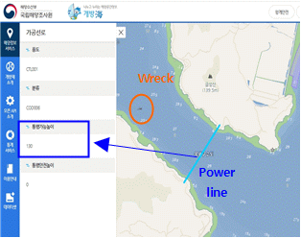 | 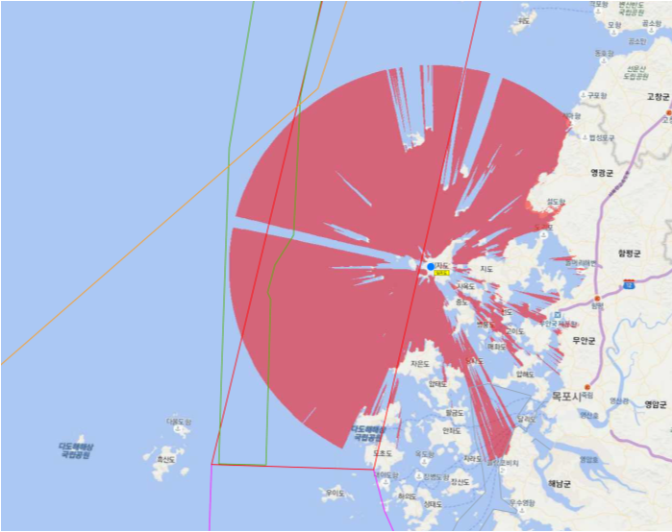
Sea Area Characteristics | Radar detection simulation
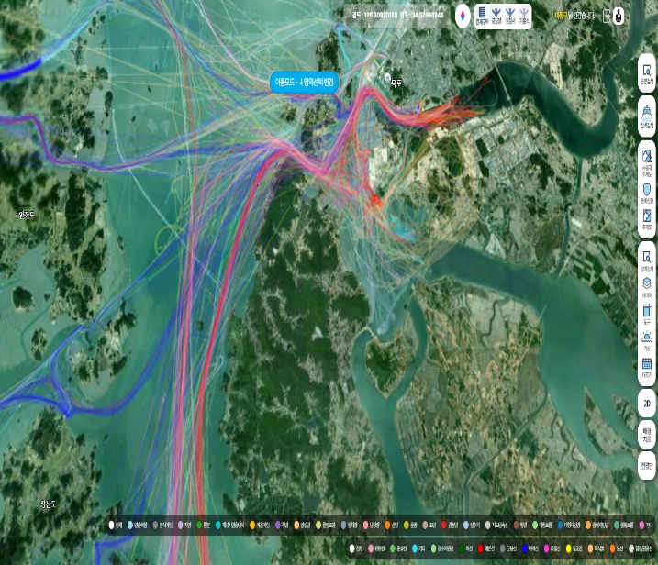 | 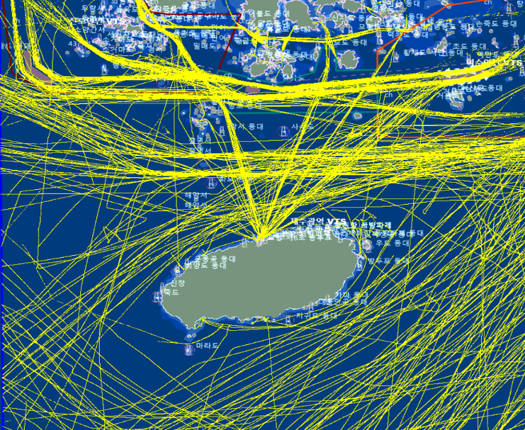
Korea Coast Guard “Big Data Platfrom”  Track Data | GICOMS AIS Track Data  (Ministry of Oceans and Fisheries)
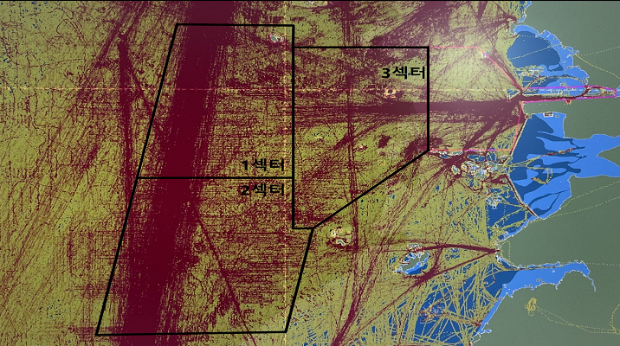 | 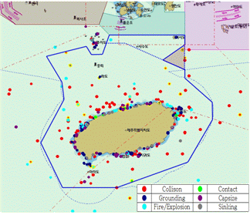
VTS Operation System Track Data | Maritime Accident Statistical Data

- Investigation Data

Step 2: Expert Consultation
After drafting the proposed VTS area and before finalizing it, consultation is conducted with experts such as pilot, stakeholders and professor of maritime universities. Related laws, radar coverage, vessel tracks, and other review materials are distributed for written or in-person consultation, and opinions are collected.

Step 3: Pilot Operation
A pilot operation is conducted for at least 3 months to verify radar coverage, navigation characteristics, and appropriateness of the VTS area. The duration may be adjusted depending on local conditions such as sea area characteristics, manpower allocation, facility stabilization, and coordination with related organizations.

*Note: If adjustments are made without additional radar installation, the pilot operation may be omitted.

Step 4: Finalization (Regulation Amendment)
Through the legislative process, domestic laws are amended and promulgated to finalize the VTS area.

References
The flowchart of the VTS area establishment procedure is provided in the Appendix.

Action requested of the Committee
The Committee is invited to take note of the Korea Coast Guard’s case when developing guidelines on the division of VTS areas.

- VTS Area Establishment Procedure Flowchart
STEP 1  Draft | Drafting a Proposed VTS Area | 1-1. When using external services  - Refer to 'Sea Area Investigation Items'  - Review suitability considering radar effective detection range, blind spots, traffic patterns, vessel traffic volume, maritime accidents
STEP 1  Draft | Drafting a Proposed VTS Area | 1-2. After radar installation  - Before pilot operation, reconfirm suitability considering radar detection range, blind spots, recent traffic patterns, and vessel traffic volume

STEP 2  Refinement | Expert Consultation | - Determine consultation targets (experts, related organizations)  - Decide consultation method (written or face-to-face)  - Incorporate consultation results
STEP 3  Pilot Operation | Pilot Operation | - Set pilot operation period (minimum 3 months)  - Review and supplement appropriateness of proposed VTS area  - Confirm radar detection range, blind spots, traffic patterns, VHF channels, VTS sectors  *Note 1: Pilot operation may be omitted if adjusted without additional radar installation
STEP 3  Pilot Operation | Pilot Operation | *Note 2: Expert consultation (Step 2) should be conducted before finalization
STEP 4  Finalization | Regulation Amendment | - Revise and promulgate domestic law to finalize the VTS area

Input document number, to be assigned by the Committee Secretary
Leave open if uncertain

