Input paper: VTS59-8.1.3

Input paper for the following Committee(s): Purpose of paper:
□ ARM □ ENG □ PAP ☑ Input
□ ENAV X VTS □ Information

Agenda item 8.1
Technical Domain / Task Number 1.1.5………………
Author(s) / Submitter(s) China Maritime Safety Administration…………

PROPOSAL ON THE DRAFT GUIDELINE ON ESTABLISHING A REGULATORY FRAMEWORK FOR VTS – RESPONSIBILITIES OF A COMPETENT AUTHORITY

Document Purpose
This document provides supplements and suggestions to the draft Guideline on establishing a regulatory framework for VTS - Responsibilities of a competent authority being developed by the Committee.

Related documents

WP VTS53-12.1.2 New VTS Task Register 2023-2027

WP VTS58-12.5.1.2 Draft Guideline -Establishing a regulatory framework for VTS - Responsibilities of a competent authority

background
Governments of Contracting States should make sufficient preparations in national policies and laws before planning and establishing their own VTS system with reference to IALA Recommendation 0119 and IALA Guideline 1150 in order to fulfill the obligations of Article 12 "Vessel Traffic Services" of Chapter V of SOLAS Convention. VTS53 Meeting included "developing guidelines to assist VTS authorities in establishing appropriate policy and legal frameworks to fulfill their obligations" as task 1.1.5 in the 2023-2027 Work Plan. VTS54 Meeting provided working paper VTS54-12.5.1.2 on drafting guideline for establishing a policy and legal framework for VTS. Then, VTS58 Meeting updated the working paper VTS58-12.5.1.2 on drafting guideline for establishing VTS policy and legal frameworks, and completed the task as planned at either the VTS59 or VTS60 Meeting.

Discussion
In accordance with VTS58-12.5.1.2 working paper, the following amendments are proposed for discussion to enhance the comprehensiveness of the draft Guideline.
VTS58-12.5.1.2 Draft Guideline Revision Position | Content of amendments | Reason for amendments
(Page 5)Section 3  International regulatory and legal framework | Adding: "the development of international regulatory and legal frameworks must maintain overall alignment with the strategies and objectives of and ."at the first line | In safeguarding maritime safety and protecting the marine environment, IALA and IMO share many common strategies and objectives. Under the joint recommendation of IALA and IMO, national members and are working to support the United Nations Sustainable Development Goals (SDGs). In dealing with the national administrative and legal affairs associated with these strategies and objectives, Member States should ensure that the policies align with national development strategies is a prerequisite.
(Page 5)Section 3  Key components of the international framework | Adding"● the IMO Instruments Implementation Code (III Code)" | Part 3 of the IMO Instruments Implementation Code explicitly states that "A coastal State should ensure that its legislation, guidance and procedures are established for the consistent implementation and verification of its rights, obligations and responsibilities contained in the relevant international instruments to which it is a party. Those rights, obligations and responsibilities may include: vessel traffic services." This provision also serves as a key basis for formulating domestic VTS legal frameworks in accordance with international law.  The IMO Implementation Code (III Code), as a mandatory IMO instrument, is binding on all member states and thus serves as a key basis for establishing domestic VTS legal frameworks.
(Page 5)Section 3  "International regulatory and legal framework"  "The international regulatory and legal framework for VTS is provided in the IALA VTS Manual and IALA Guideline G1150 Establishing, Planning and Implementing a VTS" | Adding  "During the refinement of the international regulatory and legal framework for VTS, IALA's standards, recommendations, and guidelines on VTS operation and management serve as key references. The interrelationships among these documents are illustrated in Figure 1." | Figure 1 systematically categorizes VTS Manual and IALA guidelines, providing clear guidance and reference for member states to define the responsibilities of their VTS authorities.
(Page 6)  In the corresponding position of Section 3 "International regulatory and legal framework:"  This national system or structure of laws, regulations, rules and policies should reflect how the responsibilities of the competent authority are implemented nationally. For example:  - The competent authority and VTS provider may be the same entity.  - The competent authority may delegate some or all of its tasks or responsibilities to VTS providers." | Adding  "3) Mechanisms and Procedures for the Transforming International Conventions into Domestic VTS Regulations  4) The nature of VTS authorities varies across countries, e.g, they may be affiliated with coastguard departments, administrative agencies, ports, pilotage institutions or public welfare organizations, etc." | ●National policies embody the will of the state through legislation. The process of transforming international instruments such as conventions and codes into national laws is determined by each country's policies. Although different countries have varying policies regarding the domestication of international treaties, this does not affect the requirements for domestic legislation and practice to align with the fundamental principles of international law.  ●Within the legal frameworks of SOLAS Convention contracting states, VTS providers vary in their affiliations, ranging from direct subordination to government competent authorities to those legally authorized by them. This diversity impacts the division of regulatory responsibilities among governments, competent authorities, and VTS providers.
(Page 9) Following Section 4.2.7 "The competent authority should determine whether the authorization should be granted for a limited or unlimited period of time . “ | Adding "According to Recommendation R0119 and Guideline G1150, the competent authority shall fully evaluate the importance and expected role of VTS in reducing maritime risks, classify and differentiate the demand and necessity of providing VTS services. and subsequently propose plans to establish, manage, or cancel VTS at different levels." | Given the dynamic nature of vessel traffic flow and risk levels, the need to establish VTS or provide equivalent services is ever-changing. The competent authorities should carefully assess the practical necessity of cancellation or downgrading VTS services to prevent redundant or excessive construction of VTS..
(Page 10) Section 4.2.9  "Suspension or cancellation of an authorization——Key elements for consideration include:" | Adding  "The competent authority shall establish a compliance monitoring mechanism during the transition period to avoid impacting vessel traffic safety and the legitimate rights and interests of VTS stakeholders caused by the cancellation or suspension of authorization." | During the transitional period between the decision to cancel or suspend VTS providers' authorization and its effective date, VTS providers shall continue to perform its core statutory duties. The competent authority shall establish a compliance monitoring mechanism during this transition to avoid impacting navigational safety and the legitimate rights and interests of VTS stakeholders caused by changes in authorization.
(Page 13) Section 4.4 "Requirements for Participating Ships" | 4.4.3 adding to the main text  "The directive is primarily based on VTS traffic management regulations. including navigation and anchoring, as published by VTS providers through VTS user guides or other official channels." | In addition to complying with the competent authority on vessel reporting, necessary information provision, and VTS regulations, s must also comply with the special provisions issued by the competent authority regarding ship routing systems, traffic laws, and navigation orders.
(Page 13) Section 4.4 "Requirements for Participating Ships" | 4.4.4Change"Compliance and enforcement" to "Mechanism for dealing with ships in violation of regulations"  Adding "When VTS providers discover violations by vessels, disposal procedures should be initiated according to their management authority in accordance with Figure 2 ." | The competent authority shall establish a mechanism for handling VTS vessel violations, including but not limited to  The competent authority or a VTS provider authorized by it may impose penalties or warnings on non-compliant vessels;  VTS providers report violations of regulatory duties by foreign vessels to competent authorities or flag states.
(Page 13) Section 4.4 "Requirements for Participating Ships" | Adding 4.4.5"Notification and liaison"  "The competent authority shall make arrangements for notification and liaison on the violation with the flag state authority and VTS providers." | When a vessel's violation involves the jurisdiction of multiple administrative bodies (e.g., ports, police, environmental agencies), the competent authority or the authorized VTS provider shall establish an information-sharing and coordination mechanism with other relevant agencies. If the VTS provider lacks such authorization, it should first establish a reporting system with the competent authority, which will then liaise with the other agencies.

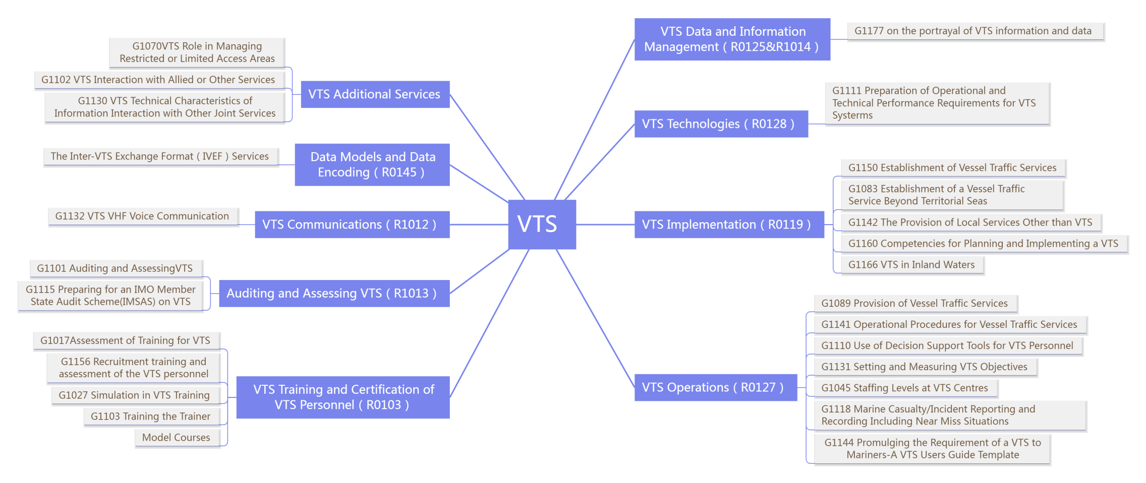
Figure 1. IALA VTS Document Framework

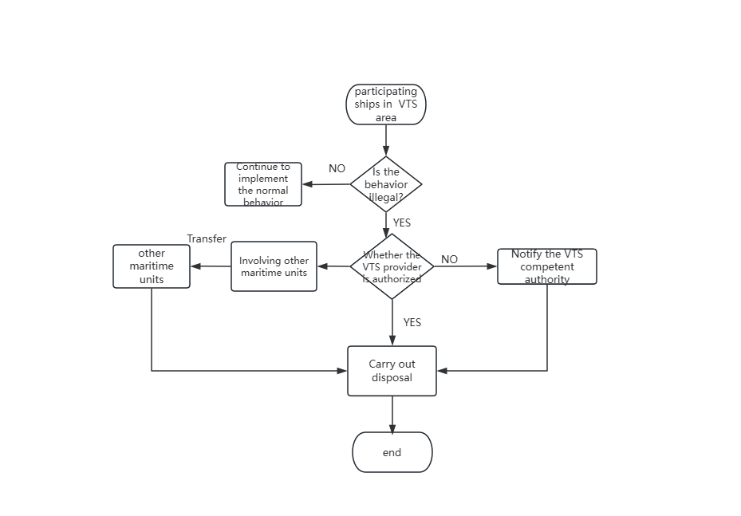
Figure 2. Procedures for huddling violations of participating vessels in VTS area

References
- IALA R0119-Establishment of VTS
- IALA G1150-Establishing, Planning and Implementing VTS
- IALA Standards-S1040, Ed2.0&S1050, Ed2.0
- IMO Resolution A.1158(32)-Guidelines for Vessel Traffic Services

Action requested of the Committee
The Committee is requested to consider the comments of Sections 3 when developing the draft Guideline for Establishing a Regulatory Framework for VTS - Responsibilities of a Competent Authority.

