Input paper: VTS59-9.1.3

Input paper for the following Committee(s): Purpose of paper:
□ARM □ENG □PAP ☑ Input
□ENAV XVTS □ Information

Agenda item 9.1
Technical domain/ Task number 2.5.2d
Author(s)/Submitter(s) China Maritime Safety Administration

Proposals on＂Service Specification for VTS Under keEl clearance Service＂

1 Summary
This proposal proposes specific suggestions for Service Specification for VTS Under Keel Clearance Service Edition 0.5 from the aspects of improving service specification name, time reference system, key terms, use cases, and interoperability of UKC display.

1.1 Purpose of the document
The purpose of this document is to provide input document for the VTS Committee to update Service Specification for VTS Under Keel Clearance Service Edition 0.5 and Share Case Study on the Application of Under Keel Clearance (UKC) in Shanghai Port VTS Area, China

1.2 Related documents
- IALA VTS Committees Task Plan 2025-2027
https://iala-task-register.com/committee-homepage?id=1
[2] IALA VTS53-6.3.2 Development of technical service specifications for digital data exchange between VTS and other entities - primarily ships
[3] IALA VTS54-9.1.3 Proposals on the New Task of "Developing Technical Service Specifications for Digital Data Exchange between VTS and Other Entities - Primarily Ships"
[4] IALA VTS55-9.1.1 Proposals on “Service Specification for VTS Traffic Clearance Service_V1.0"
[5] IALA VTS56-9.1.1 Proposal on "Service Specification for VTS Traffic Clearance Service Edition 1.3" and "Service design"
[6] IALA VTS57-9.1.2 Proposals on "Service Specification for VTS Traffic Clearance Edition 1.4"
[7] IALA VTS57-12.3.7 Service Specification for VTS Traffic Clearance Edition 1.5
[8] VTS57-9.1.1 Proposals on the "Service Specification for VTS - Vessel Route Exchange Edition 0.3"
[9] VTS58-9.1.1 Proposals on the "Service Specification for VTS - Vessel Route Exchange Edition 1.0"
[10] VTS58-12.2.3 Service Specification for VTS - Vessel Route Exchange Edition 1.1
[11] VTS58-2.5.2d Service Specification for VTS Under Keel Clearance Service Edition 0.5
[12] IALA Revised G1128 Specification of e-Navigation Technical Services Edition 1.7
[13] IALA C03-10.4.3 Revised G1191 Maritime Service Registry (MSR) Technical Specification Edition 1.1
[14] IHO S-129 Under Keel Clearance Management Product Specification Edition 2.0

2 Background
The IALA VTS Committee Work Plan 2023-2027 raises the task "Development of technical service specifications for digital data exchange between VTS and other entities - primarily ships" (task 2.5.2), and aims to finalize the pioneer technical service specifications before VTS57. Service Specification for VTS Traffic Clearance Service Edition 1.5 had been finalized at VTS57. Service Specification for VTS -Vessel Route Exchange Edition 1.1 had been finalized at VTS58. Service Specification for VTS Under Keel Clearance Service draft Edition 0.5 working document had been developed at VTS58.

3 Discussion

3.1 Proposals on refining service specification name
This service specification is currently named VTS UKC Information Service, and the closely related IHO S-129 2.0 version is named UKCM Product Specification. It also provides multiple related derivative concepts of the UKCM service in its "3.2 Terms and Definitions". Considering that VTS committee differs from the IHO, which focus on the standardized release of UKC data and information, and pays more attention to interactive services to achieve safe and efficient TOS, it is suggested to uniformly change the service specification name to VTS UKCM Service. There are also multiple expressions such as VTS UKC service and VTS information service in the text. It is suggested to uniformly change all kinds of UKC service to UKCM service.

3.2 ProposalS on improving time reference system
The service specification frequently uses the time reference system interchangeably. For example, in the pre-plan stage, it is "UKC time window with fixed time ranges start and end global time tidal windows", and in the actual plan stage, it is "UKC time window with fixed time ranges start and end time tidal windows". The control points in this stage are "Fixed time ranges start and end time local tidal window".
Considering the "12.4 Time Reference Coordinate System" in IHO S-129 Edition 2.0 clearly requires the use of UTC time, the latest editions of service specifications for related pre-processing services such as Traffic Clearance and Route Exchange all default to uniformly using UTC time. It is suggested to uniformly change to "UKC time window with fixed time ranges start and end time tidal windows".

3.3 ProposalS on improving key terms

3.3.1 Maximum Draught
The description of Use Cases 1 mentions "maximum allowed draught" and lists "Under Keel Clearance Calculation Requested: Max allowed draught" as a key parameter in the typical sequence. Considering that section A8.17 Under Keel Clearance Calculation Requested of IHO S-129 Edition 2.0 defines "Maximum Draught" as "The maximum draught for a given time window". It is suggested to clearly distinguish between related terms such as Max allowed draught, Maximum Clearance Calculation Draught, Maximum Draught, Safety depth (ECDIS setting), and navigable depths. Priority should be given to terms explicitly adopted by S-129, such as Maximum Draught, to avoid ambiguity.

3.3.2 Time Window
There are certain instances of the mixed use of "tidal window", "tidal windows", "time window", and "time tidal windows" in the current text, as well as the mixing of "waypoint" and "control point". Considering the following points:
1 Section A8.17 Under Keel Clearance Calculation Requested of IHO S-129 Edition 2.0 defines "time window" as "The available time window(s) for a given draught." and clearly states that "Time Window" is an enumeration value of the key attribute UnderKeelClearanceCalculationRequested.
2 The adjacent two "waypoints" in the interactive route are usually turning or speed-changing points in terms of navigation, rather than the control points for UKC based on water depth, water levels, and meteorological factors. There is a relatively high probability that the control point with the shallowest soundings does not correspond to the actual situation of the "waypoint".
3 IHO S-129 Edition 2.0 stipulates that each S-129 Under Keel Clearance plan should be mandatory associated with at least one control point (UnderKeelClearanceControlPoint) feature, and the attribute "Expected passing time" of UnderKeelClearanceControlPoint is a timestamp often used in combination with "Expected passing speed", indicating "Time Window" is usually represented by the complex attribute "Fixed time range", which contains one or more time windows composed of start and end timestamps.
"VTS area" in this specification is usually tens of nautical miles and a several-hour navigation plan. Generally, there are multiple UnderKeelClearanceControlPoints. Therefore, it is suggested that in Use Case s 2 to 6, all the relevant terms returned by VTS calculation should uniformly use "time windows via control points", which is in line with the "Time Window" enumeration value of UnderKeelClearanceCalculation RequestedType, while also clarifying the difference between the waypoint parameters by vessels and the time windows by VTS calculation as the control points for draft limitation, avoiding ambiguity.

3.4 Proposals on improving Use Cases
G1128 emphasizes that "The Service Specification must provide sufficient detail in the use cases and logical data model ", as well as "the operational context shall describe any requirement the service shall fulfil or adhere to. This refers to functional as well as non-functional requirements at a high level". This refers to both high-level functional and non-functional requirements. The Use Cases section of "Service Specification for VTS - Vessel Route Exchange Edition 1.1" provides important parameters such as route status, route version, route information description, and confirmation, as well as their value changes, on multiple occasions. In terms of the detailed correspondence between Use Cases and subsequent functional and non-functional requirements, Use Case 1 of "Service Specification for VTS - Vessel Route Exchange Edition 1.1" states, "For the complete list of requirements, please refer to RESF007." Use Case 3 points out that "for more details, see RESF012" and others are all related to the logical data model of functional requirements and other subsequent sections. By comparing the new edition of G1128 with the "Service Specification for VTS - Vessel Route Exchange Edition 1.1" both horizontally and vertically, it is suggested that the Use Cases details be further enriched in the context of the specification. Specific suggestions are as follows:

3.4.1 ProposalS related to S-129 Geographical Feature
According to the IHO S-129 Edition 2.0 data model (S-129 Figure 7-2), each S-129 UnderKeelClearancePlan feature should be mandatory associated with at least one control point (UnderKeelClearanceControlPoint) geographical feature, meaning that the UnderKeelClearanceControlPoint should be mandatory rather than optional geographical features. Its multiplicity ranges from 1 to many (1, *). However, the other three geographical feature types of UnderKeelClearancePlanArea, UnderKeelClearancePlanNonNavigableArea, and UnderKeelClearancePlanAlmostNon-NavigableArea are all optional geographical features, with a multiplicity ranging from 0 to many (0, *). Moreover, in the Pre-plan stage, only the "time windows via control points" should be interactively handled, while the UnderKeelClearancePlanNonNavigableArea and UnderKeelClearancePlanAlmostNonNavigableArea are generally used in conjunction with the UnderKeel ClearancePlanArea. In accordance with the requirements provided in G1128 for providing sufficient details, the following proposals are suggested to facilitate the design of functional requirements and service design and to enable refined parameter management during these stages:
1 In Use Case 1 and Use Case 2 of the Pre-plan stage, it is suggested to delete the descriptions of "Geometry for non-navigable areas [optional]" and "Geometry for Almost non-navigable areas [optional]".
2 In Use Case 1 of the Pre-plan stage, it is suggested to add a description related to the maximum draft of UnderKeelClearanceControlPoint.
3 In Use Case 2 of the Pre-plan stage, it is suggested to add the conditional judgment of "maximum draught" that, for non UKC critical areas, there is no need to feedback the UKC Pre-plan. For areas where the UKC could not meet all times, proceed to Use Case 8 for handling.
4 In Use Case 4, Use Case 5, and Use Case 6 of the Actual plan stage, add "Geometry for UnderKeel ClearancePlanArea [optional]".

3.4.2 ProposalS related to Routes
IMO 530(106) REV.1 and IHO S-129 Edition 2.0 both support two route-exchange standards, RTZ and S-421. There are significant differences in multiple important parameters. Considering the previously released pre-standard "Technical Service Specification for VTS - Vessel Route Exchange Edition 1.1" only supports S-421, the keywords of specification identification currently only reference S-421. It is suggested:
1 If this specification clearly only supports UKC related to S-421, it should be further clarified in section 1.3 Input from Other Sources and section 3 Operational Context. If this specification simultaneously supports both RTZ and S-421 by referring to S-129 and ECDIS Performance Standard, it is suggested to refine and clarify the important features or attributes of the route such as waypoints and schedules in Use Cases, to avoid potential conflicts.
2 Refer to Service Specification for VTS - Vessel Route Exchange Edition 1.1, the route sent by the vessel should have Legs, including cross-track distance limit (CL) and route status parameters (planned or checked). If the VTS UKCM needs to optimize the route (such as avoiding shallow soundings), the route status parameters should be set to recommend. Considering the supporting role of the route exchange service for this specification, it is suggested to add the descriptions related to setting and change of route status parameters.
3 UKC Use Case 5-Vessel requests UKC information from a VTS (actual plan) after a route change has listed VTS - Vessel route exchange as a Pre-condition, corresponding to Service Specification for VTS - Vessel Route Exchange Edition 1.1, Use case 3 - VTS requests route updates from vessel (For more details, see RESF012). Through functional requirements RESF012, mandatory requirements in terms of process, status, time limit, etc. (multiple musts had been listed) are given to ensure safety. Considering that VTS is also restricted by multiple situations such as the coordination of multiple vessel UKC services and the time windows of UKC control points with limited draft, it is suggested to provide detailed functional requirements explanations in Use Case 5 and subsequent functional requirements, such as routes with tidal influence that have a safety passage time window shorter than 30 minutes and control points in narrow and dangerous sea areas are not supported for route changes, to avoid potential risks of grounding or collision.

3.4.3 ProposalS related to Time
This specification used "48-24 hours prior" three times to represent the actual planned datasets (Actual Plan datasets are produced closer to the arrival/departure). In Figure 1: High-level view of VTS UKC information use cases, "48h" is used to distinguish "Pre-planned" and "Actual Route Plans", and "Pre-planning" is used in multiple places. Based on the relevant descriptions of IHO S-129 and the context, it is suggested to uniformly change "Pre-planned" and "Pre-planning" to "Pre-plan", and "Actual Route Plans" to "Actual Plans", to uniformly change "48h" or "48-24 hours" to "24 hours".
In Use Case 3, 4, and 6, "between 10 and 60 minutes" is used to represent the service update frequency in the actual plan stage. However, in combination with the relevant descriptions of IHO S-129 and the context, it is suggested to uniformly change it to "between 5 and 60 minutes", and further refine it in the functional requirements.

3.4.4 ProposalS related to service registration and discovery

"VTS queries the VTS Service registry" and "Vessel provides an update link" in Use Case 3 is ambiguous and insufficient for exchanging the detailed description of the UKCM service. It is suggested to apply the relevant object entities and service discovery interfaces such as discover, search, and subscribe in MIR and MSR. For multiple UMCM operation areas, both local and global discovery modes should be applicable to provide for multiple potential VTS in long voyages. Additionally, in light of the context, it is suggested that Use Case 3 be replaced with a new Use Case 1, and its name be changed to "Initialize UKCM Service".
Use Case 14 in Service Specification for VTS - Vessel Route Exchange Edition 1.1 states "Vessel can discover compatible route services". In light of the relevant requirements of the newly released G1191 "Maritime Service Registration Technical Specification" in December 2025, and considering the existing content related to Traffic Clearance Services Specifications and Service Design, it is suggested to add "Vessel can discover UKC" Use Case in this specification.

3.4.5 ProposalS for Adding UKCM Automated Operation and Monitor Services
Use Case 11 in Service Specification for VTS - Vessel Route Exchange Edition 1.1 describes the use of automated services for route exchange, and through "Use Case 12 Update route status from planning to monitoring" and "Use Case 15 VTS requests route after it has been shared" further enriches the scenarios related to route automation operation and monitoring services. Considering that the actual update stage in IHO S-129, which is closely related to this service specification, has not yet been echoed in the Use Case section, combined with the understanding of the UKCM data model and the complexity of digital communication technology interaction, as well as the technical similarity analysis of the two specifications, it is suggested to add "UKCM automated operation and monitor services" and the relevant user cases for the actual update stage.
Based on the relevant general requirements of SECOM and MSR, referring to RESF007, RESF008, RESF009, RESF010, and RESF012, it is suggested to add five new functional requirements as follow: Requirements for a valid UKCM message received from the vessel, Requirements for sharing a valid UKCM message from VTS to the vessel, Requirements for identities, Requirements for authenticity, and Requirements for when the route has changed.

3.5 ProposalS for Interoperability of UKC Display
The three descriptions of "3.1 S-129 datasets are typically intended to be overlays to S-101 ENC and are always displayed with S-101 ENC data in the background. Systems that support the display of S-129 datasets should provide users with simple functions to turn the display of S-129 datasets on and off", 3.1.4 and 3.1.6 "The vessel is able to display geometries from received messages as a layer on an ENC" are suggested to be deleted. Because the technical requirements for how S-129 data sets can be used in standard ECDIS display applications are given in the IMO ECDIS performance standard (IMO 530(106) REV.1), IHO S-98 and S-164, IEC 61174, However, the interoperability and even alarm triggering of the UKCM message in the IMO ECDIS performance standards has not been regulated yet. To avoid potential inconsistencies or conflicts, it is suggested to delete and simplify the UKCM technical service-related descriptions.

4 Action requested of the Committee
The Committee is requested to consider the proposals in this document and take actions as appropriate.

Appendix A

Introduction of Under Keel Clearance Information Services in VTS area of Shanghai, China

A.1. Summary
South Channel Fairway, within Shanghai Port VTS area, serves as one of the primary waterway for small and medium-sized vessels navigating to and from Shanghai Port and the Yangtze River, as well as for large vessels sailing in ballast condition. The channel has an overall length of approximately 46 nautical miles and accommodates an average daily traffic volume of around 500 vessel movements. The shallow-water section of the South Channel Fairway, near the Jiuduansha Precautionary Area, has a charted depth of 6.0 meters. Subject to tidal influences, this area experiences a maximum tidal range of approximately 5 meters and an average tidal range of 2.3 meters. In accordance with local navigation requirements, vessels are required to maintain a minimum under keel clearance (UKC) of 0.7 meters. Consequently, vessels with a draught exceeding 6 meters must plan their passage with the tidal windows. Some vessels have risk of grounding incidents due to lack of tidal information.
To address this, Shanghai VTS and Eastern Navigation Service Centre, People's Republic of China to develop a dynamic under keel clearance of depth application providing tidal information services.

A.2. Overview of the application
The application is developed based on S-102, S-104 and S-111 data products, enabling the provision of real-time and dynamic water depth information. Users can obtain precise water depth data with tidal height, and can query and predict the water depth for specific locations at any given time. In accordance with the S-129 standard, it integrates AIS data to compute and display navigable/non-navigable area tailored to a vessel's draught and position.

A.3. VTS Service Scenarios

A.3.1. Water Depth Information Service
By positioning the cursor over the selected location, the system displays the charted depth, the predicted tidal height, and the resulting water depth with tidal effects applied. As illustrated in Figure 1, the location of the Jiuduansha Precautionary Area is shown on the chart. The lower-left section of the interface presents detailed water depth data for the selected position, while the upper-right section visualizes water depth variations using color-coded depth layers. The latitude and longitude of the cursor position are displayed at the bottom of the interface.
This functionality assists VTS operators to better understand spatial and temporal variations in water depth within the fairway. It also provides vessels with depth data, supports VTS operations, and delivers relatively precise depth information to vessels, thereby ensuring navigational safety.
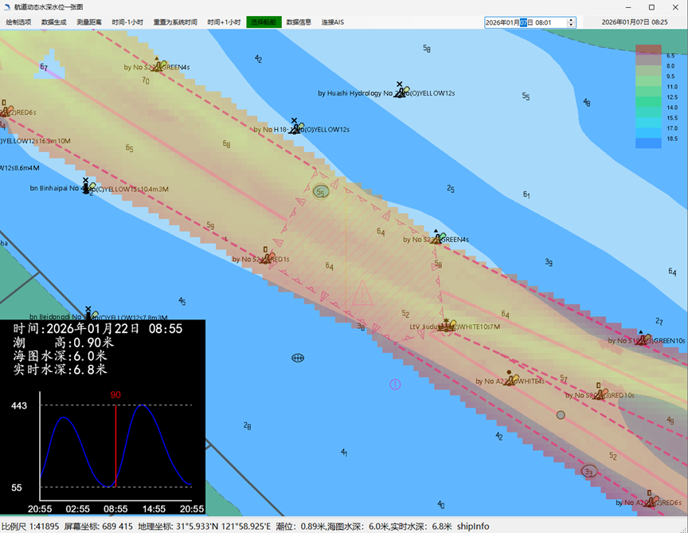
Figure A.1 Water Depth Data Information

A.3.2. Calculation of Navigable and Non-Navigable Areas
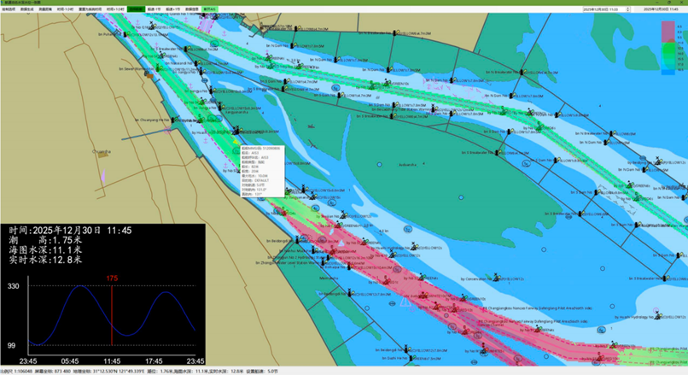
This application supports communication protocols that can access vessel AIS data. Click on the target vessel, and the system will automatically calculate the navigable and non-navigable areas based on the selected vessel's type, draft, speed, and the set minimum required UKC. As shown in Figure 2, the green areas indicate navigable areas, while the red areas denote non-navigable areas where the water depth below the vessel's draught at its current speed.

Figure 2 Display of navigable and non-navigable areas
This functionality assists VTS operators in the early identification of grounding risks due to insufficient UKC, enabling timely advisories for vessels to adjust their navigation plans, such as transiting shallow-water sections during more favourable tidal windows.

A.3.3. Fleet management and efficient navigation of vessels
Given that the chart datum depth of this fairway section is six meters, with a total bottom width of approximately 600 meters, vessels are required to transit the area in a single line. At the same time, a relatively large number of inbound vessels rely on tidal windows each day to safely pass through this shallow-water section. Shanghai VTS uses the dynamic water level application to calculate and issue the applicable tidal windows for the following day. Based on vessel information associated with the use of a specific tidal window, including vessel type, draught and main engine power, vessels are grouped in advance to facilitate the coordinated use of available tidal windows. This practice supports the more efficient utilization of the fairway while maintaining navigational safety.
The application also has function of analysis of historical traffic data, thereby assisting VTS authority in formulating useful safety management measures.

