Blue Sky Thinking - future work for VTS / VTS WG3
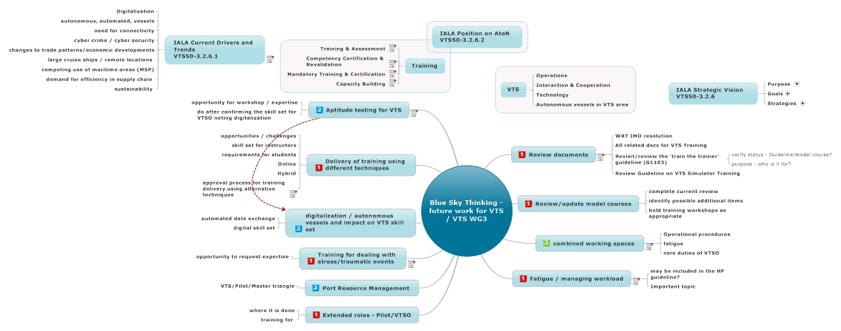

- Review documents
- Note work that is ongoing
- Barry is Task Leader

  - WRT IMO resolution
  - All related docs for VTS Training
  - Revisit/review the 'train the trainer' guideline (G1103)
    - verify status - Guideline/model course?
    - purpose - who is it for?
  - Review Guideline on VTS Simulator Training
- Review/update model courses
  - complete current review
  - identify possible additional items
  - hold training workshops as appropriate
- combined working spaces
Stefaan Priem thoughts:
- pilot services
- port operations services

- Role of Pilot/VTS
- training for the Pilot/VTS personnel

  - Operational procedures
  - fatigue
  - core duties of VTSO

- Fatigue / managing workload
- May be covered in Human Factors Guideline
  - may be included in the HF guideline?
  - Important topic
- Extended roles - Pilot/VTSO
  - where it is done
  - training for
- Port Resource Management
  - VTS/Pilot/Master triangle
- Training for dealing with stress/traumatic events
- VTS Operators dealing with high stress event
- VTS as first responders
- Note - opportunity to learn from other organisations - ATC; Soldier On; RUOK
  - opportunity to request expertise

- digitalization / autonomous vessels and impact on VTS skill set
  - automated date exchange
  - digital skill set
- Delivery of training using different techniques
  - opportunities / challenges
  - skill set for instructors
  - requirements for students
  - Online
  - Hybrid
  - approval process for training delivery using alternative techniques
Any implications for G104
- Aptitude testing for VTS
See also: digitalization / autonomous vessels and impact on VTS skill set
- Noting the changes in digital/digitalization
- what are the aptitudes required for VTSO of the future

- Overview of aptitude testing in use
- Canada - math, spatial reasoning, data interpretation (5 set aptitudes tested for)
- Finland - also do

- Role of aptitude testing - need for expertise - opportunity for a workshop, include experts on expertise for aptitude

  - opportunity for workshop / expertise
  - do after confirming the skill set for VTSO noting digitalization

