

VTS Digital Information

Draft 0.7.3 – September 2024

VTS Digital Information Product Specification

Document Revisions
Revisions to the IALA Document are to be noted in the table prior to the issue of a revised document.
Date | Page / Section Revised | Requirement for Revision
15 October 2019 | -- | Initial draft
01 September 2020 | Various
01 November  2020 | Various | Published draft
21 September 2023 | Redesign of the document | VTS 54: WG 1, task 1.3.1 and WG 2, tasks 2.5.2 and 2.8.1. Interoperability to IHO S-100 version 5.0.0
14 March 2024 | Added application schema to section 4.4  Changed S-100 version to 5.2.0 in references | Application schema development  IHO S-100 version update
26 September 2024 | Updated to better address S-100 version 5.2.0 | Updated to conform S-100 version 5.2.0 based on the input to VTS 56 and the review of the document.

Table of Contents
1 Overview 5
1.1 Introduction 5
1.2 Scope 5
1.3 References 5
1.3.1 Normative 5
1.3.2 Informative 6
1.4 Terms, definitions and abbreviations 6
1.4.1 Use of language 6
1.4.2 Terms and definitions 6
1.4.3 Abbreviations 8
1.5 General data product description 9
1.6 Data product specification metadata 10
1.7 Product Specification Maintenance 10
1.7.1 Introduction 10
1.7.2 New Edition 10
1.7.3 Revisions 11
1.7.4 Clarification 11
1.7.5 Version Numbers 11
2 Specification Scope 11
3 Data Product Identification 12
4 Data Content and structure 12
4.1 Introduction 12
4.2 To Be Removed: [The Scenario of the VTS Digital Information] 14
4.1 Relationships in the data model 14
4.2 Use of geometry attributes 14
4.3 VTS Digital Information schema 14
4.4 Full S-212 data model 15
4.4.1 Overview of Domain Features and Information Types 15
4.4.2 VTS-DIM Complex Attributes 15
4.4.3 VTS-DIM Enumerations and Codelists 17
4.5 Language and text 17
4.6 Classification of a VTS Digital Information 18
5 Feature Catalogue 18
5.1 Introduction 18
5.2 Feature Types 18
5.2.1 Geographic 18
5.3 Feature and information relationships 19
5.4 Attributes 19
5.4.1 Simple attributes 19
5.4.2 Complex attributes 20
5.5 Units of Measure 20
5.6 Geometric Representation 20
6 Co-ordinate Reference Systems (CRS) 21
6.1 Introduction 21
6.2 Reference systems used in S-212 21
6.2.1 Vertical Coordinate Reference System 21
6.2.2 Horizontal Reference System 22
6.2.3 Projection 22
6.3 Temporal Reference System 22
6.4 VTS Digital Information Data and Scale 22
7 Data Quality 22
8 Data Capture and Classification 22
9 Data Maintenance 22
10 Data Product format (encoding) 23
10.1 Introduction 23
10.2 Numeric Attribute Encoding 23
10.3 Text Attribute Values 23
10.4 Mandatory Attribute Values 23
10.5 Unknown Attribute Values 23
10.6 Structure of dataset files 23
10.7 Message object identifiers 24
10.8 Dataset validation 24
10.9 Location of Data Product Format schema Files 24
10.10 Detailed documentation of schema 24
11 Data Product Delivery 24
11.1 Message datasets 25
11.2 Collections 25
11.3 Dataset distribution 26
11.3.1 Datasets 26
11.3.2 Dataset size 26
11.3.3 Dataset file naming 26
11.4 Exchange Catalogue 26
12 Metadata 26
13 Use of other standard documents in VTS-DIM 26
14 Language 26
Annex A. Data Capture and Encoding Guide 27
Annex B. Feature Catalogue 28
Annex C. GML Schema 29
Annex D. Validation Checks 30
Annex E. Portrayal Catalogue 31

Overview

Introduction

This document has been produced by the IALA VTS Committee. The purpose of this document is to respond to requests to produce a data product that can be used in digital communications between Vessel Traffic Service (VTS) and other entities, primary ships. The product specification is developed in a what that parts of it can later be used as VTS Information Overlay within an Electronic Chart Display and Information System (ECDIS). It is based on the IHO S-100 framework specification and the ISO 19100 series of standards. It is a vector product specification that is primarily intended for encoding the nature and extent of VTS specific electronic messages that are exchanged between VTS and ship as well as other entities that need message-based communication with VTS.
IALA Guideline 1089 edition 2.0 on Provision of Vessel Traffic Services provides guidance on the delivery of the services provided by a Vessel Traffic Service (VTS).
According to resolution A.1158(32) on Guidelines for Vessel Traffic Services, services provided by a VTS are defined as “services implemented by a Government with the capability to interact with vessel traffic and respond to developing situations within a VTS area to improve safety and efficiency of navigation, contribute to the safety of life at sea and support the protection of the environment.”
Resolution A.1158(32) also states that “To achieve their purpose, VTS should provide information or issue advice, warnings and instructions, as deemed necessary.”
S-212 VTS Digital Information is intended to be used as real-time or near-real-time messages from VTS-to-ship and ship-to-VTS.
The VTS Digital Information datasets specified in this version describe data element used in VTS Traffic Clearance, including anchorage assignment.

Scope
This document describes an S-100 compliant Product Specification for VTS Digital Information. It specifies the content, structure, and metadata needed for creating a fully compliant S-212 product. This Product Specification includes content model, encoding, Feature Catalogue and metadata. At the moment there are no plans for developing Portrayal Catalogue.

References

Normative
IALA G1143 Unique Identifiers for Maritime Resources, Edition 3.0. International Association of Marine Aids to Navigation and Lighthouse Authorities, June 2021.
S-98 Data Product Interoperability in S-100 Navigation Systems, Edition 1.0.0, May 2022
S-100 IHO Universal Hydrographic Data Model Edition 5.2.0 June 2024
ISO 639-2/T Codes for the representation of names of languages – Part 2: Alpha-3 code
ISO 3166-1 Codes for the Representation of Names of Countries and their Subdivisions – Part 1: Country Codes
S-62 List of Data Producer Codes (online), URL: https://registry.iho.int/producercode/list2.do

Informative
IMO MSC.530(106) Revised Electronic Chart Display and Information System (ECDIS) Performance Standard

S-97 IHO Guidelines for Creating S-100 Product Specifications, Edition 1.1.0, June 2020.

ISO 8601:2004 Data Elements and Interchange Formats – Information Interchange – Representation of Dates and Times

ISO 19103:2005 Geographic Information – Conceptual Schema Language

ISO 19103-2:2005 Geographic Information – Conceptual Schema Language – Part 2

ISO 19108:2002/Cor 1:2006 Geographic information — Temporal schema

ISO 19115-1 Geographic information – Metadata – Part 1 - Fundamentals. As amended by Amendment 01 (2018)

ISO/TS 19115-3 Geographic information - Metadata - XML schema implementation for fundamental concepts

ISO 19117:2012 Geographic Information – Portrayal

ISO 19131:2008 Geographic Information – Data Product Specifications

ISO 19157:2013 Geographic Information – Data Quality
S-101 IHO Electronic Navigational Chart Product Specification Edition 1.2.0 March 2024
IEC S-421 Route Plan based on S-100 (IEC 63173-1) ED 1.0
IEC SECOM Secure communication between ship and shore (IEC 63173-2) ED 1.0

Terms, definitions and abbreviations

Use of language
- “Must” indicates a mandatory requirement.
- “Should” indicates an optional requirement, that is the recommended process to be followed, but is not mandatory.
- “May” means “allowed to” or “could possibly”, and is not mandatory.

Terms and definitions
The S-100 framework is based on the ISO 19100 series of geographic standards. The terms and definitions provided here are used to standardize the nomenclature found within that framework, whenever possible. They are taken from the references cited in clause 2.1. Modifications have been made when necessary.

application
manipulation and processing of data in support of user requirements (ISO 19101)

application schema
conceptual schema for data required by one or more applications (ISO 19101)

conceptual model
model that defines concepts of a universe of discourse (ISO 19101)

conceptual schema
formal description of a conceptual model (ISO 19101)

data product
dataset or dataset series that conforms to a data product specification

data product specification
detailed description of a dataset or dataset series together with additional information that will enable it to be created, supplied to and used by another party
NOTE: A data product specification provides a description of the universe of discourse and a specification for mapping the universe of discourse to a dataset. It may be used for production, sales, end-use or other purpose.

dataset
identifiable collection of data (ISO 19115)
NOTE: A dataset may be a smaller grouping of data which, though limited by some constraint such as spatial extent or feature type, is located physically within a larger dataset. Theoretically, a dataset may be as small as a single feature or feature attribute contained within a larger dataset. A hardcopy map or chart may be considered a dataset.

dataset series
collection of datasets sharing the same product specification (ISO 19115).
Distinction: series

domain
well-defined set (ISO/TS 19103)
NOTE: Well-defined means that the definition is both necessary and sufficient, as everything that satisfies the definition is in the set and everything that does not satisfy the definition is necessarily outside the set.

exchange set
datasets may be grouped into exchange sets. Each exchange set consists of one or more datasets with an associated XML metadata file and a single Exchange Catalogue XML file containing metadata. It may also include one or more support files.
feature
abstraction of real world phenomena (ISO 19101)
NOTE: A feature may occur as a type or an instance. Feature type or feature instance shall be used when only one is meant.

feature association
relationship that links instances of one feature type with instances of the same or a different feature type (ISO19110)
NOTE 1; A feature association may occur as a type or an instance. Feature association type or feature association instance is used when only one is meant.
NOTE 2: Feature associations include aggregation of features.

feature attribute
characteristic of a feature (ISO 19101)
NOTE 1: A feature attribute may occur as a type or an instance. Feature attribute type or feature attribute instance is used when only one is meant.
NOTE 2: A feature attribute type has a name, a data type and a domain associated to it. A feature attribute for a feature instance has an attribute value taken from the domain.

geographic data
data with implicit or explicit reference to a location relative to the Earth (ISO 19109)
NOTE: Geographic information is also used as a term for information concerning phenomena implicitly or explicitly associated with a location relative to the Earth.

metadata
data about data (ISO 19115)

model
abstraction of some aspects of reality (ISO 19109)

portrayal
presentation of information to humans (ISO 19117)

quality
totality of characteristics of a product that bear on its ability to satisfy stated and implied needs (ISO 19101)

universe of discourse
view of the real or hypothetical world that includes everything of interest (ISO 19101)

Abbreviations
This product specification adopts the following convention for symbols and abbreviated terms:
CRS Coordinate Reference System
DCEG Data Classification and Encoding Guide
ECDIS Electronic Chart Display and Information System
ENC Electronic Navigational Chart
GML Geography Markup Language
IALA International Association of Marine Aids to Navigation and Lighthouse Authorities
IHO International Hydrographic Organization
IMO International Maritime Organization
ISO International Organization for Standardization
UML Unified Modeling Language
URI Uniform Resource Identifier
URL Uniform Resource Locator
VTS Vessel Traffic Service
WMS Web Map Service
WWW World Wide Web
XML Extensible Markup Language
XSLT eXtensible Stylesheet Language Transformations

General data product description
NOTE: This information contains general information about the data product.
Title: | VTS Digital Information Product Specification
Abstract: | This specification is developed for creating datasets containing VTS digital information targeting use between VTS and ships. Some parts of the data are targeting use in ECDIS. VTS Digital Information means digital messages containing information related provision of Vessel Traffic Services in accordance of IMO resolution A.1158(32) on Guidelines for Vessel Traffic Services. Use of VTS Digital Information datasets in other systems than ECDIS is permitted.
Content: | A dataset conforming to this specification will contain one VTS digital information message from VTS-to-ship or ship-to-VTS. Datasets of a series are delivered by means of an exchange set. Additionally there will be relevant metadata about data quality, production authority, and creation date.
Spatial extent: | Global coverage of maritime areas.  East Bounding Longitude: 180°  West Bounding Longitude: -180°  North Bounding Latitude: 90°  South Bounding Latitude: -90°
Specific Purpose: | The purpose of this document is to respond to requests to produce a data product that can be used in digital communication between VTS Centers and ships. In addition there is a need to get some messages handled within an Electronic Chart Display and Information System (ECDIS). It is based on the IHO S-100 framework specification and the ISO 19100 series of standards. It is a vector product specification that is primarily intended for encoding the extent and nature of digital VTS communication, for provision of Vessel Traffic Services.

Data product specification metadata
This information uniquely identifies this Product Specification and provides information about its creation and maintenance. For further information on dataset metadata see the metadata clause.
title: | VTS Digital Information Product Specification
version: | 0.7.3
date: | 26 September 2024
language: | English
classification: | Unclassified
contact: | International Association of Marine Aids to Navigation and Lighthouse Authorities - Association Internationale de Signalisation Maritime  10, rue des Gaudines  78100 Saint Germain en Laye, France  Telephone: +33 (0)1 34 51 70 01  Email: contact@iala-aism.org
URL: | https://www.iala-aism.org/
identifier: | S-212
maintenance: | Changes to the Product Specification S-212 are coordinated by IALA VTS Committee and are made available via the IALA S-200 web site. Maintenance of the Product Specification must conform to IALA G1087 Procedures for the Management of the IALA Domain and IALA G1088 Introduction to preparing S-100 product specifications.
compliancyCategory: | category3

Product Specification Maintenance

Introduction
Changes to a product specification will be released by IALA-AISM as a new edition, revision, or clarification.

New Edition
New editions of a product specification introduce significant changes. New editions enable new concepts, such as the ability to support new functions or applications, or the introduction of new constructs or data types. New Editions are likely to have a significant impact on either existing users or future users of S-212. All cumulative revisions and clarifications must be included with the release of approved New Editions.

Revisions
Revisions are defined as substantive semantic changes to S-212 . Typically, revisions will change S-212 to correct factual errors; or introduce necessary changes that have become evident as a result of practical experience or changing circumstances. A revision must not be classified as a clarification. Revisions could have an impact on either existing users or future users of S-212 . All cumulative clarifications must be included with the release of approved revisions.
Changes in a revision are minor and ensure backward compatibility with the previous versions within the same Edition. Newer revisions, for example, introduce new features and attributes. Within the same Edition, a dataset of one version could always be processed with a later version of the Feature and Portrayal Catalogues.
In most cases a new Feature Catalogue or Portrayal Catalogue will result in a revision of S-212.

Clarification
Clarifications are non-substantive changes to a product specification. Typically, clarifications: remove ambiguity; correct grammatical and spelling errors; amend or update cross references; insert improved graphics, spelling, punctuation and grammar. A clarification must not cause any substantive semantic change to a product specification.
Changes in a clarification are minor and ensure backward compatibility with the previous versions within the same edition. Within the same edition, a data product of one clarification version could always be processed with a later version of the feature and portrayal catalogues, and a portrayal catalogue can always rely on earlier versions of the feature catalogues.

Version Numbers
The associated version control numbering to identify changes (n) to this specification must be as follows:
New Editions denoted as n.0.0

Revisions denoted as n.n.0

Clarifications denoted as n.n.n

Specification Scope
This product specification defines only one general scope which applies to all its sections.

Scope ID: Global
Level: dataset
Level name: VTS-DIM Dataset

Data Product Identification

title | VTS Digital Information
alternateTitle | VTS-DIM
abstract | VTS Digital Information dataset is a vector dataset containing the extent and nature of VTS-related digital communication message from VTS-to-ship or ship-to-VTS. Information on the extent and duration of the VTS-related information may be included.
geographicDescription | Areas specific to VTS and areas specific to marine navigation in proximity of VTS specific areas.
spatialResolution | Information is compiled as scale independent information using the required accuracy.
purpose | VTS Digital Information datasets are to allow the producer or issuer to exchange VTS specific digital information with navigators. Current edition of VTS Digital Information message dataset is not purposed to be used as a navigational data product within ECDIS. VTS Digital Information datasets can later be also produced for navigational purposes within an ECDIS as soon as ECDIS standards recognize S-212 as a navigational data product.
language | English must be used for international services, while local language may be provided in addition to English. National services may provide either local language only, or a combination of local language and English.
classification | 1) Unclassified
spatialRepresentationType | Vector
point of Contact | Producing Agency

Data Content and structure

Introduction
The VTS Digital Information product is based on the S-100 General Feature Model (GFM), and is a feature-based vector product. All VTS Digital Information features and information classes are derived from one of the abstract classes FeatureType and InformationType defined in the VTS Digital Information application schema, which realize the GFM meta-classes S100_GF_FeatureType and S100_GF_InformationType respectively.
VTS Digital Information (VTS-DIM) features are encoded as vector entities which conform to S-100 geometry configuration level 3a (S-100 clause 7-4.3.4).
The following exception applies to VTS-DIM:
• The use of coordinates is restricted to two dimensions (DirectPosition is restricted to two coordinates).

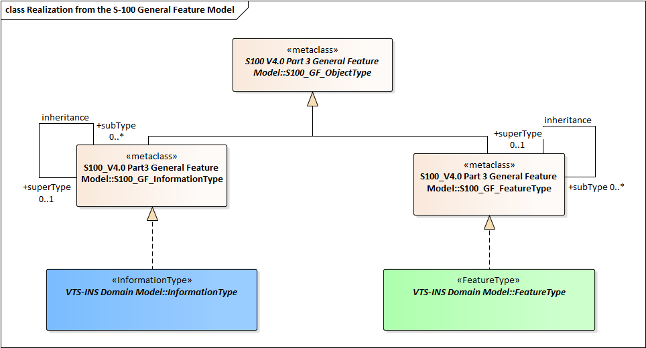
Figure 4-1 Realizations from the S-100 General Feature Model
This clause contains the Application Schema expressed in UML and an associated Feature Catalogue.

To Be Removed: [The Scenario of the VTS Digital Information]

This part has been moved out of the S-212 product specification. The respective content that follows current IALA guidances can be found in the VTS Committee document “IALA Guideline on VTS Digital Communication (draft)” and the Technical Service Specifications of the VTS Digital Services.

Relationships in the data model
To be filled according to the S-97 and S-100 guidance.

Use of geometry attributes
To be filled according to the S-97 and S-100 guidance.

VTS Digital Information schema
The UML models in this clause are segments of the overall VTS Digital Information schema, and include overviews of the feature classes, information classes, spatial types, and the relationships between them.
This clause contains a general overview of the classes and relationships in the VTS Digital Information schema. Detailed information about how to use the feature types and information types to encode VTS-DIM is provided in the VTS-DIM Data Classification and Encoding Guide (DCEG) that will be produced at the later versions of this specification.
The following conventions are used in the UML diagrams depicting the schema:
- Standard UML conventions for classes, associations, inheritance, roles, and multiplicities apply. These conventions are described in Part 1 of S-100.
- Italic font for a class name indicates an abstract class.
- Feature classes are depicted with green background; the dark shade for abstract feature classes and the light shade for ordinary (non-abstract) feature classes.
- Information type classes are depicted with blue background; the dark shade for abstract information type classes and the light shade for ordinary information types.
- Complex attributes are depicted with a pink background.
- Enumeration lists and codelists are depicted with a tan background. The numeric code corresponding to each listed value is shown to its right following an ‘=’ sign.
- No significance attaches to the colour of associations. (Complex diagrams may use different colours to distinguish associations that cross one another.)
- Where the association role or name is not explicitly shown, the default rules for roles and names apply:
- The role name is ‘the<CLASSNAME>’ where <CLASSNAME> is the name of the class to which that association end is linked.
- The association name is ‘<CLASSNAME1>_<CLASSNAME2>’ where <CLASSNAME1> is the source and <CLASSNAME2> the target. In case of a feature/information association the feature is the source.
- For feature/feature or information/information associations without explicit names the source/target are indicated by an arrowhead.
- Subclasses inherit the attributes and associations of their superclasses at all levels, unless such inheritance is explicitly overridden in the subclass.

Full S-212 data model

Overview of Domain Features and Information Types
The VTS Digital Information data product consists of information related the provision of VTS services to the vessel, either delivered to the VTS Operator or made up of messages that the operator must deliver.
The figure 7-2 shows the overview picture of the feature and information type of the VTS Digiatal Information domain model.
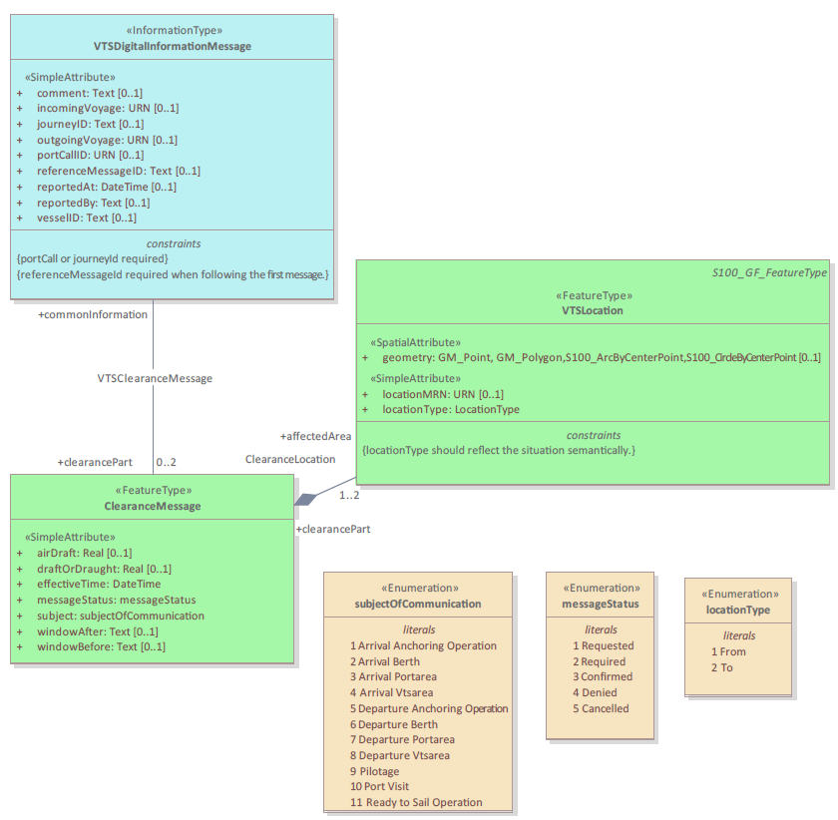

Figure 7-4 Overview of VTS-DIM Feature and Information Types

- VTSDigitalInformationMessage is a information type. Classes for distinguishing information that is sent. Manage requests, responses to requests, and results of requests, or distinguish which information is transmitted from broadcasting information. Ships can be reported to VTS in this class and transmitted with requested information, while VTS can transmit with answer information in this class.
- ClearanceMessage is a feature type. Information that is conveyed from VTS-to-ship and ship-to-VTS. ClearanceMessage covers also acknowledgement of a ClearanceMessage.

VTS-DIM Complex Attributes
The complex attributes in the VTS Digital Information domain are provided in Figures 7-3.

The figure has to be generated from the updated XSD schema.
Figure 7-5 VTS-DIM Complex Attributes

VTS-DIM Enumerations and Codelists
For completeness, the enumerations and codelists in the VTS Digital Information domain are provided in Figures 7-4.
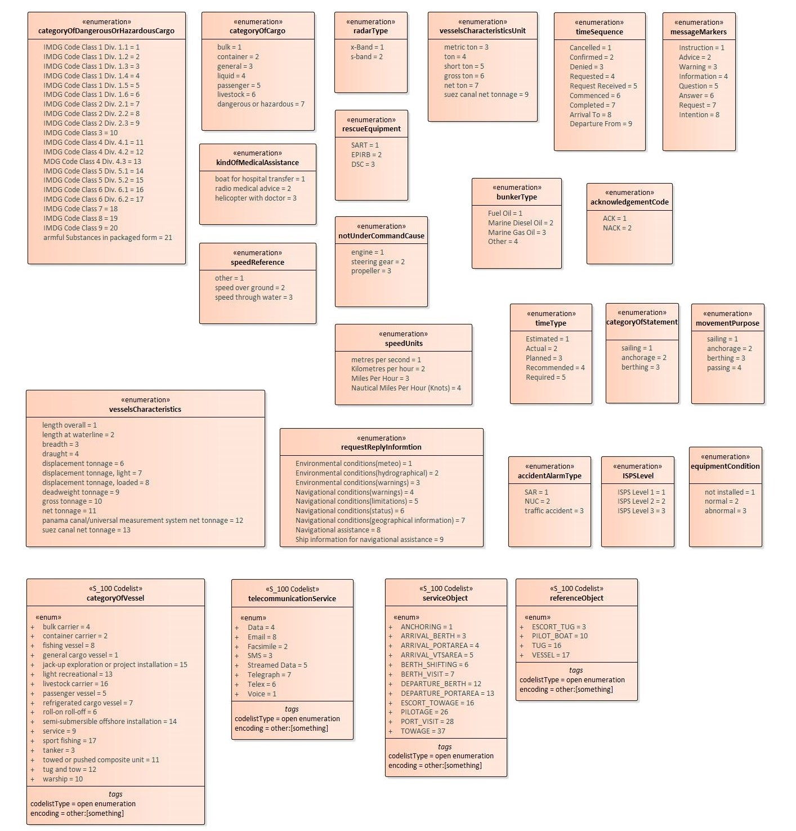
Figure 7-6 VTS-DIM enumerations and codelists

Language and text

When a VTS Digital Information messages are provided in languages other than English, a language pack for that language should be created using the methods described in S-100 Part 18 and distributed through the appropriate channels. The language pack will include appropriate translation for the feature catalogue elements needed to enhance the user interface with text in the selected language. The language pack must therefore be present in the user system to work as intended. It may be advantageous to also include support for the language pack in the S-212 initiating system to ensure best possible harmonization between data and the language pack.

Classification of a VTS Digital Information
This paragraph should define the different subtypes of VTS Digital Information and how they must be identified and how different types should be prioritized in the transmission. At the moment only type of VTS Digital Information is VTS Traffic Clearance Message.

Feature Catalogue

Introduction
The Feature Catalogue describes the feature types, information types, attributes, attribute values, associations and roles which may be used in the product. The S-212 Feature Catalogue is available in an XML document which conforms to the S-100 XML Feature Catalogue Schema and can be downloaded from the IALA S-200 website (https://www.iala-aism.org/technical/data-modelling/iala-s-200-development-status/s-212/). Simple attributes used in this specification are listed in the Table 5-1 – Simple feature attributes. A printed version of the feature catalogue is provided in Annex D.

Feature Types
Feature types contain descriptive attributes that characterize real-world entities. The word ‘feature’ may be used in one of two senses – feature type and feature instance. A feature type is a class and is defined in a Feature Catalogue. A feature instance is a single occurrence of the feature type and represented as an object in a dataset. A feature instance is located by a relationship to one or more spatial instances. A feature instance may exist without referencing a spatial instance.

Geographic

Geographic (geo) feature types carry the descriptive characteristics of a real-world entity (a location or place on the surface of the Earth). In the context of hydrographic products, this includes the adjacent regions from the sea floor to elevations of landforms and structures above the Earth’s surface.

Cartographic

Cartographic features contain information about the cartographic representation (including text) of real-world entities.

5.2.3 Information Types
Information types define identifiable pieces of information in a dataset that can be shared using information associations. They have attributes but have no geometry.

VTS-DIM makes use of the following feature types:
Geographic (Geo) feature type – carries the descriptive characteristics of a real world entity.
Relationship feature type – A feature relationship links instances of one feature type with instances of the same or a different feature type.

Feature and information relationships

A feature relationship links instances of one feature type with instances of the same or a different feature type.
An information relationship links instances of feature types or information types to instances of information types.

Attributes
S-212 defines attributes as either simple or complex.

Simple attributes
S-212 uses eight types of simple attributes; they are listed in the following table:
Type | Definition
Boolean | A value representing binary logic. The value can be either true or false.
Enumeration | One of a list of predefined values
Integer (int) | An arbitrary-length sequence of characters including accents and special characters from a repertoire of one of the adopted character sets
Text or CharacterString | An arbitrary-length sequence of characters including accents and special characters from a repertoire of one of the adopted character sets
Date | A date gives values for year, month and day according to the Gregorian Calendar. Character encoding of a date is a string which shall follow the calendar date format (complete representation, basic format) for date specified by ISO 8601.  EXAMPLE 19980918 (YYYYMMDD)  In XML formats, the XML Schema standard type should be used instead of the ISO 8601 basic representation (which is not a standard type in XML).  EXAMPLE: 1998-09-18  Note: Since S-212 uses XML formats for both datasets and metadata, the XML encoding must be used.
Date and Time | A DateTime is a combination of a date and a time type. Character encoding of a DateTime shall follow ISO 8601 (see above). The “T” is a separator indicating that time-of-day follows.  EXAMPLE: 19850412T101530 (YYYMMDDThhmmss)  In XML formats, the XML Schema standard type should be used instead of the ISO 8601 basic representation (which is not a standard type in XML).  EXAMPLES: 1985-04-12T10:15:30; 1985-04-12T10:15:30+01:00;  1985-04-12T10:15:30Z  Note: Since S-212 uses XML formats for both datasets and metadata, the XML encoding must be used.
Codelist | A type of flexible enumeration. A code list type is a list of literals which may be extended only in conformance with specified rules.
URN | A persistent, location-independent, resource identifier that follows the  syntax and semantics for URNs specified in RFC 2141.  EXAMPLE: urn:mrn:iho:hydro:js:AnchorageArea01
Table 5-1 – Simple feature attributes.
Note: the use of URN in S-212 must utilize the schema of the Maritime Resource Name (MRN) concept.

Complex attributes
Complex attributes are aggregations of other attributes that are either simple or complex. The aggregation is defined by means of attribute bindings.

Units of Measure
There is no use of a specific unit of measure in the S-212 data model. However, the content of text attributes that describe the nature of VTS digital information should make use of the following units of measure where appropriate:
- Orientation is given in decimal degrees
- Radio frequency is given in hertz
- Uncertainty is given in metres
- Horizontal distance is given in either metres (m) or kilometres (km) or nautical miles (NM), as indicated by the designation
- Depths are given in metres
- Heights are given in metres

Geometric Representation
Geometric representation is the digital description of the spatial component of an object as described in S-100 and ISO 19107. This product specification uses three types of geometries: GM_Point, GM_OrientableCurve, and GM_OrientableSurface. The spatial attributes for the feature classes specify the expected geometric primitives to be inserted as either point, curve or surface. Point corresponds to GM_Point, curve corresponds to GM_OrientableCurve, and surface corresponds to GM_OrientableSurface. The VTSDigitalInformationMessage feature class defined in this specification can also use the no geometry geometric primitive. This option is reserved for cases where the geometry is not needed, where location of the VTS digital information is given by other feature class. In such cases a textual description of the area is can be expressed.
Figure 5-2 - Geometric Primitives shows an overview of how the spatial model has been implemented in S-212. This includes the option to encode spatial uncertainty where this is required.
Spatial uncertainties can be encoded using the complex attribute SpatialUncertainty. For values expressed quantitatively the positionalAccuracy simple attribute must be used, or qualitatively expressed values are captured using the qualityOfPosition enumerated list

Co-ordinate Reference Systems (CRS)

Introduction
A VTS Digital Information dataset must define one geodetic CRS and may define vertical CRS information for depths and elevations when appropriate for the VTS Digital Information content.

Reference systems used in S-212
The horizontal CRS must be EPSG:4326 (WGS84). The full reference to EPSG:4326 can be found at https://epsg.org/.
Horizontal coordinate reference system: WGS 84
Projection: None
Vertical coordinate reference system: Vertical CRS for depths and elevations may be
specified in the sub attribute information of
the vtsInformationMessage complex attribute
using amplifying text.
Temporal reference system: Gregorian calendar
Coordinate reference system registry: EPSG Geodetic Parameter Registry
Date type (according to ISO 19115): 002 – publication

The location of an object in the S-100 standard is defined by means of coordinates which relate a feature to a position. The coordinate reference system used for this product specification is World Geodetic System 1984 (WGS 84) which is defined by the European Petroleum Survey Group (EPSG) code 4326.
Spatial data are expressed as latitude (φ) and longitude (λ) geographic coordinates. Latitude values are stored as a negative number to represent a position south of the Equator. Longitude values are stored as a negative number to represent a position west of the Prime Meridian. Coordinates are expressed as real value, degree / degree decimal format. Datasets conforming to this product specification are not projected.

Vertical Coordinate Reference System
Although all coordinates in a dataset must refer to the same horizontal CRS, different Vertical Datums can be used for the depth or heights described in VTS Digital Information datasets. The S-212 data must use meter for heights when included. Some amplifying text in some attribute information of the VTS digital information message complex attribute may include information about heights or depths. When this is the case, the vertical datum used in the measurement shall be made clear from the text.

Horizontal Reference System
Positional data is expressed in latitude and longitude geographic coordinates to one of the reference horizontal reference systems defined in the HORDAT attribute. Unless otherwise defined, the World Geodetic System 84 (WGS 84) will be used for VTS digital information data products.

Projection
VTS-DIM data products are un-projected.

Temporal Reference System
Time is measured by reference to temporal attributes in accordance with ISO 19108:2002/Cor 1:2006 according to S-100 Part 3 General Feature model paragraph 3-8 describing S-100 temporal framework.

VTS Digital Information Data and Scale
VTS Digital Information data must be compiled in the best applicable scale. The use of the data itself is "scale independent". That means that the data can be used at any scale. S-100 allows the association of multiple spatial attributes to a single feature instance. In principle, each of these spatial attributes can be qualified by maximum and minimum scales.
For example, it is possible, within one dataset, to have a single instance of a feature that has more than one area geometry. Each of these geometries has different scale max/min attributes. Moreover, due to cluttering in smaller scales, the scale minimum attribute may be used to turn off portrayal of some features at smaller scales.

Data Quality
VTS Digital Information datasets must be validated using the conformance checks that are listed in Annex F(TBD). Prior to release by the data producer. The data producer must review the check results and address any issues to ensure sufficient quality of the data products. The checks are a mix of data format validation checks, conformance to standard checks and logical consistency checks.

Data Capture and Classification
The Data Capture and Classification (DCEG) guide is developed for the later versions if necessary.

Data Maintenance

Data Product format (encoding)

Introduction
Detailed documentation of the VTS-DIM encoding schema is provided in B of this document.
Format Name: XML, Specification: custom.
File Structure: (VTS-DIM Product Specification), Annex B.

Numeric Attribute Encoding
Floating point and integer attribute values must not contain leading zeros. Floating point attribute values must not contain non-significant trailing zeros.

Text Attribute Values
Character strings must be encoded using the character set defined in ISO 10646-1, in Unicode Transformation Format-8 (UTF-8).

Mandatory Attribute Values
Some attribute values are considered mandatory for the following reasons:
- Certain messages make no logical sense without specific attributes,
- Some attributes are necessary to determine which symbol is to be displayed,
All mandatory attributes are identified in the Feature Catalogue and summarised in Annex A – Data Classification and Encoding Guide.

Unknown Attribute Values
It is an error for a mandatory attribute value to be missing. Mandatory attributes cannot be “nilled”.
Optional attributes must be omitted altogether if the value is unknown or missing.

Structure of dataset files
A ‘dataset’ in this product is a message that consists of a single object encoded as an XML element VTSDigitalInformationMessage.
This product references data elements in the IHO GI Registry. Datasets of other standard documents do not exist separately in several files. They are nested in VTS-DIM Dataset as shown in Figure 12-1 using Attributes that can function as Message Identifier.
To be drawn again.
Figure 12-1 VTS-DIM Dataset with Other Standard Documents
Collections of objects may be wrapped. This wrapping is out of the scope of this product specification.

Message object identifiers
Each message object is identified by a messageIdentifier based on URN format, in accordance with RFC 4122. This allows us to assign message identifiers in a distributed manner with no centralised id management and still be guaranteed that all message identifiers are globally unique. As a result, any message that is sent has an identifier. Since a VTS-DIM dataset consists of a single message, the ID of the single message object in a dataset is the same as the ID of the dataset.
GML geometric primitives (inline or external) are required to have a gml:id attribute with a value that is unique within the file (dataset or collection). The gml:id values must be used as the reference for the object from another object in the same dataset or another dataset. Applications must therefore take care to generate a unique gml:id for each point encoded as coordinates.

Dataset validation
Fields may be repeated or omitted as permitted by the XML schemas and the validation tests. Since XML schema cannot encode rules for conditional presence or attributes, these rules must be checked by other validation code in the implementation.
Schematron rules are another possibility for validation code, but are not defined in this specification since the ability of implementations to integrate Schematron validation is unknown. Implementers may create and implement their own Schematron validation rules.

Location of Data Product Format schema Files
The schema file will provide a future location and is available from that location.

Detailed documentation of schema
The detailed documentation of the schema is in Annex B (currently a separate document enclosed with this file).

Data Product Delivery
This clause specifies the encoding and delivery mechanisms for a VTS-DIM dataset. Data which conforms to this product specification must be delivered by means of an exchange set.
There are only two delivery modes for VTS-DIM data – single messages and collections. In either delivery mode, the content may be encapsulated into a form suitable for transmission by a mapping called a transmission encoding. An encoding translates each of the elements of the content (e.g., exchange set) into a logical form suitable for writing to media and for transmission online. An encoding may also define other elements in addition to the exchange set contents (i.e., media identification, etc…) and also may define commercial constructs such as encryption and compression methods.
Examples: REST; MIME-encoded email; zip files.
If the data is transformed (e.g., for encryption or compression purposes) its content must not be changed.
This product specification does not define the transmission encoding which must be used as a default for transmission of data between parties.

Message datasets
VTS-DIM Datasets are delivered as single messages transmitted to a service broker via an appropriate delivery mechanism, e.g., REST API.
Units of Delivery: Message
Transfer Size: 10kb maximum
Medium Name: Digital data delivery
Other Delivery Information:
Each delivery packet must contain a single VTS-DIM Message.
Exchange catalogues are not included.
The allowed components are as follows:
Mandatory Elements
- VTS-DIM Message – XML encoding of single VTS-DIM Message.
Optional Elements: None.

Collections
VTS-DIM Collections are transferred as collections of messages transmitted via an appropriate delivery mechanism, e.g., REST API.
Units of Delivery: Collection
Transfer Size: 20MB
Medium Name: Digital data delivery
Other Delivery Information:
Each collection may contain zero or more VTS-DIM objects.
Exchange catalogues are not included.
The allowed components are as follows:
Mandatory Elements
- VTS-DIM Message– XML encoding of VTS-DIM features/attributes and their associated geometry and metadata.
- Collection wrapper – as specified by the service broker API.
Optional Elements: None

Dataset distribution

Datasets
Datasets are distributed as files as described in this specification. The distribution media are left to the discretion of the producer and distributor.

Dataset size
Single messages must not exceed 10kb. Collections must not exceed 20 MB.

Dataset file naming
If VTS-DIM data is communicated in the form of dataset files containing a single VTS-DIM message in each file, the files shall be named <MESSAGEIDENTIFIER>.XML
NOTE: The letter cases of the file name and the messageIdentifier encoded within the message are not guaranteed to be the same. E.g., the internal messageIdentifier may use lower case letters, or mixed case, or may have only some letters in uppercase, etc.

Exchange Catalogue
The exchange catalogue prescribed by S-100 is not used in the VTS-DIM specification and is not transmitted with VTS-DIM messages. This is to reduce demands on bandwidth and the complexity of generation and handling of VTS-DIM.

Metadata
Metadata prescribed by S-100 is not transmitted with VTS-DIM messages. This is to reduce demands on bandwidth and the complexity of generation and handling of VTS-DIM.
For this reason there is no metadata defined in this specification.

Use of other standard documents in VTS-DIM

Figure 15-1 relationship between VTS-DIM and Other Product Specification

Language
The exchange language must be English. Other languages may be used as a supplementary option. National geographic names can be left in their original national language using the complex attribute Feature Name.
Character strings must be encoded using the character set defined in ISO 10646-1, in Unicode Transformation Format-8 (UTF-8). A BOM (byte order mark) must not be used.
- Data Capture and Encoding Guide

[To be added in later versions.]

- Feature Catalogue

Name: VTS Digital Information Feature Catalogue
Scope: VTS Digital Information
Version Number: 0.7
Version Date: 2023-XX-XX
Producer:
International Association of Marine Aids to Navigation and Lighthouse Authorities
Association Internationale de Signalisation Maritime
10, rue des Gaudines
78100 Saint Germain en Laye, France
Telephone: +33 (0)1 34 51 70 01
Email: contact@iala-aism.org
Language: English

HTML version is supplied as well.

- GML Schema

This data format conforms to the profile described in S-100 Part 10b, which is based on GML. The schema is contained in the schema files and references S-100 components were appropriate.
[The Data Format Documentation is currently in a separate document enclosed with this file. See file Annex_B Data Format Documentation. The GML Schema itself is a separate file in the product specification distribution package.
Annex B 1 Data Product Format, Schemas: This package contains the S-100 Part 10b compliant GML schemas for the specification of the data product encoding for S-212 datasets.
Annex B 2 Data Product Format, Schema document: This package contains the documentation of the GML schema in a human readable form, and lists each element with their associations and definitions.]

- Validation Checks

[To be defined later.]

- Portrayal Catalogue
[To be defined later.]

